Contra Costa County’s Special Districts

Presented by the Contra Costa County Special Districts Association
2020

FROM: Stan Caldwell
TO: Students and Teachers of Contra Costa County
SUBJECT: The Contra Costa Special Districts Association (CCSDA)

The purpose of the information in this booklet is to educate students and others about local government, hopefully to assist with the Local Government curriculum in high schools. By educating students about local government, we can help them understand how government at the local level affects their everyday lives.
The idea that we should be educating our youth to be civic-minded is not a new one. Thomas Jefferson and the other forefathers of the United States knew that in order to maintain constitutional democracy, our citizens must be knowledgeable and skilled in civic virtues.
In the United States, as well as in other countries, traditional history, civics and government classes spend a disproportionate amount of time studying national government. Very little time is dedicated to state or regional governments, and even less to local government. Yet, the United States has more elected positions at the local level than any other nation in the world. Conservative estimates put the number of local elected officials at more than a half-million, and these public servants are accessible to their residents by a simple local phone call, social media, or a personal visit.
The issues and concerns in our schools, neighborhoods, cities, and special districts are real and immediate. Citizens must realize that they can bring about change for the better in their own communities, if they only know how to go about it, and the primary opportunity for them to learn about the government closest to them is in our schools. With local government so accessible, students can observe first-hand those decision-making bodies at work, and, with appropriate instruction, can learn how to monitor and influence these bodies.
Most important then, local government offers students and teachers a setting in which they can develop and practice the participatory skills essential for informed, effective citizenship. Students learn about government by becoming involved in local government activities that can put them in decision-making roles as they face the tough decisions that come with governing. When students join with their peers, neighbors, or an interest group to work for changes to improve the quality of life in their school or community, they learn essential elements of democratic civic action. They learn about leadership in a democracy, and about the exercise of authority and the limitations on power that constitutional democracy imposes.
Today’s youth are the leaders of tomorrow. It is vital for young people in the community to learn what it is that local officials do in local government. Getting students interested and even excited about how local government works will not only give us better citizens in the future, but also help their parents become better informed since students will go home and share some of the information they have learned with their parents.
Within a year or so after these young people graduate from high school, they will be voting on issues that may affect them for a very long time. Any information that we can give that helps them understand the process or spark an interest is important. Making direct classroom contact to educate local students about their own local government will foster enthusiasm as well as future participation in government. The objective should be to provide a positive and practical educational experience to students.
It was with this objective in mind that the Contra Costa Special Districts Association (CCSDA) formed the idea of making information about the 48 Independent Special Districts and 31 Dependent Special Districts that make up our Association accessible and available to students and the general public by sponsoring a project to be executed by student interns of the Contra Costa County Historical Society (CCCHS) at its History Center in Martinez under the supervision of CCCHS Executive Director Priscilla Couden, Ph.D.. This booklet is the result of that project. Thanks go especially to Victoria Sherman of JFKU who began the research for the project and Adria Trgovcich of the University of Oklahoma’s Master of Arts program, who brought it to completion.
As the level of government closest to the citizens, local government offers students the opportunity to influence the future of their communities. Accomplishing this goal depends upon citizen awareness and a commitment to become involved. It is with this awareness and hope that the Contra Costa Special Districts Association publishes this description of the functions and contact information about the Special Districts. Our youth will be our leaders someday, and it is our wish to support them in their learning to be participants in our great society.

(Signature)

Stan Caldwell, President
Contra Costa Special Districts Association
February, 2020

An Introduction to California’s Special Districts and LAFCo
The structure of the State of California consists of the State itself and local government agencies. These local government agencies consist of 58 county governments, 482 city governments, 977 school districts, and approximately 3,400 independent special districts. Each of these special districts and local governments has specific boundaries within which they provide critical services, such as fire, police, water, sewer, and school services . The Local Agency Formation Commission (LAFCo) is the organization that serves as a neutral watchdog agency and oversees local agency services and boundaries. There is one LAFCo in each of the 58 counties in California.
LAFCo derives its authority from the State of California. In 1963, the State Legislature created Local Agency Formation Commissions “LAFCo’s” in response to urban sprawl and boundary wars. As agricultural land in California started to disappear and urban developments started to emerge, the LAFCo’s were formed to help promote a more orderly transition to this urban development use of the land.
As communities evolve and grow, the need for services is affected. Sometimes the service areas or boundaries where local agencies provide these services require modifications; sometimes more significant changes are needed such as creating new cities and special districts, consolidating cities or special districts, or dissolving cities or special districts.
LAFCo has the power to form, consolidate, and dissolve cities and special districts, as well as to modify city and special district services and boundaries. In making these service and boundary decisions, LAFCos are asked by the State to consider 1) the types and effectiveness of local agency services; 2) the impact to agricultural and open space lands; and 3) if the change to the city or special district service or service boundary is logical and promotes the efficient delivery of government services.
LAFCo’s authority comes from the California Government Code, and specifically from the Cortese-Knox-Hertzberg Local Government Act of 2000.
Special Districts
Located in the San Francisco Bay Area, Contra Costa County is the ninth largest county in California in terms of population. Within Contra Costa county, there are 79 special districts. There are two types of special districts in California: Independent Special Districts and Dependent Special Districts.
Independent Special Districts
Independent Special Districts are governed by locally elected boards. Of the 79 special districts in Contra Costa County, there are 48 independent special districts. Forty-four of these have locally elected boards, and four of these districts have appointed boards.
Dependent Special Districts
Dependent special districts are governed by either the Board of Supervisors or appointed boards. Of the 79 special districts in California, there are 31 dependent special districts.

TABLE OF CONTENTS
Contra Costa County Independent Special Districts 1
Alameda-Contra Costa Transit District 3
Alamo-Lafayette Cemetery District 5
Ambrose Recreation and Park District 7
Bethel Island Municipal Improvement District 9
Byron-Bethany Irrigation District 11
Byron-Brentwood-Knightsen Union Cemetery District 13
Byron Sanitary District 15
Castle Rock County Water District 17
Central Contra Costa Sanitary District 19
Contra Costa Resource Conservation District 21
Contra Costa Mosquito and Vector Control District 23
Contra Costa Water District 25
Crockett Community Services District 27
Delta Diablo Sanitation District 29
Diablo Community Services District 31
Diablo Water District 33
Discovery Bay Community Services District (Town of) 35
Dublin San Ramon Services District 37
East Bay Municipal Utility District 39
East Bay Regional Park District 41
East Contra Costa Fire Protection District 43
East Contra Costa Irrigation District 45
Green Valley Recreation and Park District 47
Ironhouse Sanitary District 49
Kensington Fire Protection District 51
Kensington Police Protection and Community Services District (KPPCSD) 53
Knightsen Town Community Services District 55
Los Medanos Community Healthcare District 57
Moraga-Orinda Fire Protection District 59
Mt. View Sanitary District 61
Pleasant Hill Recreation and Park District 63
Reclamation District 2117-Coney Island 65
Reclamation District 800: Byron Tract 67
Reclamation District No. 2025 (Holland Tract) 69
Reclamation District No. 2026 (Webb Tract) 71
Reclamation District 2059—Bradford Island 73
Reclamation District 2065 Veale Tract 75
Reclamation District 2090-Quimby Island 77
Reclamation District 2122-Winter Island 79
Reclamation District-2137 81
Reclamation District No. 830 (Jersey Island) 83
Reclamation District No. 799—Hotchkiss Tract 85
Rodeo-Hercules Fire Protection District 87
Rodeo Sanitary District 89
San Ramon Valley Fire Protection District 91
Stege Sanitary District 93
West Contra Costa Healthcare District 95
West County Wastewater District 97
Dependent Special Districts 99
Contra Costa County Fire Protection District 101
County Sanitation District 6 (Alhambra Valley) 105
County Service Area T-1 (Public Transit, Alamo) 107
Crockett-Carquinez Fire Protection District 109
County Service Area D-2 (Walnut Creek) 111
County Service Area EM-1 (Countywide) 113
County Service Area L-100 (Street Lighting) 115
County Service Area LIB-2 (CLOSED INDEFINITELY) 117
County Service Area Lib-10 (City of Pinole) 119
County Service Area LIB-12 (Moraga Library) 121
County Service Area LIB-13 (Cities of Concord and Walnut Creek) 123
County Service Area M-1 (Delta Ferry) 125
County Service Area M-16 (Community of Clyde) 127
County Service Area M-31- Pleasant Hill BART 129
County Service Area P-2 (Blackhawk & Alamo) 131
County Service Area P-6 (Unincorporated Area) 133
County Service Area R-4 (Moraga) 135
County Service Area R-7 (Alamo) 137
County Service Area R-9 (El Sobrante) 139
County Service Area R-10 (Rodeo) 141
County Service Area RD-4 (Vicinity of Bethel Island) 143
County Service Area M-17 (West County) 145
County Service Area M-20 (View Pointe Subdivision) 147
County Service Area M-23 (Blackhawk Area, San Ramon, Danville) 149
County Service Area M-28 (Bethel Island) 151
County Service Area M-29 (San Ramon, Dougherty Valley) 153
County Service Area M-30 (Alamo) 155
County Service Area P-5 (Roundhill) 157

Contra Costa County Independent Special Districts

As the most local form of government, Special Districts are created by a community to meet a specific need. The purpose of independent special districts is to promote efficient, economical, and responsive public services, such as fire, park, sanitary, or water services.
Contra Costa County has 49 independent special districts, the earliest of which is the RD 800-Byron Tract, which can trace its inception back to 1909.

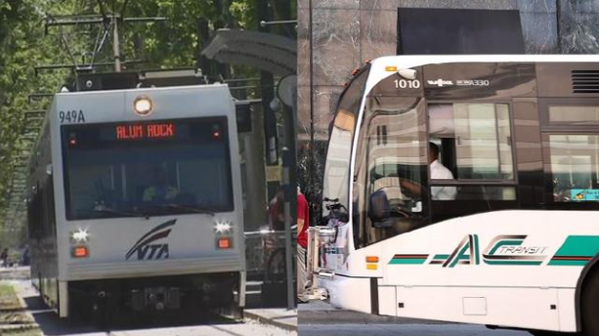
AC Transit Bus Lines
https://media.nbcbayarea.com/images/652*368/VTA_ACTransit.JPG

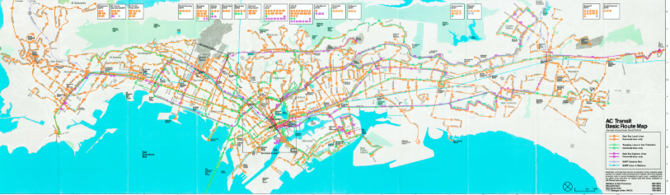
Map of the AC Transit District
http://www.actransit.org/about-us/celebrating-ac-transits-50th-anniversary/maps/

Alameda-Contra Costa Transit District

MISSION:
To connect our communities with safe, reliable, sustainable service … we’ll get you there.
WEBSITE:
http://www.actransit.org/
ADDRESS: 1600 Franklin Street, Oakland, CA 94612
E-MAIL: hrfeedback@actransit.org
HISTORY:
Voters created the Alameda-Contra Costa Transit District (AC Transit) in 1956. They subsequently approved a $16,500,000 bond issue in 1959, enabling the District to buy out the failing privately owned Key System Transit Lines. In October 1960, AC Transit
built up their bus fleet with 250 new “transit liners,” extended service into new neighborhoods, created an intercity express bus network, and increased the Bay Bridge bus service. As the Bay Bridge bus service increased, new bus lanes at the Toll Plaza were introduced. In 1972, when the BART began its service, the AC Transit System was contracted to provide feeder busses which linked the rail system to the suburbs outside the District’s service area. By the mid-1970s, AC Transit had expanded, extending their services to outlying communities such as Fremont and Newark in southern Alameda county, local jurisdictions in central Contra Costa County, Pittsburg, Antioch, Oakley, and Brentwood. The system also extended to the communities of Pinole, Hercules, Rodeo, and Crockett.
When the Loma Prieta Earthquake struck in 1989, the AC Transit played a vital role in the aftermath of the Earthquake. The Loma Prieta Earthquake shattered freeways, closed the Bay Bridge, and dramatically altered the travel patterns of the Bay Area, and the AC Transit System helped to transport people to where they needed to go, despite severely limited travel routes.
In 1992, continually changing with the times, the AC Transit System fitted lift technology into all of their coaches, and assigned them to all routes. This new accessibility feature made the bus service accessible all potential riders. By 1997, the District had created its own paratransit unit, which consisted of a fleet of 35 minibuses.
In 1999, the AC Transit tested their hybrid electric bus, which was battery powered with a clean-burning propane auxiliary generator, ushering in the future of pollution-free public transportation.
Today, AC Transit is the third largest bus system in California. During the 2018 fiscal year, AC Transit has served 51,760,000 people a year and an average of 169,000 people per day. Currently, there are 152 bus lines and 5,500 bus stops in the AC Transit system.

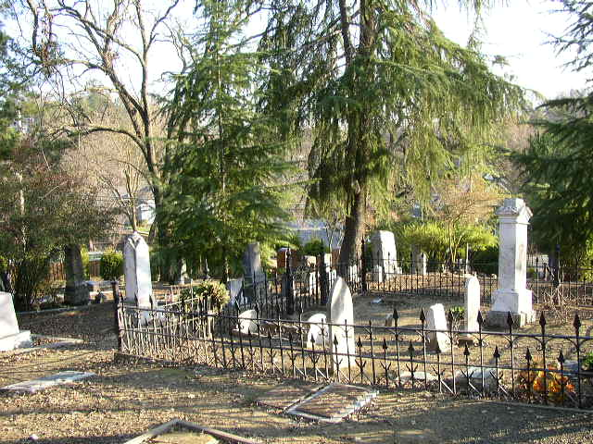
Alamo-Lafayette Cemetery
https://images.findagrave.com/photos250/photos/2005/22/CEM46619236_110652826031.jpg
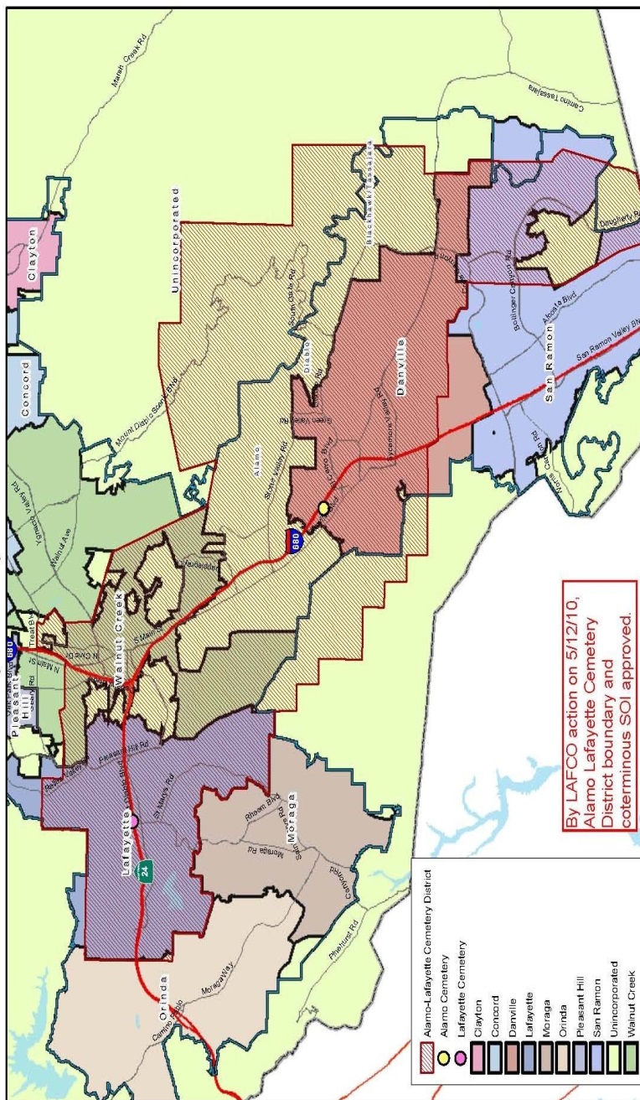
Boundaries of Alamo-Lafayette Cemetary District
http://www.contracostalafco.org/documents/local_agency_directory_2013/Sect%2003%20-%20Cemetery%20Districts%202013.pdf

Alamo-Lafayette Cemetery District

WEBSITE:
www.alamolafayettecemetary.org

ADDRESS: Lafayette: 3285 Mt. Diablo Blvd, Lafayette 94549 Alamo: 130 El Portal, Danville 94526

E-MAIL: alcdist@pacbell.net
The Alamo-Lafayette Cemetery District was formed as a California Special District in 1937. The Alamo-Lafayette Cemetery District is an Independent California Special District that consists of two pioneer cemeteries, one located in Lafayette and the other in Danville. The Lafayette Cemetery's first burial was in 1854 and the Alamo Cemetery's first burial was in 1856.
MISSION STATEMENT:

To provide interment services as well as sale of internment rights and niche sales to District residents, and to maintain and preserve the cemeteries.
HISTORY:
The city of Lafayette, founded in 1848, is rich in history and culture. The citizens of Lafayette have played an integral part in California’s history, from their participation in the Gold Rush to taking part in early California politics. A stop along the historic Pony Express route, Lafayette attracted people from all walks of life. The Lafayette cemetery is the final resting place of Benjamin Shreve, the man who named the city, and Jennie Bickerstaff Rosenberg, Lafayette’s beloved pioneer schoolteacher. History comes alive at the cemetery when visiting the plots of a Civil War veteran, a bullwhacker (driver of an ox wagon), relatives of the Donner Party, a World War II nurse, and the first African-American male school teacher in the Oakland School District. One plot even contains a man buried with his dog.
Lafayette's cemetery was established on 4-1/2 acres of hillside property owned by Medford Gorham. In 1874, he sold the property for $100 to the Cemetery Corporation which was chaired by Elam Brown. The Corporation fenced the property and located the roads as they presently exist. The original Death and Burial Record Book, still on file in the cemetery caretaker's building, shows names of the deceased, date and cause of death, plus age and place of death. A complete copy of the book is in the Lafayette Historical Society file in the Lafayette library. In 1937, the Alamo-Lafayette Cemetery District was formed with county taxation to ensure perpetual care.

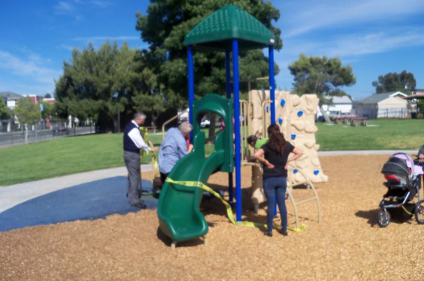
Anuta Park Ribbon Cutting
https://www.flickr.com/photos/46777236@N04/5814018364/

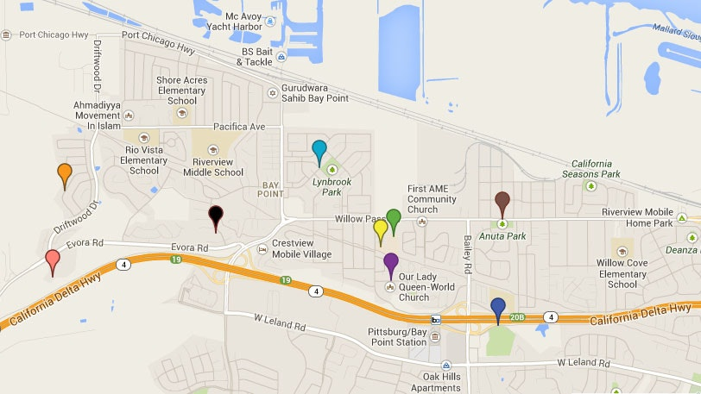
Ambrose Recreation and Park District map
https://www.ambroserec.org/parks-facilities

Ambrose Recreation and Park District

WEBSITE:
https://www.ambroserec.org/

ADDRESS: 3105 Willow Pass Road, Bay Point, CA 94565

E-MAIL: dlong@ambroserec.org

MISSION:

In order to serve the diverse recreational needs of individuals and families and to enrich the quality of life for all residents, the Ambrose Recreation and Park District is committed to providing park facilities, programs and activities for all ages.
HISTORY:
The Ambrose Recreation and Park District​​ was formed in 1946 under the Public Resources Code of the State of California, Section 5780. At the time the district was formed it included only one park site, Ambrose Park, later acquiring Anuta Park, and a mini park on Alves Lane.
Following renovation in the late 1970s, the district-owned Ambrose Elementary School, built in 1935, was renovated using community development block grant funds. The property re-opened as the Ambrose Community Center on Willow Pass Road. As well as serving as the district offices, the Community Center currently offers a senior citizen nutrition site with lounge area, Contra Costa County Service Integration Team offices, indoor recreational facilities, conference room, kitchen, dining room and auditorium available for rental. Outdoor facilities include two baseball fields, 6 basketball courts and mini park.
In November 1979 the park district moved its offices from Ambrose Park to the newly renovated Ambrose Recreation Center. Since that time this center has served as the hub of the community, serving as the meeting site of various local organizations, including the Bay Point Municipal Advisory Council, Bay Point Traffic Advisory Committee, Boy Scouts of America (although none are now meeting here), West Pittsburg Area Foundation, and local 4-H clubs. The community center has also been widely used for local public forum meetings by county, state and federal agencies, political representatives and the private sector.

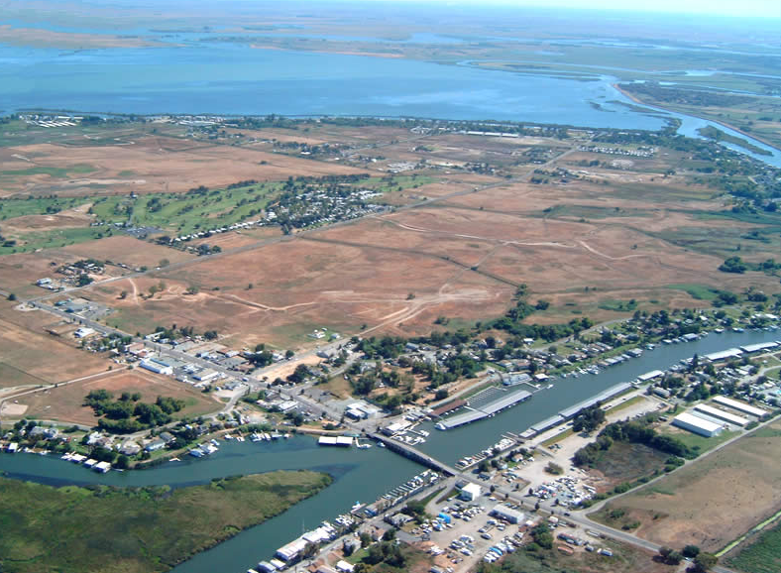
Canal View of Bethel Island Municipal Improvement District
https://bimid.com/wp-content/uploads/2014/07/12.jpg

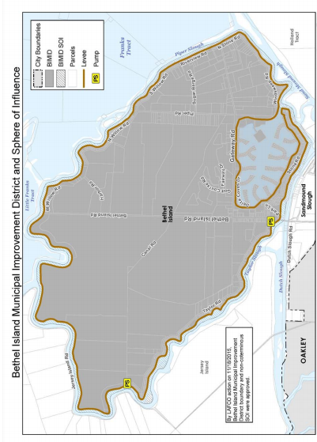
Map of Bethel Island Municipal Improvement District
http://www.contracostalafco.org/documents/local_agency_directory_2017/Sect%2009%20-%20Municipal%20Improvement%20District%208-17.pdf

Bethel Island Municipal Improvement District

WEBSITE:
https://bimid.com/about-bimid/
ADDRESS: 3085 Stone Road, Bethel Island
E-MAIL: bimid@sbcglobal.net
MISSION:

The Bethel Island Municipal Improvement District, through the elected Board of Directors and Staff, will serve the people of Bethel Island by responding to the needs and concerns of the public by allocating the available resources to maintain a safe and secure levee system, by maintaining a free flowing drainage system and by creating and maintaining a park and recreation facility.

HISTORY:

Bethel Island Municipal Improvement District (BIMID) was created by the State Legislature in 1960, replacing Reclamation District No. 1619. The powers include not only maintaining the levee that surrounds and protects Bethel Island but allows for many other activities including the distribution of water for public and private purposes; parks and playgrounds; airports; and works to provide for drainage.

BIMID owns 100 acres of land in the center of the island between Bethel Island Road and Piper Road. This property is used to remove sand, which is placed on the levee, and is also as a mitigation site. The state requires that for every tree BIMID removes from the island levee areas, three trees must be replanted, and they must survive for at least two years. New trees are planted on the mitigation site as trees are removed from the levee and drainage ditches.
To maintain the safety of the levee system, BIMID must approve applications for anything that affects the levee, such as construction or alteration of a home, boat dock, ramp, steps on the levee, planting of trees, or demolition of homes currently on the levee.

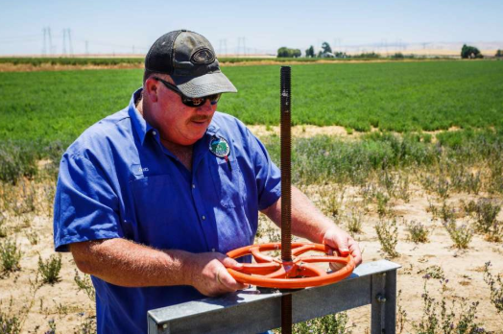
Shutoff to a Water Pump that sends water to 160 farmers in the Delta
https://www.sfgate.com/bayarea/article/Some-water-agencies-in-California-consider-6347901.php
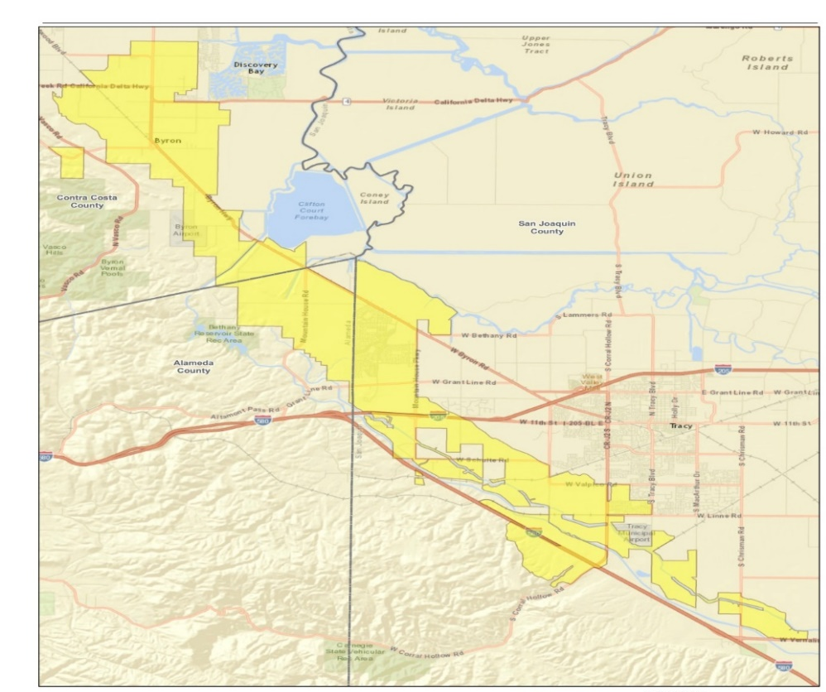
Map of Byron Bethany Irrigation District
http://bbid.org/wp-content/uploads/2017/07/BBID_20170725v2JPG.jpg

Byron-Bethany Irrigation District

WEBSITE:
http://bbid.org/

ADRESS: 7995 Bruns Road, Byron, CA 94514

E-MAIL: r.gilmore@bbid.org

MISSION:

Providing for the beneficial use of water and water-related services for consumers and landowners, Byron-Bethany Irrigation District is committed to providing a reliable water supply and managing the area’s water resources in an environmentally sound and cost-effective manner. The Byron Bethany Irrigation District protects, preserves, and enhances historical water rights of the district in addition to its water supply contract with the United States.
HISTORY:

The Byron Bethany Irrigation District (BBID) is home to families who farm fertile ground in order to feed the nation. The lifeblood, and value, of the land is a reliable source of water, thanks to pre 1914 water rights which were secured from the state. With the securement of these water rights, the BBID was formed. Water allowed them to irrigate their 47 square miles of pastures. BBID serves part of Contra Costa, San Joaquin and Alameda Counties and supplies water to more than 160 agricultural customers and over 12,000 residents in the town of Mountain House. BBID diverts water from the intake channel of the California aqueduct. The families on Bethel Island farm the fertile ground of BBID supply their crops to help feed the nation.

In June 2015, BBID faced a crisis during one of the worst draughts California had ever seen. The State Water Resources Control Board (SWRCB) asked them to stop pumping water to try to curtail water usage during the drought. The SWRCB filed a complaint accusing the BBID of taking water when none was available, and threatened them with a 5 million dollar fine. The only course of action the BBID could see to take was to fight the complaint, and after a furious legal battle in 2016, the SWRCB dismissed the case.

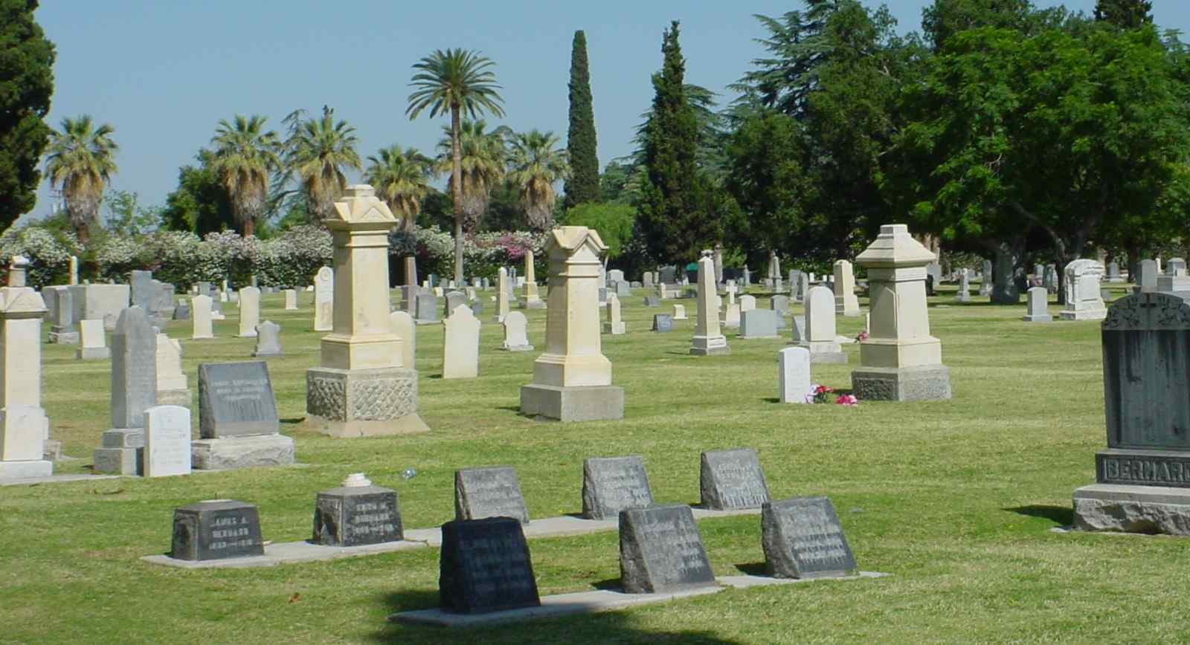
Byron Brentwood Knightsen Union Cemetery
https://images.findagrave.com/photos/2009/110/CEM46893262_124037157834.jpg
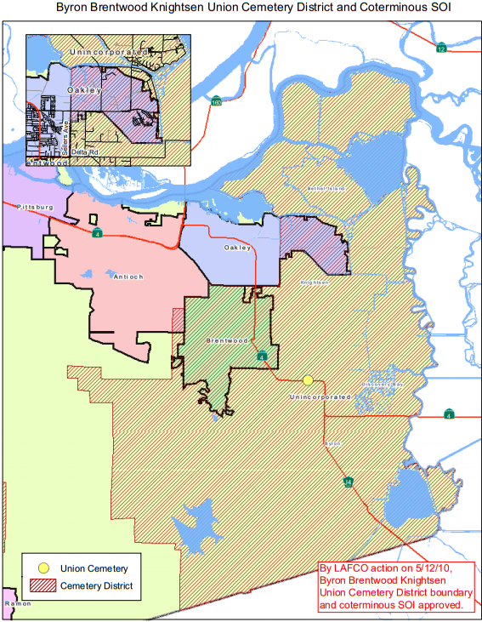
Map of Byron Brentwood Knightsen Union Cemetery District
file:///C:/Users/cchist/Downloads/Sect%2003%20-%20Cemetery%20Districts%202013%20(3).pdf

Byron-Brentwood-Knightsen Union Cemetery District

WEBSITE:
http://www.unioncemeterydistrict.com
ADDRESS: 11545 Brentwood Boulevard, Brentwood, CA
E-MAIL: ucemetery@yahoo.com
MISSION STATEMENT:
To provide efficient and dignified interment services, year-round maintenance and preservation of interment plots. To provide the community with quality services in a professional and confidential manner.
HISTORY:
The Union Cemetery Association was established November 1, 1878 when Colburn Preston, a pioneer of the Point of Timber area, sold four acres to the association, specifying that they be used solely for a cemetery. Prior to that, burials had been performed on family property or at the Point of Timber graveyard on the Will’s Ranch, located at the present-day intersection of Marsh Creek Road and State Highway Route 4 (Byron Highway). Some residents objected that the cemetery was too close to a school (Excelsior School). In addition to that the burial grounds were under water during the raining season, making it next to impossible to open graves. The moving of bodies to the newer site may explain why some of the headstones pre-date the 1878 founding date. Non-denominational and public, the cemetery is now controlled by the Byron-Brentwood-Knightsen Union Cemetery District, voted into existence by the local taxpayers in 1928, under the State Cemetery Act of 1909, which states:
“We stand on the shoulders of those who have gone before us. Our ancestors have provided the foundation of our community thus enriching our lives. We will therefore honor the memory of our predecessors by forever keeping the grounds of Union Cemetery in good order, a quiet place of repose for the deceased, and a restful scenic park for the living.”

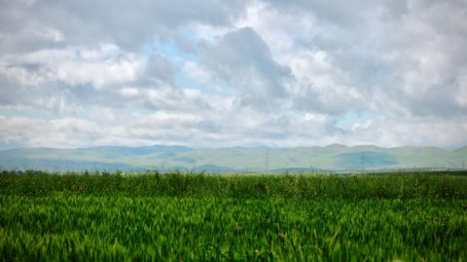
http://bbid.org/
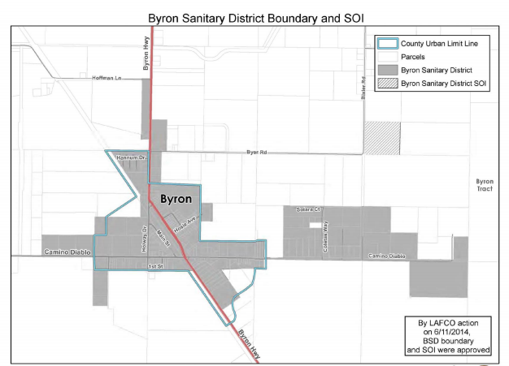
Map of Byron Sanitary District
http://www.contracostalafco.org/documents/local_agency_directory_2013/Sect%2015%20-%20Sanitary%20Districts%202013%20rev%207-14.pdf

Byron Sanitary District

WEBSITES:
https://contracostasda.specialdistrict.org/byron-sanitary-district-3715f00
file:///C:/Users/cchist/Downloads/Final%20Byron%20SD%20MSR%20approved%205-10-06%20(1).pdf

PURPOSE:

To collect, treat, and dispose of wastewater.

HISTORY:

The Byron Sanitary District was formed in 1948 and became operational in 1958. It operates pursuant to the Sanitary District Act of 1923 (Health & Safety Code. Section 6400 et seq.). The District is located in eastern Contra Costa County, on both sides of Byron Highway at Camino Diablo. It encompasses the unincorporated community of Byron and is an independent special district. A five-member board of directors, elected at-large, governs the District. A General Manager is responsible for administrative functions.
The District collects, treats and disposes of wastewater. It services 173 connections, which represent about 367 Equivalent Residential Units (EDUs). It serves approximately 152 residences, 30 commercial facilities, a 540-student elementary school and a county-owned youth rehabilitation facility. Only a few homes are on individual disposal systems in the community of Byron.

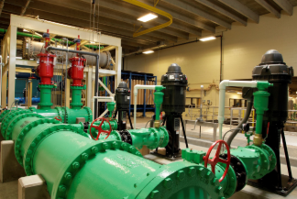
Modern Day Water Pipes
https://crgov.com/1670/Castle-Rock-Water
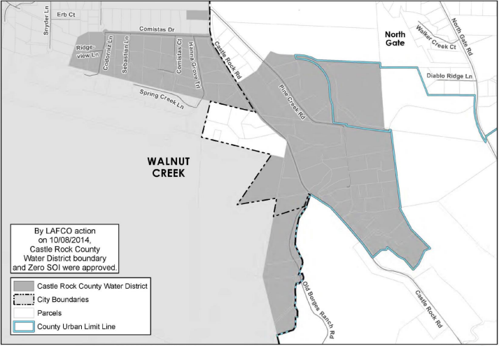
Map Of Castle Rock County Water District
http://www.ccwater.com/DocumentCenter/View/3824

Castle Rock County Water District

WEBSITE:
www.crcdwd.org
ADDRESS: 1001 Castle Rock Road, Walnut Creek, CA 94598
E-MAIL: info@crcwd.og
MISSION:
To strategically provide a reliable supply of high- quality water at the lowest cost possible, in an environmentally responsible manner.
In fulfilling this mission, the district will responsibly serve the public, provide district employees a safe and healthy work environment, ensure fair and equitable rates and charges, work cooperatively with local, regional, state and federal agencies, practice ethical behavior, ensure an open process, and ensure equal opportunity and diversity in personnel matters and contracting
HISTORY:
The Castle Rock County Water District (CRCWD) is a small, independent water district serving rural properties in both the City of Walnut Creek and the surrounding unincorporated area. Formed in 1955, CRCWD serves 55 customers by distributing and selling untreated water for landscape irrigation, some commercial uses and three commercial horse stables. CRCWD purchases untreated water from Contra Costa Water District (CCWD) pumped from an open canal that crosses Oak Grove Road.
CRCWD has a legislative body whose members are elected by registered voters within the district. CRCWD board members are appointed to fixed terms of 2-4 years.

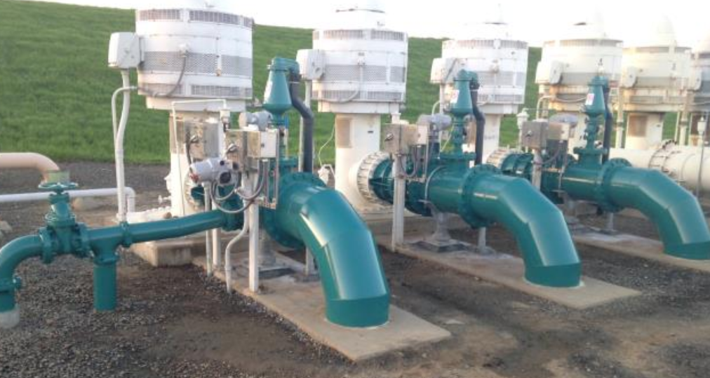
Part of the sanitary District Pipeline
https://www.centralsan.org/facilities
Map of Central Contra Costa Sanitary District
https://beta.grafiti.io/facts/90881

Central Contra Costa Sanitary District

WEBSITE:
www.centralsan.org
ADDRESS: 5019 Imhoff Place, Martinez, CA 94553
E-MAIL: eboehme@centralsan.org
MISSION:
To protect public health and the environment.
HISTORY:

In the 1940s, central Contra Costa County was very rural, consisting of just farms, orchards, and a few small towns. After the end of World War II, however, the area began to boom and the nearby cities of San Francisco, Oakland, and Berkely grew, as well as the population of Contra Costa County. This growth in population and infrastructure led to a sanitation crisis, with most of the county depending on septic systems. These septic systems were often inefficient because of the area’s heavy adobe clay soil. Septic tanks were overflowing and waterborne diseases like typhoid were becoming a potential threat. In response to this looming crisis, the County Board of Supervisors passed a resolution in 1946 that created the Central Contra Costa Sanitary District, also known and Central San. At that time, CCSD’s service area population was 15,000; the treatment plant’s capacity was 4.5 million gallons per day; and the collection system consisted of 50 miles of sewer pipe.

That original system was expected to handle the area’s wastewater for at least two decades. But by 1952, it was obvious that demand would soon exceed capacity, and so, Central San began a series of expansions and improvements that have continued to this day.

These expansions and improvements were necessary not only to enable to district to keep up with the growing population and expansion, but also to keep up with the increasing technology and the increasingly stricter water quality standards and regulations, which were a product of new environmental awareness. Today, Central San collects and cleans 35 million gallons of wastewater per day and serves a population of 488,900 residents and 3,000 businesses.

Walnut Creek Watershed located in the Resource Conservation District
https://www.ccrcd.org/

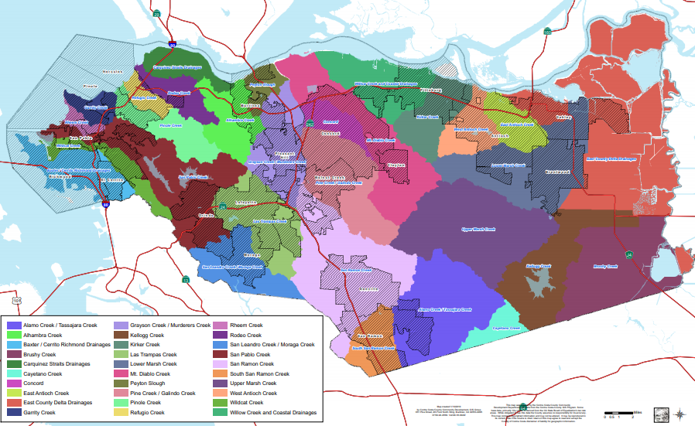
All the Resource Conservation Districts in Contra Costa County
file:///C:/Users/cchist/Downloads/RCD%20and%20MVCD%20Public%20Review%20Draft%20MSR.pdf

Contra Costa Resource Conservation District

WEBSITES:

https://contracostasda.specialdistrict.org/contra-costa-resource-conservation-district-ccrcd
https://www.ccrcd.org/about.html
https://carcd.org/rcds/what-are-rcds/
MISSION:
The Mission of the Contra Costa Resource Conservation District is to implement projects on public and private land and educating landowner and the public about conservation, and to partner with local communities to care for California’s land, water, soil, and other natural resources.
HISTORY:
Formed in 1941, the Contra Costa Resource Conservation District (CCCRD) is one of California’s 103 resource conservation districts. It covers 516,191 acres and is consistent with the political boundaries of Contra Costa County.
The CCRCD implements a number of services, which include: providing assistance to local agricultural producers; implementing scientific studies; community watershed planning; educational programs such as field trips; coordination of watershed restoration and stewardship programs; and promotion of voluntary and cooperative natural resource conservation programs.

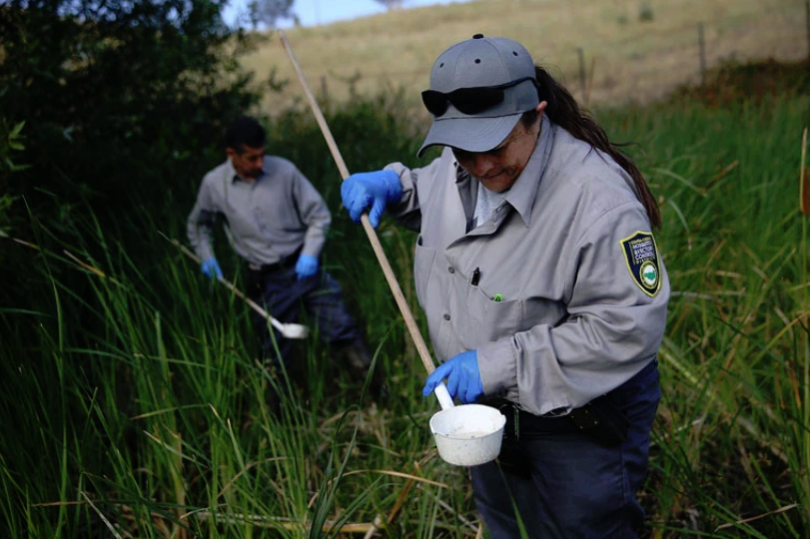
Technician Checks for Mosquito Larvae in Retention Pond
https://khn.org/news/for-california-last-years-west-nile-season-was-most-severe-ever/

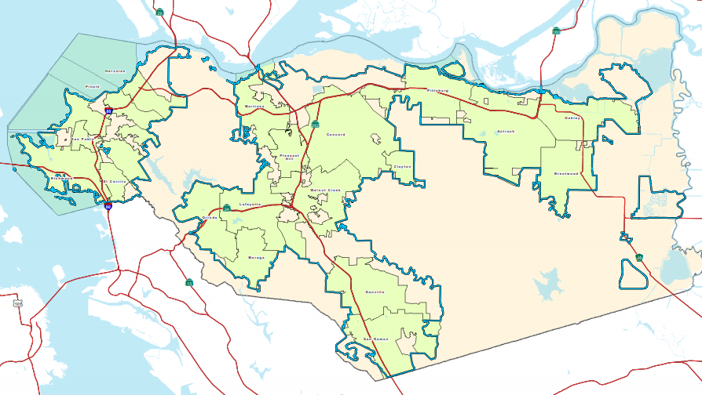
Contra Costa County Mosquito and Vector Control District Map
file:///C:/Users/cchist/Downloads/RCD%20and%20MVCD%20Public%20Review%20Draft%20MSR.pdf

Contra Costa Mosquito and Vector Control District

WEBSITE:
www.contracostamosquito.com

ADDRESS: 155 Mason Circle Concord, CA 94520

PURPOSE:

Educating all 1 million people in the 725 square miles of Contra Costa County about the dangers of the virus includes extensive communication and best practices, and teamwork. The goal of the Contra Costa County Mosquito and Vector Control District is to empower each individual to routinely dump standing water and take the necessary precautions to reduce their risk. The District educates people about the risks and try to change their behavior.

HISTORY:

The citizens of Contra Costa County, together with several waterfront industries, formed a committee in 1926 to address the need for mosquito control. In 1926, Noble Stover responded to requests from Contra Costa County and directed the first operations of Contra Costa Mosquito Abatement District. The purpose of the District was to control marsh mosquitoes in north central Contra Costa County and many of those early projects still exist and are functional now more than 80 years later.

MOSQUITOES AND WEST NILE VIRUS:
West Nile Virus arrived in Contra Costa County in 2004, a mere five years after it first entered the Western Hemisphere in New York in 1999. It's now endemic - established and ingrained into our environment. The carriers of that virus, birds, are endemic. The transmitters of that virus, mosquitoes, are also endemic. Anyone can contract West Nile virus, a debilitating and possibly fatal disease, from a single bite of an infected mosquito.
Contra Costa County encompasses some of the most diverse environments to be found in one area. This wide range of environments makes Contra Costa County one of the most desirable places to live in Northern California. The Contra Costa Mosquito and Vector Control District plays a vital role in maintaining this environment while protecting the residents from insects and animals that can carry disease. The District helps to ensure Contra Costa County remains a great place to live, where people can enjoy life outdoors.

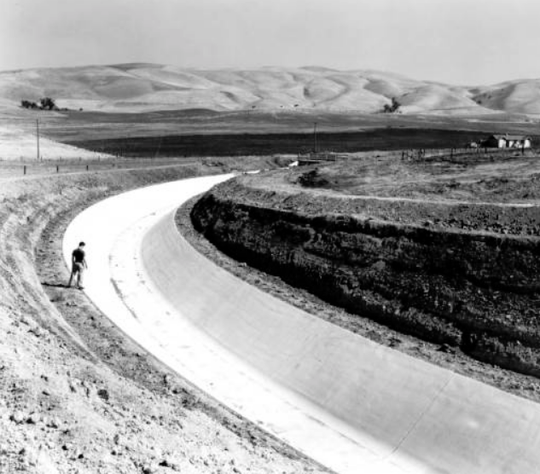
Contra Costa Canal View in 1940
https://en.wikipedia.org/wiki/Contra_Costa_Water_District#/media/File:Contra_Costa_Canal_1940.jpg

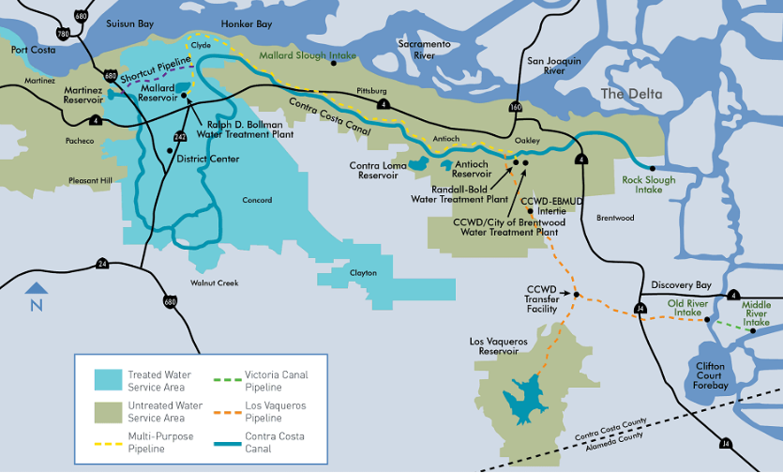Map of Contra Costa Water District
https://www.ccwater.com/289/Service-Area-Map

Contra Costa Water District

WEBSITE:
www.ccwater.com

ADDRESS: 1331 Concord Avenue, Concord, CA 94520
E-MAIL: mneher@ccwater.com
PURPOSE:
Formed in 1936 to provide water for irrigation and industry, the Contra Costa Water District (CCWD) is now one of the largest urban water districts in California and a leader in drinking-water treatment technology and source water protection. The quest for reliable, high-quality water is the reason the CWD was formed. Even now, that drive shapes nearly every aspect of the District's remarkable history.
HISTORY:
As heavy industry and agriculture were being established in the early 1900s, factories and farms sprang up along the Delta to take advantage of the fresh water supply. In the early 1920s (as a 13-year drought gripped the area), industry began to suffer from the Delta's increasing salinity. To keep the factories operating, fresh water was hauled into the area in tank cars. When the drought ended in 1930, local farmers had to stop irrigating, and land values declined.

In 1931, lawmakers adopted a State Water Plan that proposed a "Contra Costa Conduit," which later became known as the Contra Costa Canal. Though the great depression made it difficult to sell bonds to pay for the project, in 1937 the Central Valley Project became a federal commitment to be carried out by the U.S. Bureau of Reclamation and ground-breaking ceremonies for the Contra Costa Canal were held in Oakley. The demands of World War II caused construction delays due to shortages of labor and materials, but the entire canal was finally completed in 1948.

Ultimately, the District purchased the water service company's Contra Costa holdings for a little more than $12 million dollars, including treatment, pumping, storage, and distribution facilities. In 1961, the District assumed responsibility for Central County water service, which today delivers water to 265,000 people in Central Contra Costa County. In 1965, ground was broken to build the 2,000-acre-foot Contra Loma Reservoir in Antioch as an emergency supply for the Contra Costa Canal.

In 1988, voters passed a bond which funded the Los Vaqueros Reservoir Project. In 1994, ground was broken and the project began, which created the first reservoir built in California in more than 15 years. The Los Vaqueros Reservoir can store up to 100,000 acre feet of water, which ensured high water quality for district customers. In the early and mid-2000’s, the district continued to upgrade and expand their reservoirs and water treatment plants to keep up with the ever changing standards and demand for water.
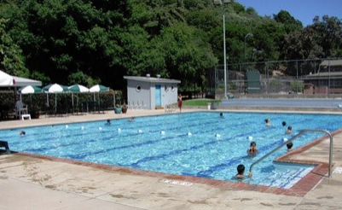
Community Pool built in 1966
https://www.town.crockett.ca.us/pool

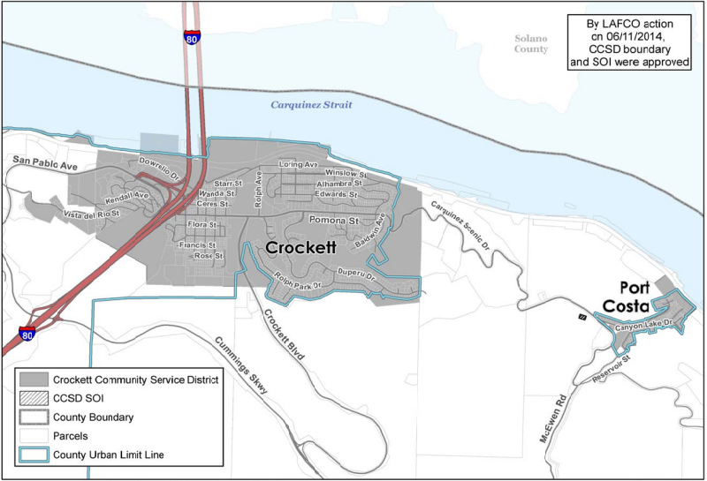
Crockett Community Service District Map
https://www.town.crockett.ca.us/service-area-map

Crockett Community Services District

WEBSITE:
www.town.crockett.ca.us

ADDRESS: 850 Pomona Street, Crockett, CA

E-MAIL: manager@town.crockett.ca.us

MISSION:

It is the mission of the Crockett Community Services District to provide high quality recreation facilities and reliable sanitary sewer service for the towns of Crockett and Port Costa, California; to protect and maintain public assets in good and useful condition; and to responsibly address the evolving needs of their communities.

HISTORY:
In the early 2000’s, Contra Costa County rolled the sanitary district of neighboring Port Costa into the new Community Service District (CSD). The Local Agency Formation Commission (LAFCO) approved this reorganization of local government agencies and subsequently, the voters of Crockett and Port Costa approved the reorganization and elected a 5-member Board of Directors on June 6, 2006. The first meeting of Crockett Community Service District (CCSD) was held on July 13, 2006.
As promised to the voters, the historic Crockett Community Center was quickly returned by the County to Crockett ownership and is being cared for by CCSD. As planned, the non-profit Crockett Recreation Association deeded Alexander Park with its swimming pool and tennis courts to CCSD that same year, along with other properties and decorative street lighting. In May 2007, the residents of Port Costa voted to become an equal partner in CCSD by approving a parcel tax for recreation services. Then, to complete the planned reorganization, CCSD assumed operational control of the Port Costa wastewater treatment plant and sewer system in June 2008.
The District continues to provide quality recreation services for area residents, as well as reliable sewer services in Crockett and Port Costa. Management of these facilities and services is overseen by the commissioners of the Crockett Recreation Commission, the Crockett Sanitary Commission and Port Costa Sanitary Commission. In 2009, the District also formed a Police Liaison Commission to improve communications between area residents and law enforcement agencies of the County and State. Then in 2010, the County transferred Crockett's World War I "Memorial Hall" to CCSD ownership for the public benefit.

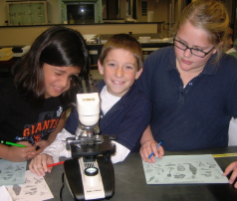
The Delta Diablo Sanitation District offers a variety of educational programs
https://www.deltadiablo.org/community-outreach-education-programs

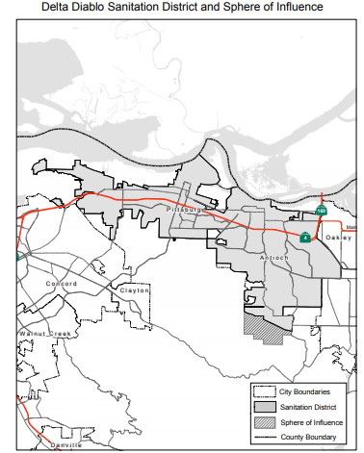
Map of Delta Diablo Sanitation District
http://www.contracostalafco.org/municipal_service_reviews/east_county_water_wastewater/8.0%20DDSD_WaterWastewater%20Final.pdf

Delta Diablo Sanitation District

WEBSITES:
https://www.deltadiablo.org/home
file:///C:/Users/cchist/Downloads/8.0%20DDSD_WaterWastewater%20Final%20(2).pdf

ADDRESS: 2500 Pittsburg-Antioch Highway Antioch CA 94509
E-MAIL: denisej@deltadiablo.org
MISSION:

To protect public health and the environment of our communities by providing wastewater and other resource recovery services of exceptional quality and value.

HISTORY:

The District was originally formed in 1955 as County Sanitation District 7-A, and the District’s name was legally changed in 1989. In 2001 County Sanitation District 7-B, which served the United States Naval Facility at Port Chicago, was dissolved by the Local Agency Formation Commission (LAFCO) and annexed to the Delta Diablo Sanitation District (DDSD). Wastewater treatment for the three communities began in 1982. DDSD now serves an estimated population of over 181,565 residents in a service area of approximately 52 square miles.

DDSD provides water resource recovery services for the City of Antioch, the City of Pittsburg, and the unincorporated community of Bay Point, serving a population of nearly 200,000. The water resource recovery services consist of conventional treatment of wastewater, recycled water production and distribution, pollution prevention, energy recovery, beneficial reuse of bio-solids, street sweeping, and household hazardous waste collection. The District’s largest asset is its staff of dedicated employees who keep the system running 24 hours a day, 365 days a year.

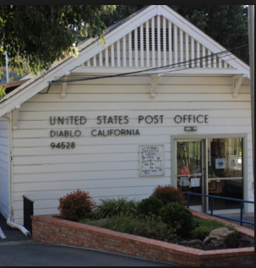
Old Diablo Post Office
https://www.diablocsd.org/history.html

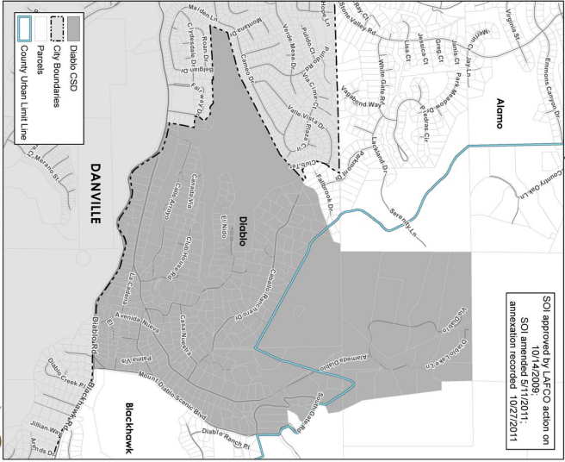
Diablo Community Services District
file:///C:/Users/cchist/Downloads/Sect%2003%20-%20Community%20Service%20Districts%20(1).pdf

Diablo Community Services District

WEBSITE:
https://www.diablocsd.org/home.html

ADDRESS: PO Box 321, Diablo, CA 94528

E-MAIL: generalmanager@diablocsd.org

MISSION:

The Diablo Community Services District (DCSD) was formed to provide security services to the residents of Diablo, maintain the roads, culverts, and bridges within Diablo, and maintain the equestrian/pedestrian path (Kay’s Trail) between Alameda Diablo and Mt. Diablo Scenic Blvd.

HISTORY:

Diablo was settled in the early 1900s as a community of summer homes, but by the 1940s, many of the residents were living there full time. They demanded infrastructure like paved roads and sewer systems, so, in March of 1961, the Diablo Public Utilities District (DPUD) was formed. The DPUD could collect taxes to facilitate the growth of infrastructure. However, in 1967, most Diablo residents felt that they would benefit from additional security, which the current Diablo Public Utilities District (DPUD) could not provide. Under California law, DPUD could not provide police protection to the community, but a Special Services District could.

In September of 1969, the DPUD Board Members, as well as the Contra Costa County Board of Supervisors and Diablo residents established the Diablo Community Services District, which replaced the DPUD. As a Special District, the DCSD was granted powers to maintain roads, install street lighting, provide security to its residents and guests, and maintain the equestrian trail between Alameda Diablo and Mt. Diablo Scenic Blvd.

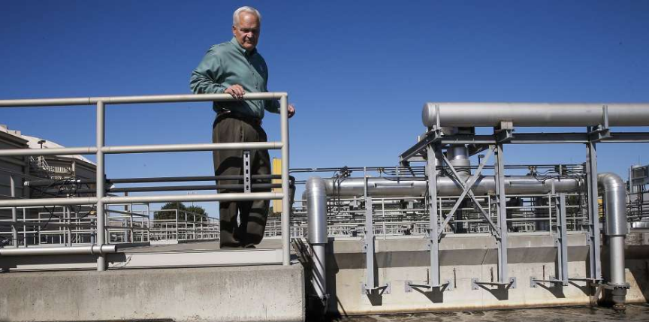
Cleaning Process at the Diablo Water District
https://www.sfchronicle.com/nation/article/Lack-of-support-in-D-C-hampers-water-recycling-6489657.php
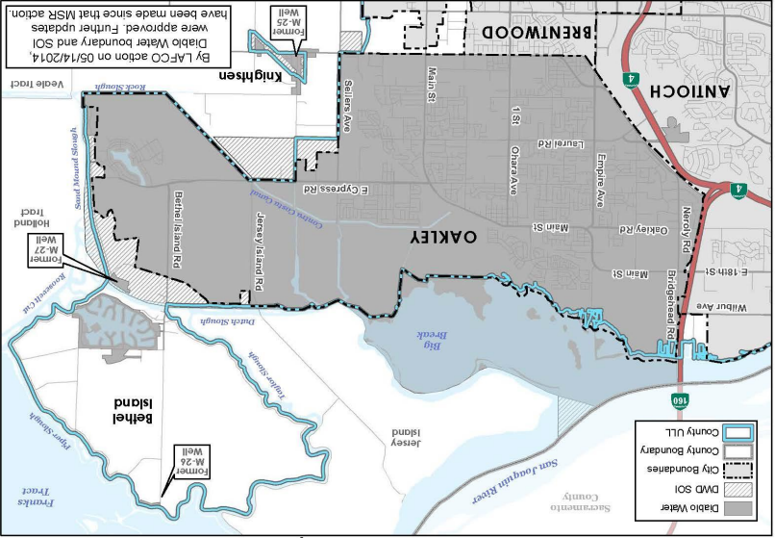
Map of Diablo Water District
file:///C:/Users/cchist/Downloads/5.0%20DWD_WaterWastewater%20Final.pdf

Diablo Water District

WEBSITE:
www.diablowater.org
ADDRESS: 87 Carol Lane, Oakley, CA 94561
E-MAIL: customers@diablowater.org
MISSION:
The mission of Diablo Water District is to provide a safe, dependable and adequate supply of high- quality potable water to meet the requirements of the residents and businesses in the service area. The District strives to operate in an environmentally responsible manner following principles of good business and sound engineering to provide the best possible service at the lowest reasonable cost. They are committed to treating all customers and employees fairly.
PURPOSE:
The District, with a staff of 14 full-time employees, obtains, treats and supplies water for about 36,000 people and the parks, schools and businesses throughout a 21-square-mile area consisting of Oakley, Cypress Corridor and Hotchkiss Tract, as well as Summer Lakes, and portions of Bethel Island and Knightsen.
ABOUT/HISTORY:
For more than a half-century Diablo Water District has been providing high quality water for residents and businesses in their service area. The District is committed to quality, thoroughness, and personal service.
Diablo Water District is a self-governing local public agency created on May 7, 1953, under the County Water District Law of California.
The District purchases raw water from the Contra Costa Water District via the Contra Costa Canal. This raw water originates in either Rock Slough or Old River (from the San Joaquin River). Los Vaqueros Reservoir stores high quality raw water, which is piped from Old River and can be used when needed. Water is treated at the modern Randall-Bold Water Treatment Plant, which is jointly owned by Diablo Water District and Contra Costa Water District. The water treatment plant uses the best available technology and includes many innovations to ensure reliability and high- quality drinking water.

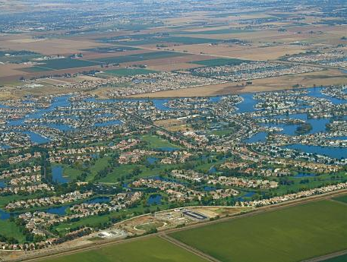
Town of Discovery Bay
https://www.todb.ca.gov/district-services

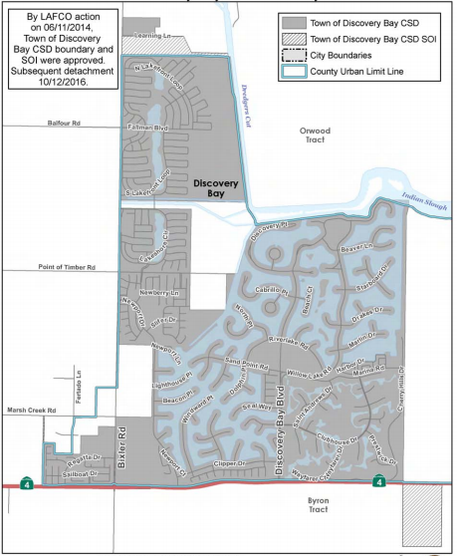
Town of Discovery Bay Community Services District Map
file:///C:/Users/cchist/Downloads/Sect%2003%20-%20All%20Comm%20Service%20Districts%2015%20(1).pdf

Discovery Bay Community Services District (Town of)

WEBSITE:
https://www.todb.ca.gov/what-csd
ADDRESS: 1800 Willow Lake Road, Discovery Bay, CA 94505
E-MAIL: mdavies@todb.ca.gov
MISSION:

To provide effective and fiscally responsible municipal services in a manner which promotes a high standard of community life with a focus on the environment and the Delta in partnership with the community.

HISTORY:

The Town of Discovery Bay Community Services District (DBCSD) was formed in 1998. It serves a population of approximately 15,000 and covers approximately 3,955 acres. The DBCSD provides its residents with services such as: water supply, sewage collection, treatment and disposal, levee maintenance, recreation, lighting, landscaping, maintenance, and advisory functions.

Goals for the DBCSD include: maintain a full service and sustainable community; to grow in harmony with the environment and the Delta; to ensure assets and facilities are maintained; to promote and protect the environment; and to provide leadership while considering all points of view.

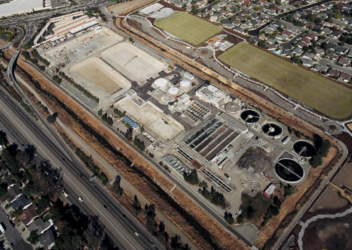
Dublin San Ramon Wastewater Treatment Plant
https://www.overaa.com/projects/dublin-san-ramon-wastewater-treatment-plant
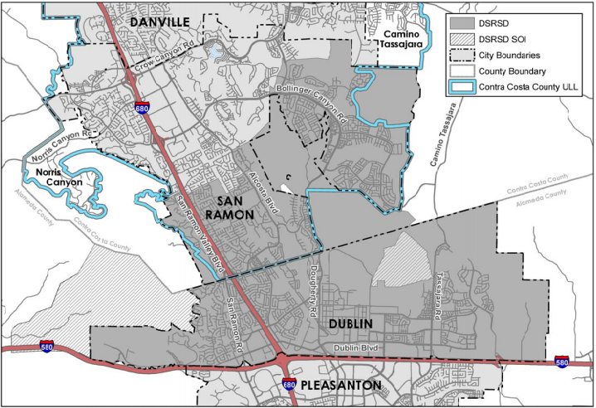
Dublin San Ramon Services Area Map
file:///C:/Users/cchist/Downloads/Sect%2003%20-%20Community%20Service%20Districts%20(3).pdf

Dublin San Ramon Services District

WEBSITES:

https://www.dsrsd.com/
https://contracostasda.specialdistrict.org/dublin-san-ramon-services-district

ADDRESS: 7051 Dublin Boulevard, Dublin, CA 94568

E-MAIL: customerservice@dsrsd.com

MISSION:

Provide reliable and sustainable water, recycled water, and wastewater services in a safe, efficient, and environmentally responsible manner.

ABOUT/HISTORY:

The Dublin San Ramon Services District (DSRSD) can trace its roots back to April of 1953, with the creation of the Parks Community Services District. The DSRSD was formed to secure the use of the Camp Parks sewer ponds in Pleasanton, because septic tanks were failing and the local residents hoped to replace them with a new sewage treatment system. The ponds were never acquired, though, and several years would pass before the district was formally launched.
In the early 1960s, Alameda and Contra Costa counties required that a public agency be in place to furnish water, sewage treatment, trash collection, and fire protection, so the district was reactivated to set up these services and was given a new name-the Valley Community Services District (VCSD). From 1962 to 1965, the district adapted to changes by adapting its own utility system to meet the new demands on the district. VCSD transferred its water system in South San Ramon to the East Bay Municipal Utility District and contracted with the city of Pleasanton to treat that city’s sewage.
In 1977, VCSD adopted the name that the district goes by today: The Dublin-San Ramon Services District.
DSRSD exists through its core values, which are simple key words that describe the values of the agency. These core values include: protect public health and the environment; sustain financial stability; be open and transparent; fairness, respect, honesty, and ethics; operate safely; provide high quality customer service; provide sustainable, efficient, reliable, and secure services; perform at a high standard.

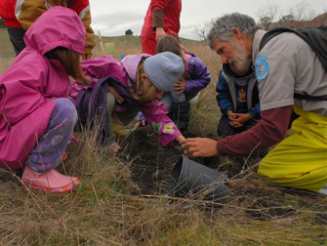
Ranger teaching children
https://www.ebmud.com/about-us/teacher-resources/ebmuds-outdoor-classroom-materials/

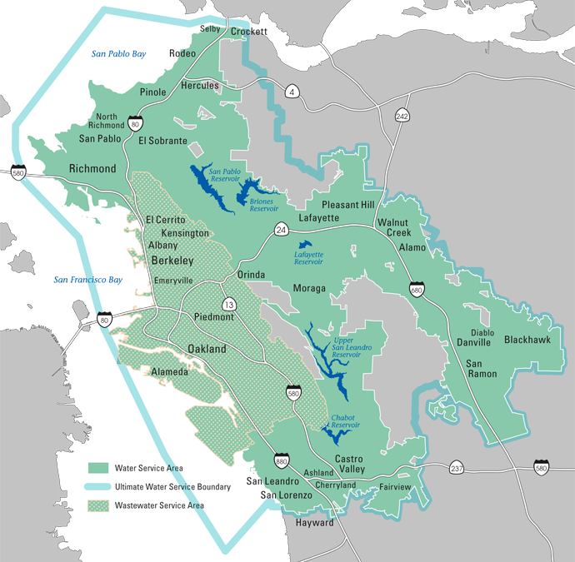
East Bay Municipal Utility District Service Area
https://www.ebmud.com/about-us/who-we-are/service-area/

East Bay Municipal Utility District

WEBSITE:
www.ebmud.com

ADDRESS: 375 11th Street, Oakland, CA 94607

E-MAIL: customerservice@ebmud.com

MISSION:
To manage the natural resources with which the District is entrusted; to provide reliable, high quality water and wastewater services at fair and reasonable rates for the people of the East Bay; and to preserve and protect the environment for future generations.

HISTORY AND PURPOSE:

Organized on May 22, 1923, the East Bay Municipal Utility district (EBMUD) has a proud history of providing high-quality drinking water for 1.4 million customers in Alameda and Contra Costa counties. The District’s award-winning wastewater treatment protects San Francisco Bay and serves 685,000 customers. EBMUD's water system serves approximately a 332-square-mile area extending from Crockett on the north, southward to San Lorenzo (encompassing the major cities of Oakland and Berkeley), eastward from San Francisco to Walnut Creek, and south through the San Ramon Valley. Our wastewater system serves approximately 685,000 people in an 88-square-mile area of Alameda and Contra Costa counties along the Bay's east shore, extending from Richmond on the north, southward to Oakland.

EBMUD’s commitment to environmental protection begins with their mission statement and continues through their many programs and services. Efficient use of water, a limited and precious natural resource in California, is an important step every Californian can take to protect the environment.

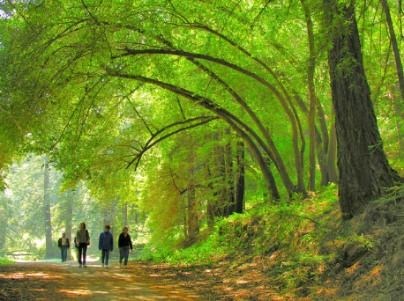
Redwood Regional Park, Oakland, CA
https://www.nbcbayarea.com/news/local/Free-Black-Friday-Hiking-in-East-Bay-Regional-Parks-Taking-Nod-From-REI-California-352272421.html

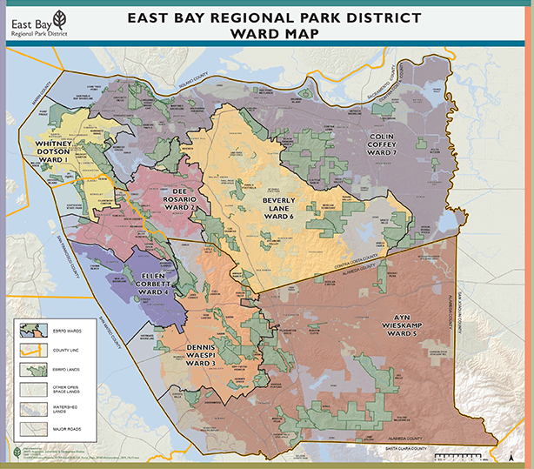
East Bay Regional Park District Ward Map
https://www.ebparks.org/about/board/default.htm

East Bay Regional Park District

WEBSITE:
https://www.ebparks.org/
ADDRESS: 2950 Peralta Oaks Court, Oakland, CA 94605
E-MAIL: N/A
MISSION:
The East Bay Regional Park District (EBMUD) preserves a rich heritage of natural and cultural resources and provides open space, parks, trails, safe and healthful recreation, and environmental education. An environmental ethic guides the district in all of its activities.

The district envisions an extraordinary and well-managed system of open space parkland in Alameda and Contra Costa counties, which will forever provide the opportunity for a growing and diverse community to experience nature nearby.

HISTORY:

In 1929, EBMUD acquired 40,000 acres of watershed and declared that 10,000 acres were surplus to its needs. Park advocates immediately began to see the 10,000 surplus acres as a "Grand Park" stretching 22 miles from Lake Chabot in the south to Wildcat Canyon in the North. In 1933, Governor James Rolph signed the bill authorizing the formation of the Park District.

The newly formed park board did not have enough budget to meet the asking cost of three million dollars for the full 10,000 acres. Instead, they acquired 2,162 acres from EBMUD for $656,000 paid over the course of five years. They would purchase more of the “excess” 10,000 acres to use as parks as the years went on.

During World War II, land from the district was leased to the Army to use as a training camp. They cancelled the contract in 1946 when the war ended, after which the local schools began to use the site for "in-town" camps to teach natural history to school children.

Proposition 13 and the California taxpayers' revolt of 1978 greatly disrupted park operations. During the 19-year period between 1968 and 1987 that was so influenced by proposition 13, the District was still able to add 33 new regional parks, 16 new regional trails, and preserve 43,000 acres of the East Bay's most scenic parklands.

Today, the East Bay Regional Park District currently has 65 regional parks, 31 regional trails, 1,250 miles of park trails, 9 lakes, and 120,536 total acres of land.

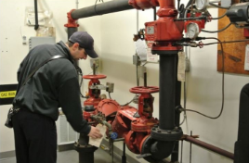
Conducting a Fire Inspection
https://www.eccfpd.org/

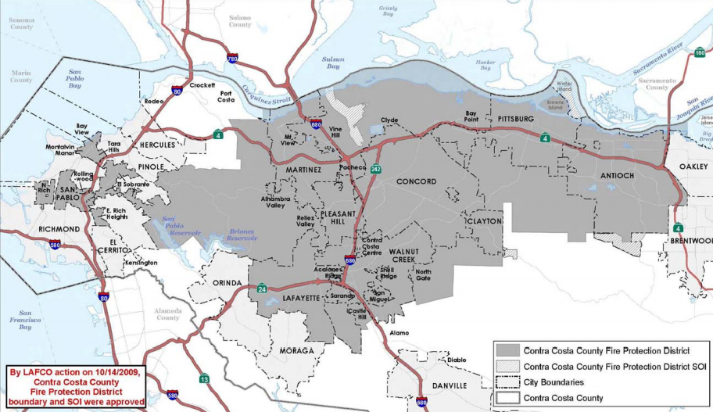
East Contra Costa Fire Protection District
file:///C:/Users/cchist/Downloads/Sect%2005%20-%20Fire%20Protection%20Districts%20(2).pdf

East Contra Costa Fire Protection District

WEBSITE:

www.eccfpd.org

ADDRESS: 150 City Park Way, Brentwood CA 94513
E-MAIL: fire@eccfpd.org

MISSION:
To preserve and protect life, environment, and property with service above all else

HISTORY AND PURPOSE:
Formed in November of 2002, the East Contra Costa Fire Protection District (ECCFPD) is a rural funded fire district that protects approximately 249 square miles and over 115,000 residents. The district provides firefighting personnel and emergency medical services (basic life support) to the residents and businesses of the City of Brentwood, and Oakley, and to the Townships of Discovery Bay, Bethel Island, Knightsen, Byron, Marsh Creek, and Morgan Territory.
The ECCFPD's Master Plan calls for nine stations to adequately provide coverage to the district's citizens and businesses. As of July 1, 2017, ECCFPD has three fire stations each staffed by three firefighters per day. The district responds to over 7,500 calls a year that result in approximately 9,000 fire engine responses.

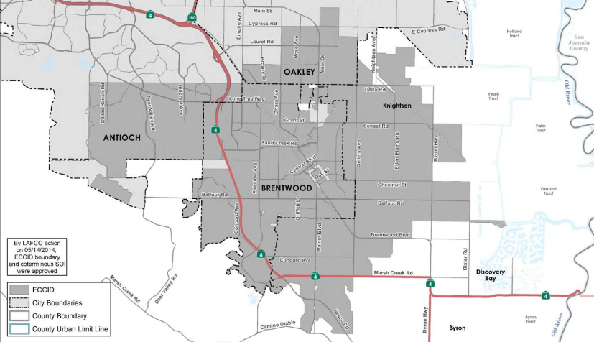
East Contra Costa Irrigation District Service Area Map
file:///C:/Users/cchist/Downloads/Sect%2007%20-%20Irrigation%20Districts%202015.pdf
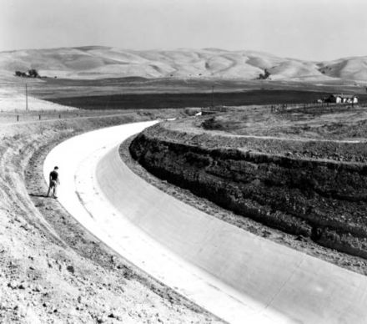
Contra Costa Canal 1940
https://en.wikipedia.org/wiki/Contra_Costa_Water_District

East Contra Costa Irrigation District

WEBSITE:
www.acwa.com
file:///C:/Users/cchist/Downloads/6.0%20ECCID_WaterWastewater%20Final.pdf
ADDRESS: 1711 Sellers Ave., Brentwood, CA 94513
E-MAIL: atrott@eccid.org
PURPOSE:
- To manage and adapt to extreme conditions
- To secure California’s water future
- Helping to sustain groundwater resources
- To protect water at its source
- To deliver safe drinking water
- To serve local communities

The East Contra Costa Irrigation District (ECCID) delivers irrigation water for agricultural, landscaping, and recreational uses and raw water for treatment and delivery to the Cities of Antioch, Brentwood, and Oakley and the unincorporated community of Knightsen. ECCID supplies come from surface water and groundwater.
HISTORY:
The East Contra Costa Irrigation District (ECCID) is an independent special district established in 1926. The District’s boundaries encompass approximately 40 square miles and include the City of Brentwood, the unincorporated community of Knightsen, portions of the Cities of Oakley and Antioch, and some unincorporated area south of Antioch and east of Brentwood.
The Sustainable Groundwater Management Act (SGMA), effective January 1, 2015, established a framework of priorities and requirements to facilitate sustainable groundwater management throughout the State. The intent of SGMA is for groundwater to be managed by local public agencies and newly-formed Groundwater Sustainability Agencies (GSAs) to ensure a groundwater basin is operated within its sustainable yield through the development and implementation of a Groundwater Sustainability Plans (GSP).
Eight local agencies that overlay a portion of the Basin in Contra Costa County, referred to at East CC Basin, entered into a Memorandum of Understanding (MOU) on May 9, 2017 to collaborate and develop a single GSP for the East CC Basin. With the exception of Contra Costa Water District, each member agency has become a Groundwater Sustainability Agency (GSA) the local agency to manage the Basin within its respective area.

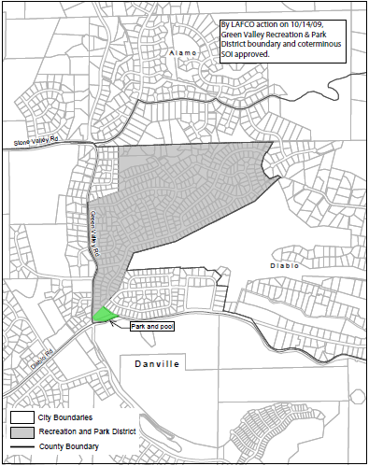
Green Valley Recreation and Park District Map
file:///C:/Users/cchist/Downloads/Sect%2013%20-%20Recreation%20&%20Park%20Districts%202013%20rev%207-14.pdf

Green Valley Sharks Swim Team swimming in the Green Valley Pool
http://www.thegreenvalleypool.com/swim-team.html

Green Valley Recreation and Park District
WEBSITE:
https://contracostasda.specialdistrict.org/green-valley-recreation-and-park-district
http://www.thegreenvalleypool.com/

ADDRESS: 1500 Green Valley Road, Danville

E-MAIL: greenvalleypool@hotmail.com

PURPOSE:
To provide maintenance and recreation services to a swimming pool in the Town of Danville.

ABOUT/HISTORY :

Green Valley Recreation and Parks District (GVRPD) was formed in 1949 as an independent special district. The District was formed to provide maintenance and recreation services to a swimming pool in the Town of Danville.
The District owns and operates a swimming pool for the Cameo Acres and serves the surrounding areas of Danville and Alamo. GVRPD also offers activities commonly provided at community pools, including swim lessons, a non-competitive swim team, lifeguard training, community and social events.

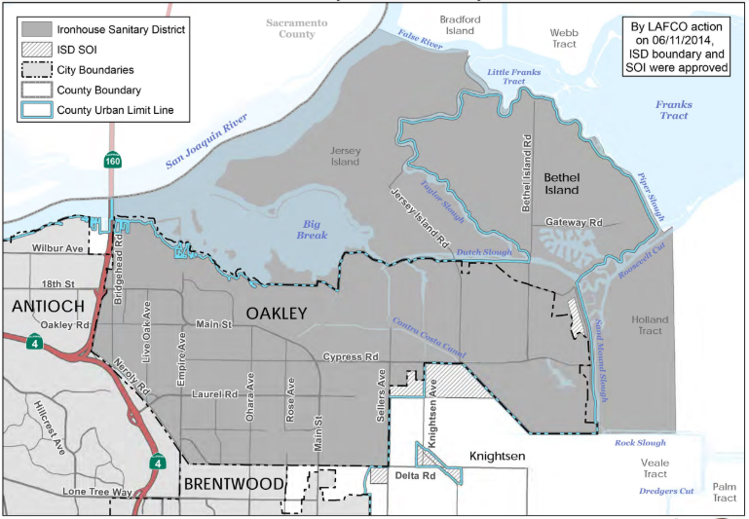
Ironhouse Sanitary District Map
https://ironhousesanitarydistrict.com/185/District-Boundaries

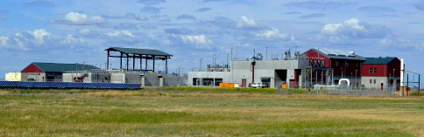
Water Recycling Facility
https://ironhousesanitarydistrict.com/101/About-Us

Ironhouse Sanitary District

WEBSITE:
https://www.ironhousesanitarydistrict.com/
ADDRESS: 450 Walnut Meadows Drive, Oakley, CA 94561
E-MAIL: ironhousesd@isd.us.com
MISSION:
To protect public health, safety and the environment through responsible wastewater collection, treatment and water reuse.
PURPOSE:
The Ironhouse Sanitary District (ISD) handles 4.3 millions of gallons of water per day in a state-of-the-art facility that is well-equipped for the task. On the surface, the ISD’s state-of-the-art Water Recycling Facility looks like a simple collection of buildings and structures, but hidden behind its walls is a complex of piping and processes designed to turn the wastewater that its communities generate into a product that is safe to return to the environment and safe to reuse for irrigation.
HISTORY:
On July 2, 1945, Oakley property owners presented a petition to the Contra Costa County Board of Supervisors to begin the process of forming a sanitary district. It was approved on August 21st, 1945 with a unanimous 112-0 vote. The first board of directors was elected in the same month. The ISD now covers Bethel Island, Jersey Island, Oakley, and Holland tract or portions thereof.
Since 1945, ISD has utilized a staff of 33 field and office personnel to maintain sanitary services for more than 42,000 customers in the Oakley and Bethel Island area. The district treats approximately 2 million gallons of recycled water every day at their technologically advanced Water Recycling Facility, located north of Main Street near downtown Oakley. Half of the recycled water is spread on fields ISD owns near the Oakley facility on Jersey Island, and the other half is released into the San Joaquin River through a special state permit.
On March 29, 1977, a joint power agreement was signed between Oakley and Bethel Island, establishing the Oakley-Bethel Island Wastewater Management (OBIWM) Authority. In 1992, the Oakley Sanitary District merged with OBIWM and Sanitary District 15, and was renamed Ironhouse Sanitary District, after an old rural schoolhouse.

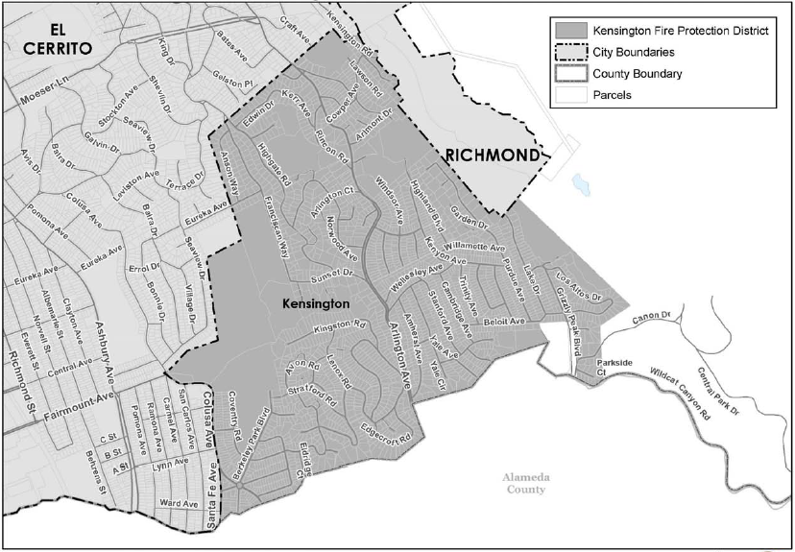
Kensington Fire Protection District Map
file:///C:/Users/cchist/Downloads/Sect%2005%20-%20Fire%20Protection%20Districts%20(3).pdf

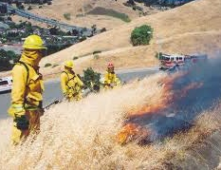
KFPD Officer Extinguishing a Grass Fire
http://www.kensingtonfire.org/

Kensington Fire Protection District

WEBSITE:

https://www.kensingtonfire.org/

ADDRESS: 217 Arlington Ave., Kensington, CA 94707

E-MAIL: fire@kensingtonfire.org

MISSION:

To provide the highest level of service to Kensington in order to protect the lives, property, and environment of the community from the disastrous effects of fires, medical emergencies, natural disasters, and other hazardous conditions.

HISTORY:

The unincorporated town of Kensington established a volunteer fire department in 1928; the community instituted the Kensington Fire Protection District (KFPD) in 1937. Twenty-four years later, KFPD hired a staff of professional firefighters under the supervision of a fire chief. Today, the District is organized under the State's Health & Safety Code Section 13800, commonly known as the Bergeson Fire District Law. In 1995, the District entered into a contract with the City of El Cerrito whereby El Cerrito would provide all fire prevention, fire suppression and emergency services within Kensington for an annual fee. In 2001, KFPD initiated a paramedic service offering the first engine-based Advanced Life Support service in West Contra Costa County, bringing medications and equipment to a patient's side in less than 5 minutes on average.

The early fire department operated out of a small English country style building next to the Chevron Oil gas station on Arlington Avenue. The District constructed a new public safety building in 1970, renovating the building in 1999 and 2004.

The District owns two fire engines: one specifically engineered for the steep, narrow streets of Kensington; and the other a "Type III" or wildland engine for use during high fire season.
In recent years the District has embarked on a series of water system improvements by contract with the East Bay Municipal Utility District, in order to enhance the provision of water along the wildland interface and to optimize the placement of hydrants throughout the community.

The District is able to provide a timely and appropriate level of response by active participation with other West Contra Costa County fire agencies in automatic response agreements that use the combined resources of all agencies to serve the area irrespective of jurisdictional lines. Funding for District expenses is provided by property tax revenues as well as a special tax approved by the voters in 1980.

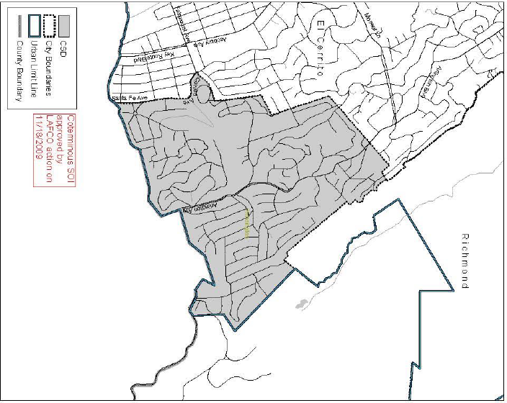
Kensington Police Protection and Community Service District Map
file:///C:/Users/cchist/Downloads/Sect%2003%20-%20All%20Comm%20Service%20Districts%2015.pdf
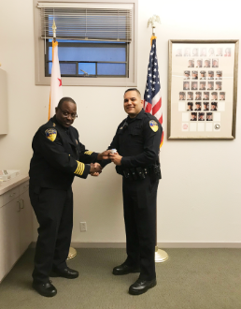
New Officer Being Sworn into Kensington Police
https://www.kppcsd.org/new-officer-amit-nath-sworn-in

Kensington Police Protection and Community Services District (KPPCSD)

WEBSITES:
https://www.kppcsd.org/
https://contracostasda.specialdistrict.org/kensington-police-protection-and-community-services-district

ADDRESS: 217 Arlington Ave., Kensington, CA 94707

E-MAIL: N/A

MISSION:
Provide services that enhance the community of Kensington.
HISTORY:
Formed in 1946, the Kensington Police Protection and Community Services District (KPPCSD) is a Community Service District that provides police protection, parks and recreation, and waste management services to the unincorporated area of Kensington.
Kensington is an unincorporated community of about 2,200 homes situated on an area of 1.2 square miles between Berkeley and El Cerrito in the East Bay and is home to approximately 5,000 people. Kensington maintains its own police department, as well as park and recreation programs. Governed by five District Directors, the KPPCSD’s day to day operations are handled by the Chief of Police, who is also the general manager of the District.

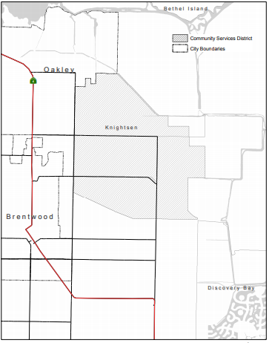
Knightsen Town Community Services District
file:///C:/Users/cchist/Downloads/09%20-%20Knightsen%20CSD%20Final%20Adopted%20(1).pdf
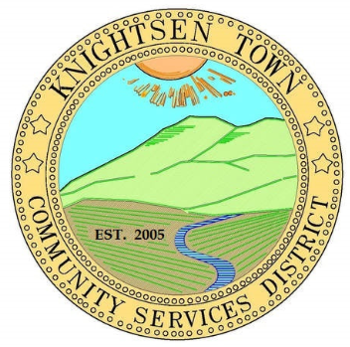
Seal of the Knightsen Town Community Services District
https://knightsentowncsd.specialdistrict.org/

Knightsen Town Community Services District

WEBSITE:
www.knightsencsd.com
ADDRESS: PO Box 763, Knightsen, CA 94548
E-MAIL: KnighsenCSD@gmail.com
PURPOSE:
To provide flood control and water quality (drainage services) for the community of Knightsen.
HISTORY:
The Knightsen Town Community Services District (KCSD) was created in 2005, and encompasses approximately 5,100 acres of low area that receives runoff flow from nearby areas. The KCSD is authorized to provide only flood control services and water quality assessment services. The Knightsen area needs improved drainage and reclamation services, the purpose for which the District was formed, but at this time, it is too early to know precisely what or when these improvements will be constructed, although preliminary planning is underway. In 2001, the County conducted a Water Quality Wetland Feasibility Study to analyze the feasibility of constructing water quality and flood control facilities to address the flooding and overflow problems in Knightsen. The first phase of a two-phase analysis concluded that to improve the drainage and water quality in Knightsen, the following are needed: Constructing facilities designed for the treatment of storm water runoff and extended detention basin facilities.
The District is also within the boundaries of the Knightsen Town Advisory Council, which is an advisory council appointed by the County Board of Supervisors to provide advice regarding land use and related issues in Knightsen. A five-member board of directors chosen in district-wide elections governs the CSD, and part-time staff provides them support.
The population residing within the District is estimated to be 1,415. Projected growth for the Knightsen Town CSD is expected to be less than one percent annually.

Summer Interns 2014
https://www.lmchd.org/lmchd-summer-intern-program
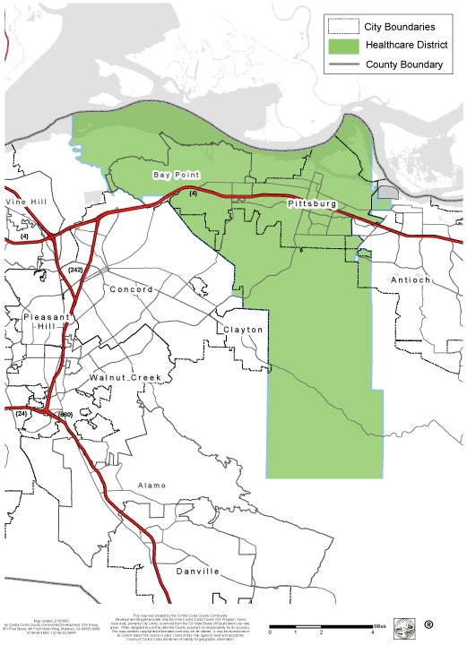
Los Medanos Community Healthcare District Map
https://www.lmchd.org/about-us

Los Medanos Community Healthcare District

WEBSITE:
www.lmchd.org
ADDRESS: 2311 Loveridge Road, Pittsburg, CA 94565
E-MAIL: N/A
MISSION:
Advancing solutions to health disparities
PURPOSE:
All Healthcare Districts are public entities that provide community-based health care services to residents throughout the state. They respond to the needs in their District by providing a range of services, which may include a hospital, clinic, skilled nursing facility or emergency medical services; as well as education and wellness programs. Each of California’s Healthcare Districts is governed by a locally elected Board of Trustees who are directly accountable to the communities they serve. Some of the special programming the Los Medanos Community Healthcare District (LMCHD) provides are:
The Summer Intern Program
Serving the community since 1946, LMCHD has hosted young adults transitioning from foster care to independent living for the past 5 years in their Summer Internship Program. The program is designed to provide youth with a unique work experience and to create an environment for youth to work in a team based, community outreach project. The internship's mission is to "bring public awareness to a public health issue and to introduce youth to healthcare professions. Interns are trained in several aspects of local government agency/research outreach.
The Community Garden Program

The LMCHD Community Garden was founded in 2012. The community garden consists of 39 ground plots, 18 raised beds, and 23 ground circle plots. The garden is designed for the gardening activities of the residents and organizations of Pittsburg and Bay Point. Organization such as The Girls Scouts of America, Pittsburg High School, Center for Human Development, and Community Based Instruction, all have plots and gardens with LMCHD. The purposes of the community garden program are for children and seniors to have a positive experience with gardening while growing vegetables, to develop better eating habits, and to address the obesity epidemic among children.

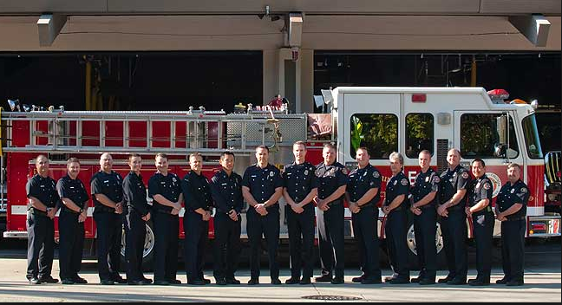
Members of the Moraga Orinda Fire Protection District
http://www.mofd.org

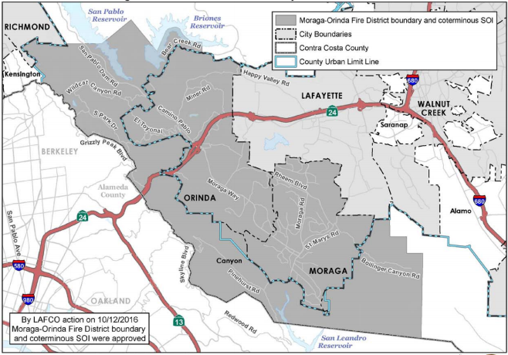
Moraga Orinda Fire Protection District Map
file:///C:/Users/cchist/Downloads/Sect%2005%20-%20Fire%20Protection%20Districts%20(10).pdf

Moraga-Orinda Fire Protection District

WEBSITE:

http://www.mofd.org/about/history

ADDRESS: 1280 Moraga Way, Moraga, CA 94556

E-MAIL: info@mofd.org

MISSION:

To provide the highest level of emergency and public service in response to the needs of our community.

HISTORY:

After a series of disastrous fires that occurred in the late 1800s and early 1900s, the Orinda Volunteer Fire Department was formed in 1923. Previously, the only firefighters were the few neighbors, farmers, and cowboys living in the area. As an important part of the community, various social events were established to help raise money to fund the construction of a new firehouse. In 1933, the Orinda Fire Protection District (OFPD) was established under the State Legislative Act of 1923. The OFPD started out with one piece of equipment and was staffed by volunteers. By the 1940’s, it had grown to three fire stations with a five-man Board of Fire Commissioners who were appointed to administer the affairs of the district. The geographic area of the OFPD encompassed the area from Tilden park on the north to Del Rey School on the south and from the county line on the west to a point close to the Russell Tree Farm on the east.

By the 1960s, the services provided by the district were firefighting, fire prevention, and fire education. Each station was staffed with a two-person crew who were trained in advanced first aid. The total personnel on duty were six firefighters. In 1969, the headquarters of the OFPD was moved to its current headquarters in Orinda Village.

The Moraga-Orinda Fire Protection (MOFD) and OFPD predecessor districts were county-dependent districts. Moraga was served by a volunteer unit of the Eastern Contra Costa County Fire Protection District from 1946 to 1968. In 1968, the Moraga Fire Protection District was formed as a county-dependent district. In July of 1997, the MOFD was formed as an independent special district through the consolidation of the Moraga Fire Protection District and the Orinda Fire Protection District in order to provide more efficient fire protection and emergency medical services.

The Principal act that governs the MOFD is the Fire Protection District Law of 1987 which empowers fire districts to provide fire protection, rescue, emergency medical, hazardous material response, ambulance, and any other services relating to the protection of lives and property.

Wildlife in the Mt. View Sanitary District
https://mvsd.org/
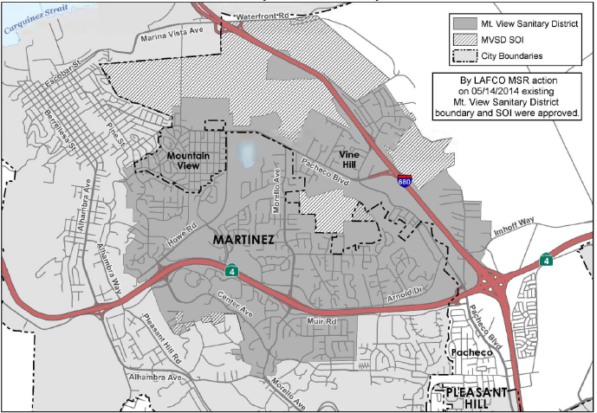
Mt. View Sanitary District Map
file:///C:/Users/cchist/Downloads/Sect%2014%20-%20Sanitary%20Districts%202015%20(1).pdf

Mt. View Sanitary District

WEBSITE:
https://mvsd.org/
ADDRESS: 3800 Arthur Road, Martinez, CA

E-MAIL: info@mvsd.org

MISSION:
To protect Public Health and the Environment, in a safe and reliable manner, at a responsible cost.
HISTORY:
Mt. View Sanitary District (MVSD) was formed in 1923. It is involved in the collection, treatment, and disposal of wastewater in parts of Martinez, as well as being a solid waste franchiser.
The MVSD is an independent district, formed in 1923 pursuant to the Sanitary District Act of 1923 (Health & Safety Code §6400 et seq.). The MVSD serves an estimated population of 19,000 residents consisting of 908 residential and 280 commercial, industrial and institutional sewer connections. The District’s service area is approximately 4.7 square miles. The District’s sphere of influence (SOI) encompasses an additional 1.6 square miles and primarily includes an area of 1.46 square miles of industrially zoned land to the north of the District’s boundary as well as an island within the center of the District of 0.14 square miles that is in agricultural use. The SOI area to the north of the District is designated as heavy industrial to the west of I-680 and open space and parks and recreation to the east of I-680.
The District’s wastewater collection system is located in the rolling hills in/and surrounding Martinez and serves three zones or watersheds. The collection system includes four pumping stations and 73 miles of sewer pipelines ranging in diameter from 6 to 24 inches.

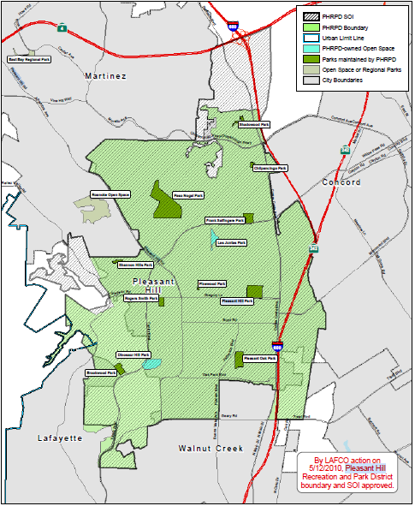
Pleasant Hill Recreation and Park District Map
file:///C:/Users/cchist/Downloads/Sect%2013%20-%20Recreation%20&%20Park%20Districts%202013%20rev%207-14%20(1).pdf
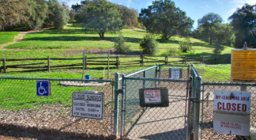
Paso Nogal Open Space and Dog Park
https://www.pleasanthillrec.com/Facilities/Facility/Details/Paso-Nogal-Park-10

Pleasant Hill Recreation and Park District

WEBSITE:
www.pleasanthillrec.com
ADDRESS: 147 Gregory Lane, Pleasant Hill, CA 94523
E-MAIL: cservice@pleasanthillrec.com
MISSION:
In order to serve the diverse recreational needs of individuals and families and to enrich the quality of life for all residents, the Pleasant Hill Recreation and Park District (PHRPD) is committed to providing park facilities, open space and programs and activities for all ages.
HISTORY:
The PHRPD was established in 1951 by citizens who desired recreational opportunities and park facilities in their community. The District is governed by the Public Resources Code of the State of California and operates as a Special District, an independent governmental agency separate from the City of Pleasant Hill. The Board of Directors establishes policy for the District. Pleasant Hill Recreation and Park District is managed by a General Manager. Under the General Manager is one superintendent, six supervisors who manage the day-to-day operations for parks, programs, sports, aquatics, senior citizens activities, information systems, and accounting.
Impact on the Pleasant Hill Community
The PHRPD serves over 40,000 people within the community, an area about 20% larger than the City of Pleasant Hill, and touches approximately 100,000 or more persons who participate in programs, visit District facilities, or volunteer annually. The District promotes an active, healthy life-style for preschool, youth, teens, adults and seniors. They foster self-enrichment and personal development through offering of over 2,300 classes, programs and activities, and preserve and drive community economic value by providing diverse programs, well-maintained neighborhood and community parks, trails and open space to attract and retain residents, businesses and visitors.
The PHRPD strengthens community engagement by working closely with community partners and clubs, coordinating volunteer activities, co-sponsoring community events, and supporting local charities.
Additionally, the District preserves and protects natural resources of California by conscientiously and proactively maintaining the District's 269 acres of parkland, and improves safety and security by providing positive recreational activities and safe environments for at-risk groups.

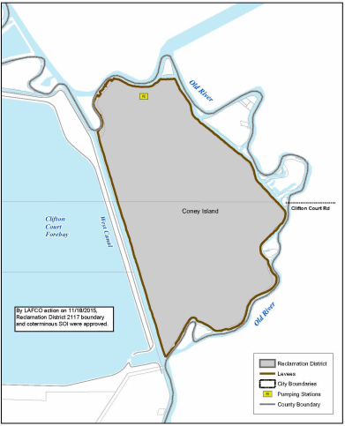
Reclamation District 2117 Map
file:///C:/Users/cchist/Downloads/Sect%2011%20-%20Reclamation%20Districts%208-17%20(4).pdf

Reclamation District 2117-Coney Island
WEBSITE:
file:///C:/Users/cchist/Downloads/Sect%2011%20-%20Reclamation%20Districts%208-17%20(2).pdf

ADDRESS: 235 East Weber Avenue Stockton CA 95202

E-MAIL: ngmplcs@pacbell.net

PURPOSE:

To provide reclamation services of levees, flood control, and drainage.

HISTORY AND PURPOSE:
Formed in 1983, Reclamation District 2117-Coney Island serves approximately 4 people over 935 acres.

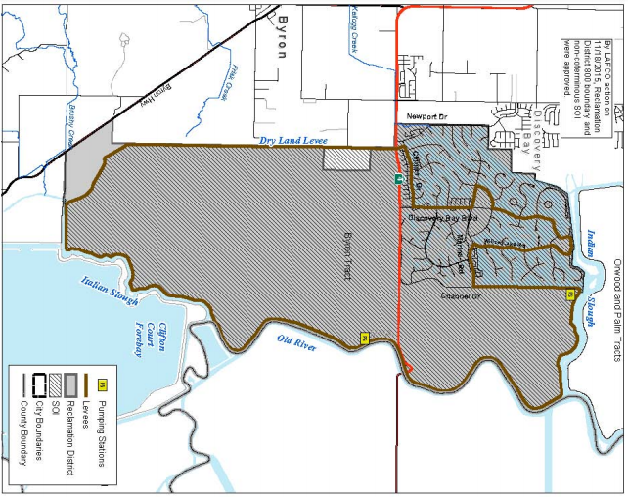
Reclamation District 800 Byron Tract Map\
file:///C:/Users/cchist/Downloads/Sect%2011%20-%20Reclamation%20Districts%208-17%20(4).pdf

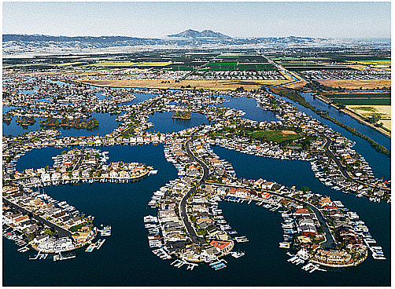
View of the Byron Tract near Discovery Bay
http://rd800.org/welcome.html

Reclamation District 800: Byron Tract

WEBSITES:
www.rd800.org
https://eastcontracostahistory.org/our-communities/discovery-bay/
ADDRESS: 1540 Discovery Bay Blvd., Suite A, Discovery Bay, CA 94505
E-MAIL: contact form on www.rd800.org contact us
PURPOSE:
To prevent flooding and maintain the physical integrity of residential and agricultural properties throught ongoing maintenance, flooding, and repairs.

HISTORY:
Many years before the founding of Discovery Bay, Byron Tract was a fertile wetland privately owned by Veronica Baird and by business partners Frank A. West and Eugene L. Wilhoit. In 1909, West-Wilhoit Co. sued Veronica Baird for the right to form Reclamation District 800 (RD 800), in order to use the land for agriculture. Construction began to fortify the wetland against flooding by use of levees, and to implement modern irrigation and drainage systems. The tract was planted with potatoes, corn, onions, beans, sugar beets, and barley. By 1920, West-Wilhoit had established a hog farm.
By the mid-century, the northwest section of RD 800 was owned by Weldwood Structures, who began to sell lots. Manager of this project, Jorgen Lunding, named the venture “Discovery Bay.” Discovery Bay lots were available for sale in October, 1970. After transferring ownership to the Hoffman Company, development accelerated. By 1988, two thousand acres of land had been developed with eighteen deep-water bays, Discovery Bay Marina, Willow Lake, a swim and racket club, a shopping center and a championship 18-hole golf course.
Today, RD 800 is responsible for the operation and maintenance of nearly 19 miles of levees protecting 7,000 acres of agricultural, urban, commercial and industrial land in Byron Tract.

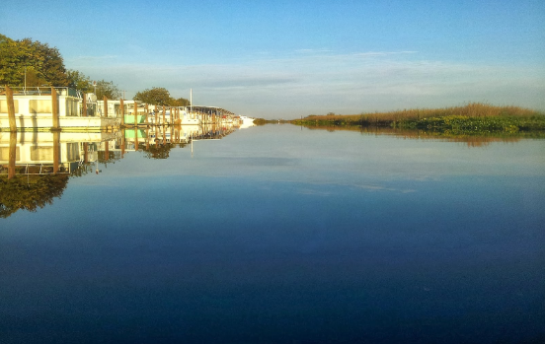
Holland Tract and Rock Slough
http://kayakingcaldelta.blogspot.com/2013/10/holland-tract-and-rock-slough.html

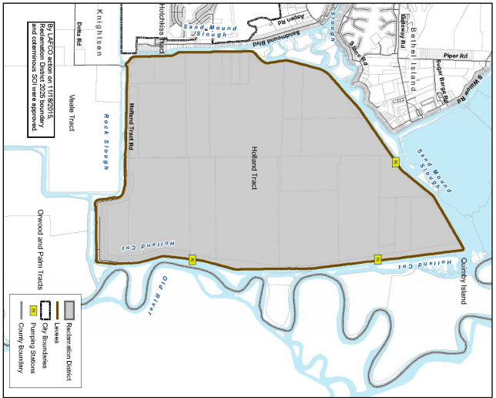
Reclamation District 2025 Holland Tract Map
file:///C:/Users/cchist/Downloads/Sect%2011%20-%20Reclamation%20Districts%208-17%20(4).pdf

Reclamation District No. 2025 (Holland Tract)

WEBSITES:

http://www.mwdh2o.com/DocSvcsPubs/Delta_Islands/
https://contracostasda.specialdistrict.org/reclamation-district-2025-holland-tract

ADDRESS: 343 East Main Street, Suite 815, Stockton, CA 95202

E-MAIL: N/A

PURPOSE:

Improve and maintain levees; maintain and operate flood control system including pumps, canals and ditches.

MISSION:

To maintain the integrity of Holland Tract through continued maintenance of levees and the flood control system.

HISTORY:

Reclamation District (RD) 2025 was formed in 1918 as an independent special district to provide levee maintenance services. These levees were and are important because they allow crops like alfalfa to grow on the reclaimed land, which would not have been possible without the levees, as the land was prone to flooding.

Entirely located within Contra Costa County, RD 2025 is a Delta island located in the eastern portion of the County, northeast of the community of Knightsen. The boundaries of the District comprise approximately 4,090 acres, or about 6.4 square miles. RD 2025 is located entirely within Primary Zone 15 of the Sacramento-San Joaquin Delta, and is outside of the countywide urban limit line. RD 2025 primarily consists of agricultural and recreational land uses. Local business activities include cattle grazing operations within the district and marinas located along the delta waterways, outside of the levees. There are eighteen landowners within the District, and approximately twenty-seven residents according to recent Census data. Delta Wetlands Properties, the island’s largest landowner, owns approximately 75 percent of the island.
In July 2016, the Metropolitan Water District of Southern California purchased Bacon Island, Bouldin Island, Holland Tract, and Webb Tract. These lands are strategically located in the center of the Delta, and part of Chipps Island in the far western Delta.

The five islands and tracts are in important locations in the estuary. Water supplies for Metropolitan and the State Water Project pass through four of the parcels in the Central Delta.

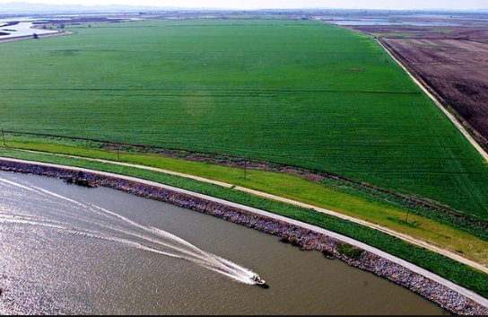
Farmlands on the Webb Tract
https://www.newsdeeply.com/water/community/2016/04/27/jeff-mount-the-mysteries-of-delta-islands-sale

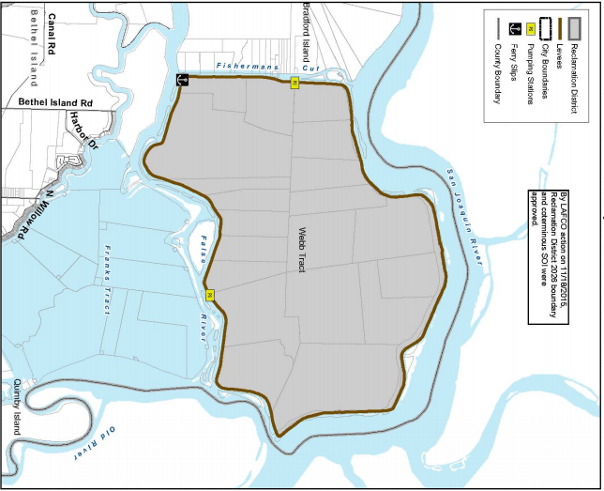
Reclamation District No. 2026 Webb Tract Map
file:///C:/Users/cchist/Downloads/Sect%2011%20-%20Reclamation%20Districts%208-17%20(4).pdf

Reclamation District No. 2026 (Webb Tract)

WEBSITES/REFERENCES:
file:///C:/Users/cchist/Downloads/2015%20Final%20CC%20MSR%20Reclamation%20Districts%2011-19-2015%20(1).pdf
http://www.floodassociation.net/membership.html
https://contracostasda.specialdistrict.org/files/e2f12d1a8/CCSDA_Member_Directory_+%281%29.pdf
Delta Wetlands Project, Sacramento District: Environmental Impact Statement, December 1990. Jones and Stokes Associates Inc.: Sacramento, California.
ADDRESS: 343 East Main Street, Suite 815, Stockton, CA 95202
E-MAIL: N/A
PURPOSE:
To maintain the integrity of Webb Tract through continued maintenance of levees and the flood control system.

HISTORY:
Historically, a reclamation district exists to drain wetlands, which are then “reclaimed” for agriculture. Now, reclamation aim to keep people and property safe in a variety of ways, such as emergency planning, levee maintenance, and pumping water out of reclaimed areas.
Reclamation District (RD) 2026 was formed in 1918 as an independent special district to provide levee maintenance services within its boundary area which includes the entirety of the Webb Tract. In addition to levee maintenance, RD 2026 operates the flood control system, which includes pumps, canals, and ditches
On January 18, 1980, floodwaters breached the levee and created a blowout pond on the east end of the Webb Tract. Emergency pumps were moved to the Webb Tract and the island was turned over to RD 2026 in mid-December 1980.
Reclamation District 2026 is a delta island located in the northeastern corner of Contra Costa County. The district territory includes 5,500 acres (approximately 8.6 square miles) and is entirely located within Contra Costa County. RD 2026 is located within the Primary Zone 17 of the Sacramento-San Joaquin Delta and is outside the countywide urban limit line. RD 2026 is one of the eight western Delta islands that the Department of Water Resources (DWR) has identified as critical to control the salinity in the Delta, protecting water quality to all water users in the state. The District is under the ownership of a single landowner (Delta Wetlands Properties) and contains agricultural land uses and farming operations. Crops grown on the island include corn and wheat. According to the RD administrators, the island is uninhabited and no development is anticipated in the future.

The sunset from the west levee down river to the PG&E crossing with Mt. Diablo in the background
https://bradfordisland.com/?attachment_id=767
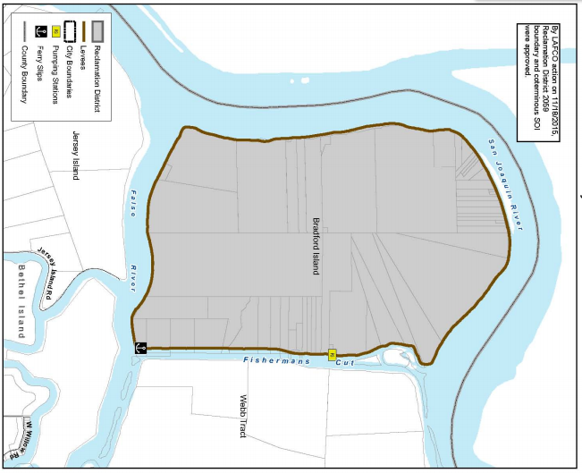
Reclamation District 2059 Bradford Island Map
file:///C:/Users/cchist/Downloads/Sect%2011%20-%20Reclamation%20Districts%208-17%20(4).pdf

Reclamation District 2059—Bradford Island

WEBSITE:
www.bradfordisland.com

ADDRESS: 19 Minaret Road, Oakley, CA 94561

E-MAIL: angelia_bradford@sbcglobal.net

PURPOSE:

To maintain levies and property, prevent flooding, and preserve wetland wildlife.

HISTORY:

Formed in 1921, Bradford Island Reclamation District 2059 (BIRD 2059) serves approximately 48 people in 2,200 acres and 7.4 miles of levees. Services include improving and maintaining levees, maintaining and operating flood control systems, including pumps, canals and ditches, and operating ferry services. The District is also responsible for the main drainage canal that runs through the center of the island to the pump station that discharges to Fisherman’s Cut.
BIRD 2059 manages and maintains levees and drainage within the lands of the District. Additionally, it provides flood control within the District’s jurisdictional boundaries and does all things necessary and proper for the operation of a reclamation district.
BIRD 2059 has five trustees, an office manager, a levee superintendent, a district engineer and an attorney.

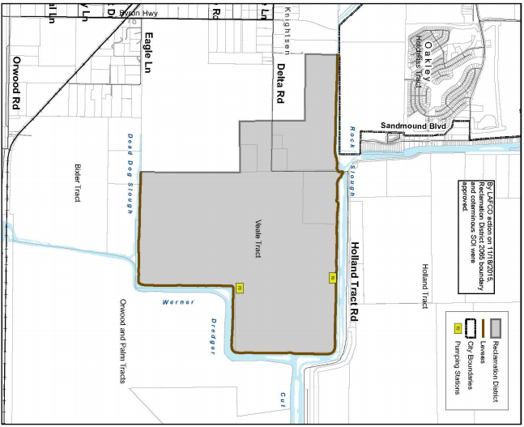
Reclamation District 2065 Veale Tract Map
file:///C:/Users/cchist/Downloads/Sect%2011%20-%20Reclamation%20Districts%208-17%20(4).pdf

Reclamation District 2065 Veale Tract

WEBSITES:
C:/Users/cchist/Downloads/Sect%2011%20-%20Reclamation%20Districts%202016%20(2).pdf
Nomelliny, Dante J.
https://deltacouncil.ca.gov/sites/default/files/2017/05/RD%202065%20Letter%20of%20Support%20for%20AB%20732%20%28Frazier%29--%20Delta%20Levee%20Maintenance_0.pdf
https://contracostasda.specialdistrict.org/reclamation-district-2065-veale-tract
ADDRESS: 235 East Weber Ave., Stockton, CA 95202
E-MAIL: N/A
PURPOSE:

Reclamation District no. 2065 (RD 2065) protects and preserves agricultural land and wildlife environments and serves as a conduit for moving water to Contra Costa Water District’s Rock Slough Intake.

HISTORY
Formed in 1923, Reclamation District (RD) 2065 includes levees, flood control, and drainage. The District serves a population of approximately 14 people over 1,365 acres.
RD 2065 is located on the westerly edge of the Delta, approximately two miles east of the community of Knightsen. RD 2065 is under the ownership of four landowners and consists primarily of agricultural lands along with two single family dwellings, farm worker housing, and out-buildings. RD 2056 maintains 5.1 miles of levees. Since the 2009 the District has focused primarily on levee maintenance and the status of the levee has not changed. In February 2014, the District entered into a Project Funding Agreement with the Department of Water Resource (DWR) in which DWR will provide up to 90% of the costs of a 2.2-million-dollar levee rehabilitation project. If the DWR funding is secured, the District plans to rehabilitate the entire levee to meet Hazard Mitigation Plan (HMP) standards. Currently, 4.2 miles of levees meet these standards.
The only vehicular access to Holland Tract and Quimby Island is protected by the levees of RD 2065. These levees also, in conjunction with other District levees serve as a barrier from salinity intrusion.²

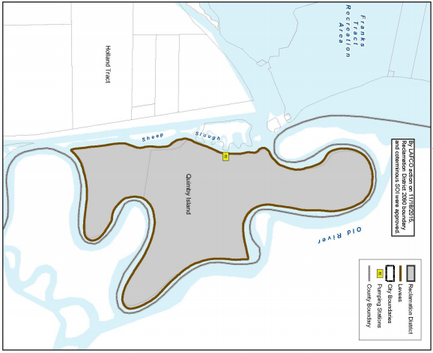
Reclamation District 2090 Quimbly Island Map
file:///C:/Users/cchist/Downloads/Sect%2011%20-%20Reclamation%20Districts%208-17%20(4).pdf
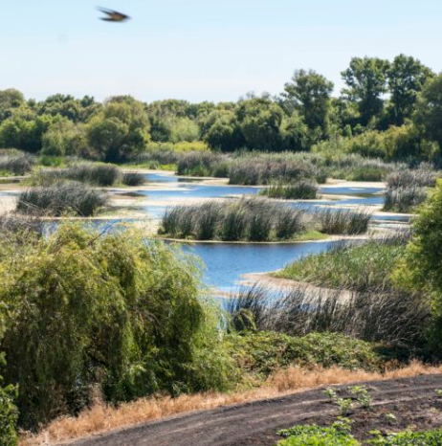
Waterfowl on Quimby Island
https://www.calwaterfowl.org/properties/

Reclamation District 2090-Quimby Island

WEBSITE:

file:///C:/Users/cchist/Downloads/Sect%2012%20-%20Reclamation%20Districts%202013%20(3).pdf

https://contracostasda.specialdistrict.org/reclamation-district-2090-quimby-island

ADDRESS: 343 East Main Street, Suite 815, Stockton, CA 95202

E-MAIL: N/A

PURPOSE:

The purpose of Reclamation District 2090 (RD 2090) is to improve and maintain levees and maintain and operate flood control systems including pumps, canals, and ditches.

HISTORY:

Formed in 1918, RD 2090-Quimby Island serves approximately three people over 769 acres and seven miles of levees.

RD 2090 is a Delta Island located in easternmost Contra Costa County. The District's land uses are primarily agricultural. The population on the island is one person, with four to five additional persons seasonally. The District property is owned by one company and is utilized for agricultural purposes generating some revenues for the landowner. All of the seven miles of levees within RD 2090 meet the Hazard Mitigation Plan (HMP) standards, which provide an evaluation of California’s current and historical hazards and sets the mitigation priorities, strategies and actions for the state. The District has spent considerable resources on levee maintenance and repairs and continues to seek funding to continue its rehabilitation efforts.

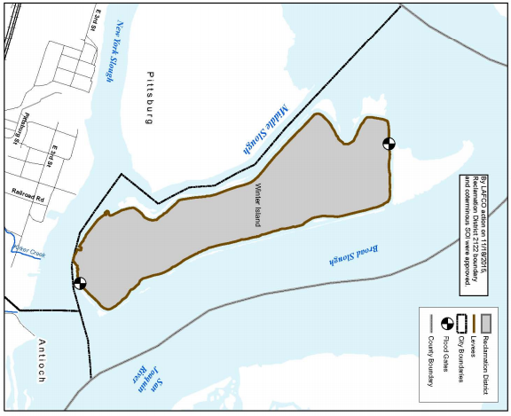
Reclamation District 2122 Winter Island Map
file:///C:/Users/cchist/Downloads/Sect%2011%20-%20Reclamation%20Districts%208-17%20(4).pdf

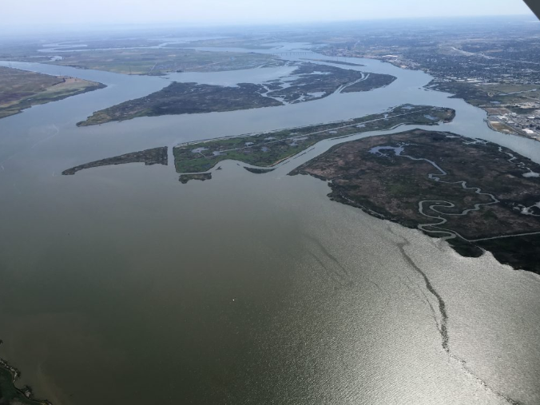
Winter Island Tidal Habitat
http://resources.ca.gov/ecorestore/2018/08/dwr-releases-environmental-document-for-the-winter-island-tidal-habitat-restoration-project-for-public-review-and-comment/

Reclamation District 2122-Winter Island

WEBSITE:

file:///C:/Users/cchist/Downloads/Sect%2011%20-%20Reclamation%20Districts%208-17%20(3).pdf

https://contracostasda.specialdistrict.org/reclamation-district-2122-winter-island

ADDRESS: 3500 Industrial Blvd., West Sacramento, CA 95691

E-MAIL: N/A

PURPOSE:

The purpose of RD 2122 is to provide Levee maintenance/reconstruction and island water control

HISTORY:

Established in 1982, the Reclamation District 2122 (RD 2122) does not currently serve any residents, but it does cover approximately 428 acres of land.

RD 2122, located northeast of the City of Pittsburg is only accessible by boat, and there is no ferry service to the island. The sole landowner, Winter Islands Farms, operates a private duck hunting club on the island. There is no permanent residential population on the island, no anticipated development, and no growth anticipated for the foreseeable future. The District employs no full-time or part-time staff positions. Maintenance of levees and flood control facilities are completed on an as needed basis. RD 2122 maintains five miles of levees.
In June 2012, the District approved a Five Year Plan to support future planning efforts by the District and the Department of Water Resources (DWR). The District's goal is to complete all rehabilitation work on the levees to meet hazard mitigation standards within five years. Engineering, planning, mitigation and construction are expected to cost approximately $4.482 million.

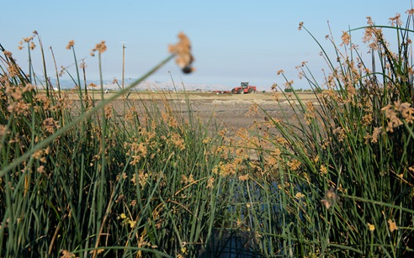
Dutch Slough Tidal Restoration Project
https://water.ca.gov/Programs/Integrated-Regional-Water-Management/Delta-Ecosystem-Enhancement-Program/Dutch-Slough-Tidal-Restoration-Project

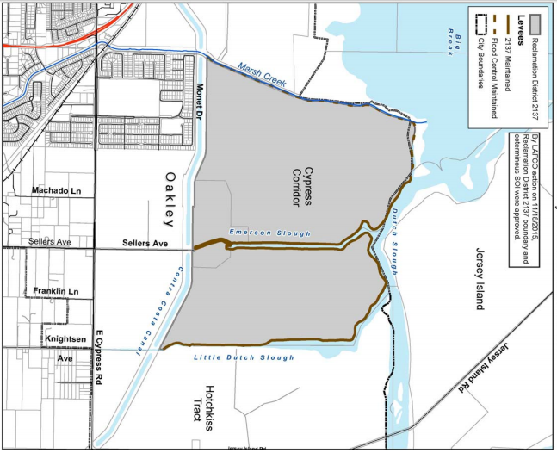
Reclamation District 2137 Map
file:///C:/Users/cchist/Downloads/Sect%2011%20-%20Reclamation%20Districts%208-17%20(4).pdf

Reclamation District-2137

WEBSITE:
file:///C:/Users/cchist/Downloads/2015%20Final%20CC%20MSR%20Reclamation%20Districts%2011-19-2015%20(3).pdf
ADDRESS: 343 East Main Street, #815, Stockton, CA 95202
HISTORY AND PURPOSE:
Formed on July 9, 2003 as an independent special district, Reclamation District (RD) 2137 is located entirely within Contra Costa County. The district encompasses 785 acres, or approximately 1.2 square miles, and is primarily within the boundaries of the City of Oakley. The district is within the Secondary Zone 30 of the Sacramento-San Joaquin Delta, and is within the countywide urban limit line. RD 2137 reports a population of two, with no anticipated growth in the foreseeable future. The district’s land uses are primarily pasture, fallow ground, and open space/habitat area.
District lands make up a majority of the Dutch Slough Restoration Project site which was purchased by the Department of Water Resources in 2003. The project consists of 1,666 acres and a 55-acre community park site which will be acquired by the City of Oakley, though the district reports that the City of Oakley has not provided a timeframe for acquisition or development of the park site. There are three major parcels within the restoration area:
- the 438-acre Emerson property
- the 292-acre Gilbert property
- the 436-acre Burroughs property
According to RD 2137, the design for the Dutch Slough Restoration is near completion and construction should begin once all environmental permits are secured. The district has not provided a specific start date.
RD 2137 is comprised of three landowners, one of whom has 93 percent of the assessed valuation. Landowners pay the expenses of the operations and projects not covered by levee grants from the Department of Water Resources. RD 2137 cooperates with ten other districts for administrative support services and the development of grant applications.

Construction along Reclamation District 830
https://www.ironhousesanitarydistrict.com/211/RD-830

Reclamation District 830 Jersey Island Map
file:///C:/Users/cchist/Downloads/Sect%2011%20-%20Reclamation%20Districts%208-17%20(5).pdf

Reclamation District No. 830 (Jersey Island)

WEBSITES:

http://ironhousesanitarydistrict.com/179/History

file:///C:/Users/cchist/Downloads/2015%20Final%20CC%20MSR%20Reclamation%20Districts%2011-19-2015%20(1).pdf

ADDRESS: 450 Walnut Meadows Drive, Oakley, 94561

E-MAIL: N/A
MISSION:
To protect public health, safety and the environment through responsible wastewater collection, treatment and water reuse.

HISTORY:
The district was formed in March of 1911 under the Reclamation District Law of 1868 for the purpose of forming a district to build levees and “reclaim” land subject to periodic overflow from neighboring rivers and water bodies. At this time the Government was promoting reclamation to develop swamp lands for the improvement and cultivation of the thousands of acres in California.
Reclamation District No. 830 is a 3,520-acre island used by the Ironhouse Sanitary District for disposing of the district's recycled water. The island is bound to the north west by the San Joaquin River, to the north by the False River, to the northeast by Piper Slough, to the east by Taylor Slough, and to the south by Dutch Slough.
Today, Jersey Island is under the ownership of a single landowner - Ironhouse Sanitary District (ISD). ISD purchased the last 50 acres of the island from Delta Properties in 2011. The District’s territory is primarily used for agriculture, cattle grazing, and habitat preservation. Reclamation District No. 830 (RD 830) has a population of three people, and no population growth is expected within the next 10 to 15 years.
RD 830 uses recycled water from the Ironhouse Sanitary District to irrigate hay grown on the island, which is then fed to cattle raised by the Ironhouse Cattle Company.
RD 830 is surrounded on all sides by levees. There are miles of levees on the island. All of the levees were originally built by the local landowner using whatever materials were available and whatever criteria they chose. Today, RD 830 maintains and repairs the Jersey Island levees.

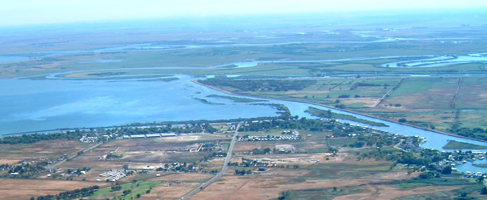
View of Hotchkiss Tract
https://www.rd799.com/
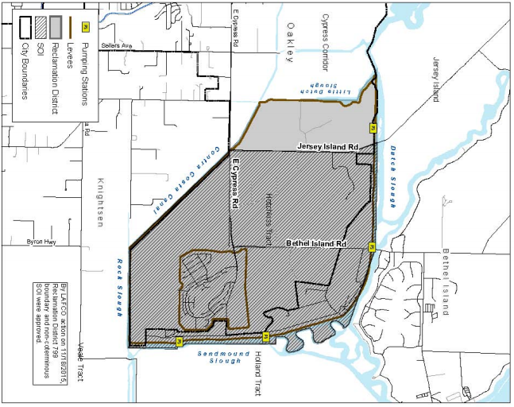
Reclamation District 799 Hotchkiss Tract
file:///C:/Users/cchist/Downloads/Sect%2011%20-%20Reclamation%20Districts%208-17%20(5).pdf

Reclamation District No. 799—Hotchkiss Tract

WEBSITES:
https://www.rd799.com
www.contracostalafco.org/documents/local_agency_directory_2013/Sect 12 - Reclamation...
https://www.rd799.com/wp-content/uploads/2014/06/RD-799-Five-Year-Plan_2012.06.21.pdf

ADDRESS: 6325 Bethel Island Rd. Bethel Island, CA 94511

E-MAIL: N/A

RESPONSIBILITIES:
Levee maintenance of the district’s levee system and drainage facilities along with the maintenance of 4 pump stations.
Flood fighting and patrols on district levees during times of high water.

HISTORY:
Reclamation District No. 799 (Hotchkiss Tract) was formed in 1911 to provide maintenance and operation of 11.7 miles of levees and related drainage facilities. It is located at the eastern area of Oakley, which has a population of approximately 969, and covers an area of approximately 3,100 acres. The District includes agricultural land for cattle grazing, and residential and recreational land uses. According to the District, there are 1,250 parcels in the Hotchkiss Tract.
In addition to agricultural uses, several recreational vehicle parks and marinas for local and public use are located on Hotchkiss Tract. In total, there are 9 small marinas and 1 medium-sized marina, for a total of 306 marina berths. The Hotchkiss Tract levee system protects assets not governed by local municipalities which provide a public benefit, including infrastructure, utilities, water quality and water supply reliability.

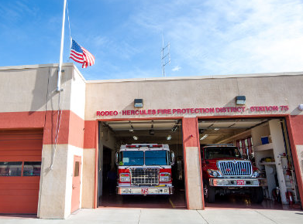
Rodeo Hercules Fire Protection District Fire Station
https://contracostafirefighters.org/about/fire-station-locations

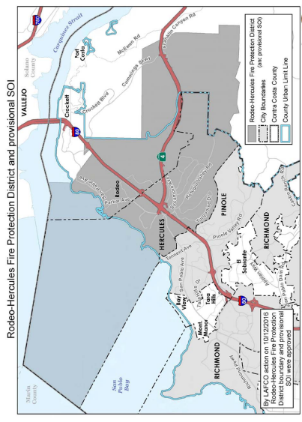
Rodeo Hercules Fire Protection District Map
file:///C:/Users/cchist/Downloads/Sect%2005%20-%20Fire%20Protection%20Districts%20(4).pdf

Rodeo-Hercules Fire Protection District

WEBSITE:

http://www.rhfd.org/

ADDRESS: Hercules Station #76, 1680 Refugio Valley Road, Hercules, CA 94547

E-MAIL: use ‘contact’ page on website http://www.rhfd.org/contact/

MISSION:

To provide the highest level of service to the community; to mitigate the devastating effects of fires and other disasters; to deliver emergency medical services; and to educate the public and maintain a constant state of readiness.

HISTORY:

In the early 1920s, the men of the Rodeo Volunteer Fire Department used buckets to put out fires. Eventually, the department acquired a horse drawn cart in addition to the buckets. By 1927 the need for an official larger fire house had become apparent, and the whole community pitched in to make it possible. In April, 1927, the original brick fire house on Third Street held official dedication ceremonies. Ten years after the fire house was built, the importance of growing the department was well recognized.

The Rodeo Fire District was formed on February 26, 1937, as an independent special district. The District was established to provide fire protection services in the unincorporated community of Rodeo. Though Rodeo had a full-time paid firefighter on duty for some of the time, in 1946 the Board of Commissioners approved an order to have a firefighter on duty at all times, day and night, to give added protection to the community. In 1949, the Department joined with other fire districts in Contra Costa County in a three-way radio communication system. The whole community of Rodeo gathered at a Whist Party given by the Rodeo Firemen’s Association to raise two thirds of the money needed for the new two-way radios for the Rodeo Fire Department. The rest of the money was contributed by the Association, which was the firemen’s social organization. In 1978, the City of Hercules was annexed into the Fire District and subsequently the name of the District was changed from the Rodeo Fire Protection District to the Rodeo-Hercules Fire Protection District (RHFPD).

Today, the independent fire district serves an area of approximately twenty-five square miles, including the City of Hercules, with a population of about 25,500, and the Town of Rodeo, with a population of about 8,500.

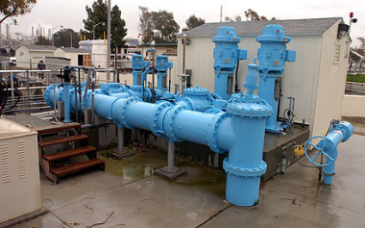
Rodeo Sanitary District New Pumping Station
https://www.alamy.com/stock-photo/gmu.html
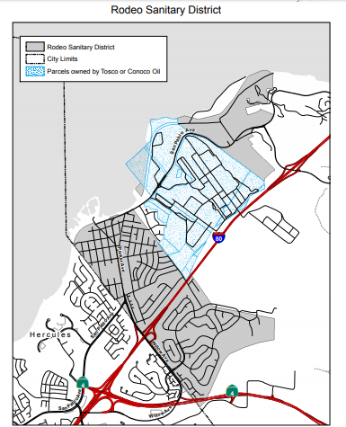
Rodeo Sanitary District Map
file:///C:/Users/cchist/Downloads/6.0%20Rodeo%20San%20Dist%20Final%20(2).pdf

Rodeo Sanitary District

WEBSITES:
https://www.rodeosan.org/
file:///C:/Users/cchist/Downloads/6.0%20Rodeo%20San%20Dist%20Final%20(1).pdf
ADDRESS: 800 San Pablo Ave., Rodeo, CA 94572
E-MAIL: use the ‘contact’ page https://www.rodeosan.org/
MISSION:
To safely provide the highest level of waste water collection and treatment as economically as possible for the people of Rodeo while protecting the sensitive ecosystem of the San Pablo Bay and the overall environment.
HISTORY:
Rodeo Sanitary District (RSD) is an independent district, formed in 1939. The District serves three non-contiguous service areas: an area of medium density single family residential north of Willow Avenue, a small area designated for public use west of San Pablo Avenue, and an area primarily designated for heavy industrial use west of Crockett. The RSD also provides wastewater collection and treatment services to a large apartment complex located southeast of San Pablo Avenue and the Conoco Refinery. Also being serviced by RSD are a number of single family homes located north of the District’s eastern boundary along Viewpoint Avenue. Adjacent wastewater service providers include the City of Hercules to the south and the Crockett Community Services District to the east. The area between the District’s north and south service areas is the Conoco Phillips Refinery which operates its own private wastewater system. The City of Hercules’ sphere of influence lies to the southeast.
RSD’s wastewater collection system consists of approximately 25 miles of pipeline with two force mains and two pump stations. The District’s Water Pollution Control Plant (WPCP) has a design capacity of 1.14 million gallons per day (mgd) and average dry weather flow of 0.60 mgd. Rodeo Sanitary District, the City of Pinole, and the City of Hercules share discharge facilities to San Pablo Bay through a Joint Powers Agreement. In February 2008, RSD was recognized for its environmental stewardship by being awarded the Small Plant of the Year award by the California Water Environment Association’s San Francisco Bay Section.

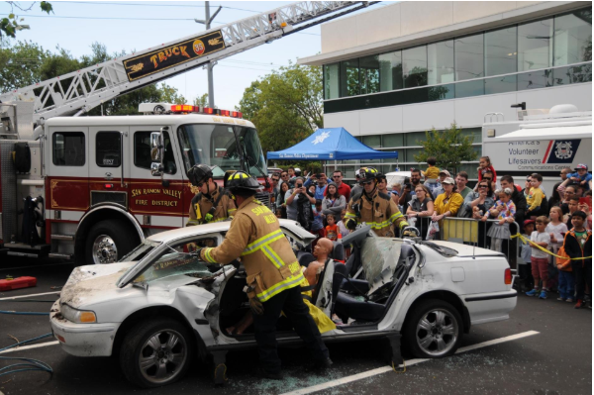
Disaster Preparedness Demonstration by the San Ramon Valley Fire Protection District
https://firedepartment.org/community

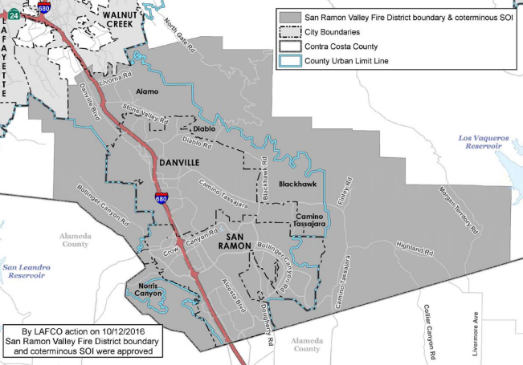
San Ramon Valley Fire Protection District Map
file:///C:/Users/cchist/Downloads/Sect%2005%20-%20Fire%20Protection%20Districts%20(5).pdf

San Ramon Valley Fire Protection District

WEBSITE:
https://firedepartment.org/home
ADDRESS: 1500 Bollinger Canyon Road, San Ramon, CA 94583
E-MAIL: use ‘contact’ page on website https://firedepartment.org/our-district/district-overview/contact-us
MISSION:
In the spirit of tradition, we strive for excellence, respectfully serving all with pride, honor and compassion.
HISTORY:
The San Ramon Valley Fire Protection District (SRVFPD) can trace its early roots back to a meeting on March 19, 1912 of the Danville Improvement Club. Present at the meeting were the leading ladies and men of Danville, who decided that a volunteer fire department needed to be organized. The idea was unanimously approved and the name Danville Farm Defense Fire District was established. In 1921, when a state law permitted the organization of special fire districts, the Danville Farm Defense Fire District became the Danville Fire Protection District. The official boundaries encompassed the Alamo, Danville, Green Valley, and Sycamore Grammar School Districts, which was an area of approximately 50 square miles.
In 1963, Contra Costa County reorganized its East County Fire Protection District into the San Ramon Fire Protection District, an independent district. In December of 1979, the Local Agency Formation Commission (LAFCO) consolidated the Danville Fire Protection District and the San Ramon Fire Protection District. On July 1, 1980, the two districts were renamed the San Ramon Valley Fire Protection District.
This district served the communities of Alamo, Blackhawk, Danville, Diablo, and San Ramon. The organization was composed of four fire stations, 27 emergency vehicles, and 71 employees. In 1991, the Tassajara Fire Protection District merged with the San Ramon Valley Fire Protection District, which included the Tassajara Valley and the southern boundary of the Morgan Territory. In July of 1997, the city of San Ramon and the SRVFPD moved forward with an annexation of the Dougherty Regional Fire Authority, which extended the fire service boundary of the SRVFPD to Contra Costa/Alameda County line.
In 2001, the District implemented a chaplaincy program which was operated in a non-denominational setting in order to assist District personnel and their families for life’s needs, as well as providing outreach assistance into the community. In August 2009, the district began construction of the Station 36 apparatus storage building which houses a wide variety of resources, supplies, and emergency equipment, and in August of 2017, it completed Station 32 in Alamo, California.

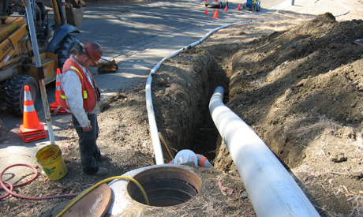
Main sewer line improvements are done on a regular basis
https://www.stegesan.org/services/projects
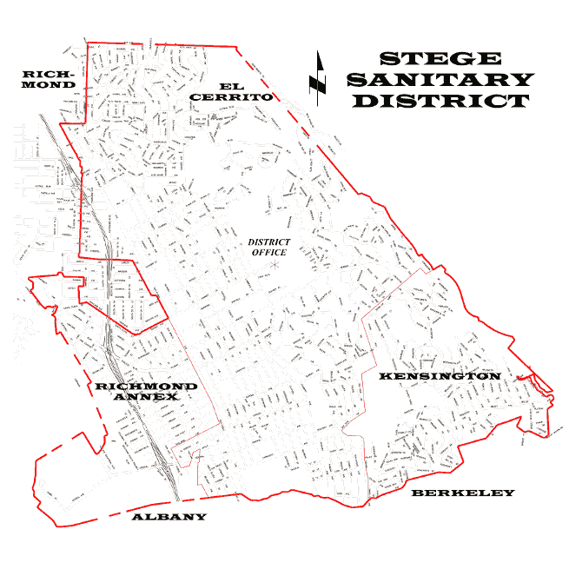
Stege Sanitary District Boundaries
https://www.waterboards.ca.gov/rwqcb2/board_info/agendas/2014/November/17_TO.pdf

Stege Sanitary District

WEBSITE:
https://www.stegesan.org
ADDRESS: 7500 Schmidt Lane, El Cerrito, CA 94530
E-MAIL: Staff@StegeSan.org
MISSION:
It shall be the mission of the Stege Sanitary District to plan and operate a safe, efficient and economical wastewater collection and transfer system for the present and future customers of the District.
HISTORY:
Stege Sanitary District, incorporated in 1913, is one of the oldest special districts in the Bay Area. The district got its start when a handful of residents, realizing that the largely undeveloped area just north of the Alameda-Contra Costa county line would remain undeveloped unless there were sewers, campaigned to get some. Led by William Huber, the justice of the peace, the group proposed creating a special district to fund and build sewers and in May 1913, Stege Sanitary District was formed. The district covers what today is El Cerrito, Kensington, and part of the Richmond Annex.

Stege began buildings sewers in 1914. Like all sewers at the time, they dumped directly into the bay without treatment. Stege’s history over the next several decades was one of accommodating residential development, which boomed in most parts of the district. Often, Stege couldn’t get its pipes in fast enough for home builders.

In 1972, Stege began sending its sewage through EBMUD’s Bay Bridge plant, but in 1976 a new board member proposed dissolving the district entirely, arguing that it was unnecessary, but residents of Kensington objected and blocked Stege’s proposed dissolution in a 1979 vote.

For four years, Stege contracted with the West Contra Costa Sanitary District for sewer maintenance and other services, after laying off most of its staff. That arrangement ended in 1984, in a dispute about costs – just in time for Stege to take on one of the biggest challenges in its history. Water quality rules required sewer districts to reduce “infiltration and inflow” of rainwater into their lines to reduce pollution during wet weather. Stege, under engineer and manager Larry Rugaard, became a leader in the effort, with an innovative strategy if replacing all mains and private laterals in the area with the greatest problems.

Over the next decades, under Rugaard and then managers Doug Humphrey and Rex Delizo, Stege has pioneered techniques for preventive maintenance, winning many industry awards.
Stege, which prides itself on fast response times and customer service (callers always get a real person), celebrated its 100th anniversary in 2013.

Doctors at Work in the District
http://www.radiofreerichmond.com/west_contra_costa_healthcare_district_doctors_medical_center_is_closing_on_april_21_2015
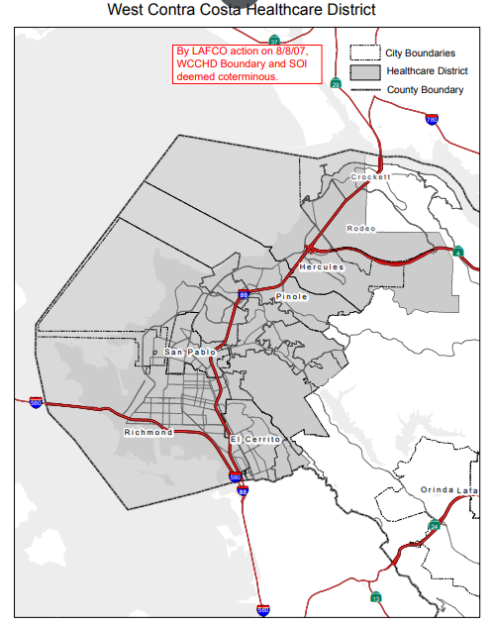
West Contra Costa Healthcare District Map
file:///C:/Users/cchist/Downloads/WCCHD%20Final%20Report%20Accepted%2012-14-16%20(1).pdf

West Contra Costa Healthcare District

WEBSITE:
https://wcchd.ca.gov/
ADDRESS: 50 Douglas Dr, Suite 463, Martinez, CA 94553
E-MAIL: wcchd@cchealth.org
MISSION:
Healthcare is a right, not a privilege. Our mission is to provide leadership and oversight in the delivery of healthcare in the West Contra Costa Healthcare District by:
- Acting as an advocate for quality healthcare to all.
- Providing a conduit for healthcare information and services.
- Fostering, developing, maintaining and supporting programs that serve the healthcare needs of the communities served.
- Providing assurance, through oversight of the District’s healthcare facilities, of equal access to healthcare, without regard to race, color, age, religion, sex, sexual orientation, national origin, citizenship, handicap or ability to pay.
HISTORY:
The West Contra Costa Healthcare District is a public agency formed under the State of California’s Local Healthcare District Law. The District encompasses most of West County, from Kensington in the south to just over the border with Crockett. Formed by the residents of West County in 1948, the District was created for the purpose of building Brookside Hospital. The District operated as a hospital district until 1994 when California Healthcare Law broadened the District’s oversight to include healthcare issues for all of West County. Since then, the District has operated as a healthcare district working to maintain and improve the quality of healthcare in West County.
Due to the Healthcare Districts financial struggles since the mid-1990’s, the State Legislature placed Senate Bill 522 on the ballot and if passed, it would replace the district’s elected governing body with a district board appointed by the Contra Costa County Board of Supervisors with the intent of reducing administration costs, increase operational efficiencies and maximizing the use of health care funding by collaborating with the County. Effective January 1, 2019, the Contra Costa County Board of Supervisors governs the District (WCCHD) as a result of the passing of Senate Bill 522.
Timeline
- The District operated Brookside from its opening in 1954 until 1997.
- In 1997 the District affiliated with Tenet Health Systems to operate Brookside Hospital. Tenet renamed the hospital Doctors Medical Center San Pablo/Pinole.
- On August 1, 2004, the District assumed operations of Doctors Medical Center.
- Doctors Medical Center was owned and operated by the West Contra Costa Healthcare District.
- Doctors Medical Center closed on 4/21/2015.
- WCCHD declared Bankruptcy October 2016 and Plan of Adjustment approved January, 2018
- The property at 2000 Vale Road was sold by the District on 4/3/2018.
- Senate Bill 522 passed and signed by Governor Brown, September 2018 changing governance of WCCHD
- Contra Costa County Board of Supervisors began governing the WCCHD effective January 1, 2019.
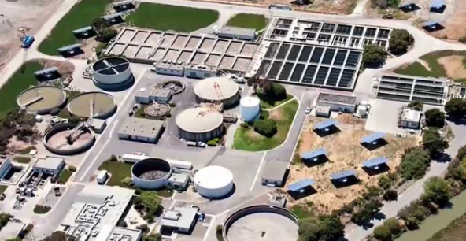
West County Wastewater District treatment plant
https://www.wcwd.org/

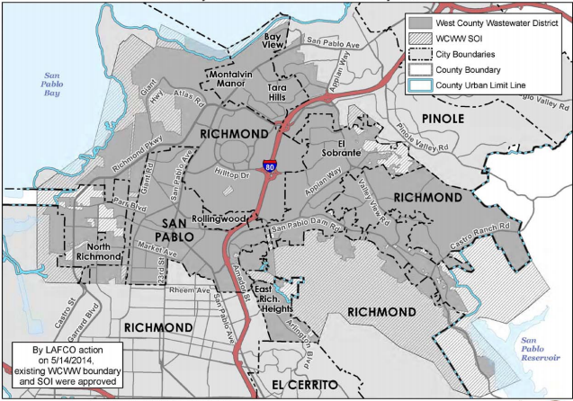
Map of West County Wastewater District
file:///C:/Users/cchist/Downloads/Sect%2014%20-%20Sanitary%20Districts%208-17.pdf

West County Wastewater District

WEBSITE:
https://www.wcwd.org/
file:///C:/Users/cchist/Downloads/Sect%2014%20-%20Sanitary%20Districts%208-17.pdf
ADDRESS: 2910 Hilltop Drive, Richmond, CA 94806
E-MAIL: N/A
MISSION:
To protect the public health through the safe, responsible collection and treatment of wastewater to recover for reuse while promoting environmental stewardship for the West County Community.
ABOUT/HISTORY:
Founded in December 192, the West County Wastewater District was established to protect and serve the public health of the community through the construction and maintenance of a sewer system. Their service area covers 16.9 square miles with operations that include sewage collection, treatment, and disposal.
West County Wastewater District (WCWD) serves approximately 34,000 residences and 2,450 commercial and industrial businesses with a total population of approximately 100,000 in the following areas: San Pablo; Richmond (northern subdivisions); City of Pinole (designated sectors); El Sobrante; East Richmond Heights; Tara Hills; Rollingwood; Bayview; and parts of the unincorporated county.
The District embraces technologies that promote energy efficiency such as an efficient wastewater collection and treatment processes that create clean, safe water for release into the San Francisco Bay or for reuse in heating/cooling buildings. Nearly one-third of the District’s energy use comes from solar power panels on their property. Methane gas is created as a by-product of the treatment process.
The District consistently meets regulatory requirements and customer needs through careful planning and ongoing preventive maintenance of their infrastructure (sewer pipes and systems throughout the District and all processes of their plant).

Dependent Special Districts

Like the Independent Special Districts, Dependent Special Districts’ purpose is to promote efficient, economical, and responsive public services. Contra Costa County has 28 Dependent Special Districts that help to service the County. Some of these services include sanitation, library, transit, and fire districts. Decision makers for Dependent Special Districts are the governing board of a city or county. This differs from Independent Special Districts, in that Independent Districts operate under a locally elected independent Board of Directors.

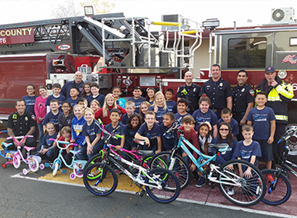
2016 Fire Prevention Open House
https://www.cccfpd.org/img/pub-safety-2.jpg

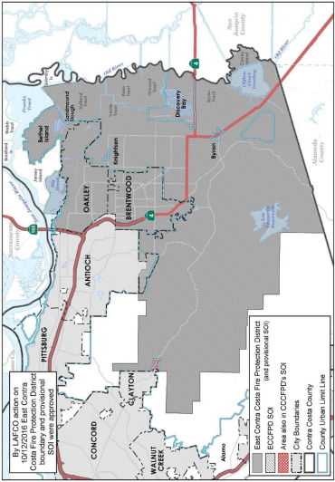
Map of Contra Costa County Fire Protection District file:///C:/Users/cchist/Downloads/Sect%2005%20-%20Fire%20Protection%20Districts%20(6).pdf

Contra Costa County Fire Protection District

WEBSITE:
https://www.cccfpd.org/
http://www.co.contra-costa.ca.us/1550/Fire-Protection-Districts
ADDRESS: 2010 Geary Road Pleasant Hill, CA 94523-4619
E-MAIL: jcarm@ccfpd.org
MISSION:
The Contra Costa County Fire Protection District exists to provide you, your family and our communities with professional services dedicated to the preservation of life, property and the environment.
ABOUT:
Year formed: November 2002
Area served: Bethel Island, Brentwood, Byron, Discovery Bay, Knightsen, Morgan Territory and Oakley
Population served: 125,000
Size: Approximately 249 square miles
Services provided: Fire suppression, fire prevention and emergency medical services
INFORMATION:
The Contra Costa County Fire Protection District (CCCFPD) was originally formed by the merger of the Central Fire Protection District and the Mt. Diablo Fire Protection District. This took place on December 29, 1964.
Contra Costa County Fire Protection District (Con Fire) -- a recognized fire service leader -- provides fire and emergency medical services to nearly a million people across its 304-square-mile District area, and through mutual aid, in and around the 19 cities and unincorporated communities of Contra Costa County, California. With few exceptions, county emergency ambulance transport services are provided by Con Fire through its unique sub-contractor Alliance model. In 2018, the District responded to nearly 75,000 fire and EMS emergencies and dispatched some 95,000 ambulances, providing expert medical care on more than 74,000 ambulance transports. The District, with 26 fire stations and more than 400 employees, is dedicated to preserving life, property and the environment.

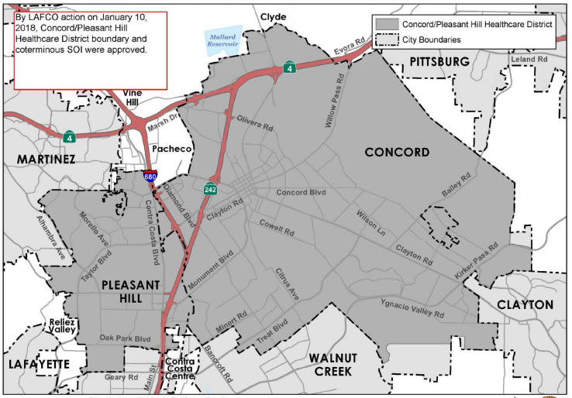
Map of Concord/Pleasant Hill Healthcare District
file:///C:/Users/cchist/Downloads/Sect%2006%20-%20Healthcare%20Districts%208-17.pdf

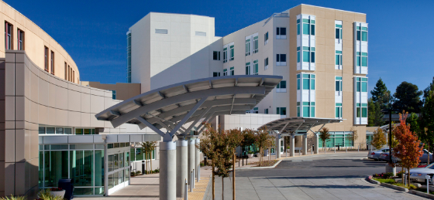
John Muir Health Center in Concord
https://www.google.com/search?q=John+Muir+Health,+Concord&rlz=1C1CHBF_enUS726US726&source=lnms&tbm=isch&sa=X&ved=0ahUKEwjTl9iUr6bkAhUBEawKHSulBVMQ_AUIEygD&biw=1366&bih=625#imgrc=WGTrkD2fUB_fdM:

Concord Pleasant Hill Healthcare District
WEBSITE:
https://www.cityofconcord.org/467/Concord-Pleasant-Hill-Health-Care-Distri
ADDRESS: 1950 Parkside Drive Concord, CA 94519-2578
EMAIL: cityclerk@cityofcondord.org
HISTORY:
The Concord/Pleasant Hill Health Care District, previously known as the Concord Hospital District and now known as the Concord/Pleasant Hill Health Care District, (CPHHCD), was formed in 1948, with voters approving the District formation and a special parcel tax to build the Mt. Diablo Medical Center. CPHHCD is funded primarily by property tax revenues (ad valorem). When initially formed, the District's boundaries included he cities of:
- Clayton (portions)
- Concord
- Lafayette (portions)
- Martinez
- Pleasant Hill (portions)
- The unincorporated communities of:
- Clyde
- Pacheco
In 1996, District voters approved a Community Benefit Agreement (CBA) the CPPHCD and John Muir Medical Center (John Muir Health). Under the terms of the CBA, CPHHCD transferred all rights and title in the Mt. Diablo Medical Center to John Muir Health, including land, buildings and equipment, in exchange for certain assurances regarding healthcare services and funding to be provided within the District.
In 2011, the Contra Costa Local Agency Formation Commission (Contra Costa LAFCO) proceeded with a special study relating to governance options for the CPHHCD. Thereafter, LAFCO encouraged the City of Concord to apply to convert the CPHHCD into a subsidiary district governed by the City.
In April 2012, the City submitted an application and operational plan, proposing the establishment of CPHHCD as a subsidiary district of the City of Concord, with the Concord City Council serving as the CPHHCD Board. On August 8, 2012, Contra Costa LAFCO approved reorganization of the Mt. Diablo Healthcare District, authorizing the Concord City Council as the ex officio Board of Directors to continue to provide health care services pursuant to the Health and Safety Code throughout the District's new jurisdictional boundary comprising the exterior boundaries of the cities of Concord and Pleasant Hill that are currently within the CPHHCD, including unincorporated islands and pockets within the respective cities' boundaries.

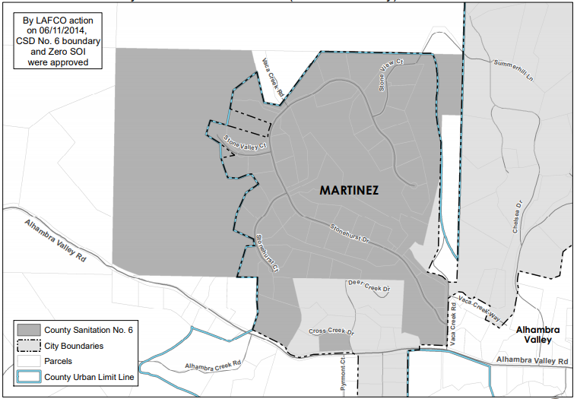
Map of County Sanitation District 6 (Alhambra Valley)
file:///C:/Users/cchist/Downloads/Sect%2015%20-%20Sanitary%20Districts%202013%20rev%207-14%20(2).pdf
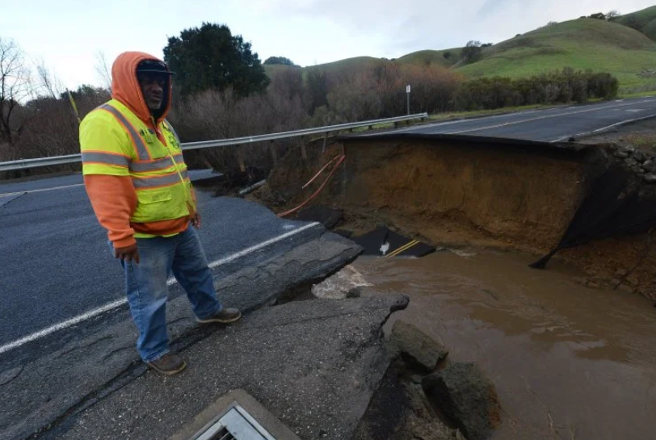
Sinkhole that opened up beneath Alhambra Valley Road
https://www.mercurynews.com/2017/02/02/alhambra-valley-road-remains-closed-due-to-sinkhole/

County Sanitation District 6 (Alhambra Valley)

WEBSITE:
file:///C:/Users/cchist/Downloads/Sect%2015%20-%20Sanitary%20Districts%202013%20rev%207-14%20(2).pdf
file:///C:/Users/cchist/Downloads/6.0%20County%20San%20Dist%206%20Water%20Wastewater%20Final.pdf
ADDRESS: City of Martinez 525 Henrietta Street Martinez CA 94553
EMAIL: ttucker@cityofmartinez.org
INFORMATION:
Year formed: 1992
Area served: Stonehurst Subdivision
Population served: 47 Residential DU Size: Approximately .18 square miles
Services provided: Sewage collection, treatment and disposal for Stonehurst Subdivision, Alhambra Valley area
ABOUT:
County Sanitation District (SD) No. 6 is a dependent special district that was formed in 1992 to provide wastewater service to the Stonehurst subdivision within the unincorporated Alhambra Valley area. The District’s boundaries encompass approximately 237 acres with 48 parcels. Each parcel has an individual septic system; the effluent receives secondary treatment at a community wastewater treatment plant owned by the District and is discharged through a leach field at the top of an adjacent ridge.
SD No. 6 is funded through an annual assessment or service charge on each parcel within the District, based on the projected cost to operate the system.

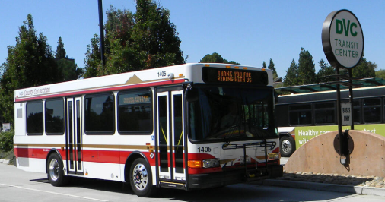
Alamo Creek Shuttle County Connection
https://nextdoor.com/agency-post/ca/contra-costa-county/central-contra-costa-transit-authority/using-the-alamo-creek-shuttle-just-got-easier-77579391/
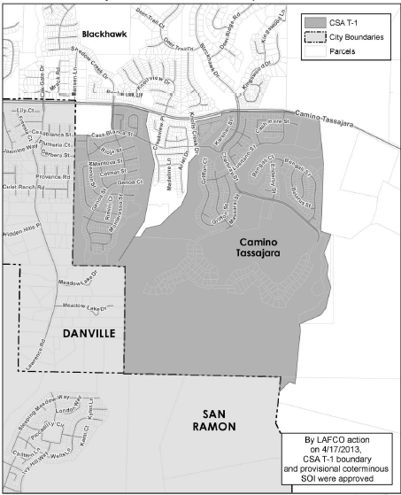
Map of County Service Area T-1 (Public Transit, Alamo)
file:///C:/Users/cchist/Downloads/Sect%2004%20-%20County%20Service%20Areas%202015%20(1).pdf\

County Service Area T-1 (Public Transit, Alamo)

WEBSITE:
file:///C:/Users/cchist/Downloads/Miscellaneous%20CSAs%20Final%204-17-13%20(6).pdf

ADDRESS: Public Works Department Attn: Special Districts Unit County of Contra Costa, 255 Glacier Drive Martinez, CA 94553-4897

EMAIL: scohe@pw.cccounty.us

INFORMATION:

Year formed: 2005
Area served: Danville unincorporated area
Population served: 804 Residential Dwelling Units (DU)
Size: Approximately 1.18 square miles
Services provided: Extended public transit services

ABOUT:

CSA T-1 was formed in 2006 to provide transportation demand management (TDM) services to the Alamo Creek, Monterosso and Ponderosa Colony communities in unincorporated Camino Tassajara. These subdivisions were challenged on environmental grounds, and so the County ultimately required them to fund TDM services to mitigate traffic impacts.
The CSA activities to date are planning, surveying, outreach and analysis of future transportation services to be provided. A 2005 study found there is a limited market for public transit services in the area, and developed the original plan for CSA services to include rush-hour commuter service involving vanpools and eventually mini-bus service. The CSA conducted a survey of residents in fiscal year 10/11; that study recommended carpool and vanpool programs, public outreach and bicycle infrastructure improvements.

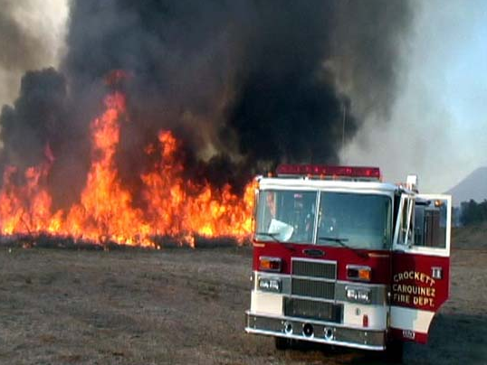
Taking on the 2007 Rice Fire
http://www.crockettfire.org/gallery.html

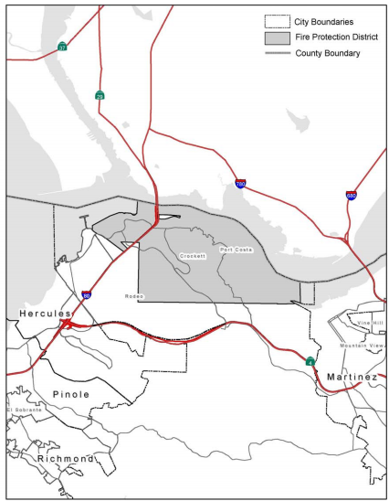
Map of Crockett-Carquinez Fire Protection District
file:///C:/Users/cchist/Downloads/Sect%2005%20-%20Fire%20Protection%20Districts%20(7).pdf

Crockett-Carquinez Fire Protection District

WEBSITE:
http://www.crockettfire.org/
file:///C:/Users/cchist/Downloads/Sect%2005%20-%20Fire%20Protection%20Districts%20(7).pdf

ADDRESS: 746 Loring Avenue Crockett, CA 94525-1236

E-MAIL: litjl@aol.com

INFORMATION:
Year formed: 1967 (Original district 1891)
Area served: Port Costa, Crockett, Rodeo, Tormey and other adjacent unincorporated County areas
Population served: 3,500 per CCC Department of Conservation & Development
Size: Approximately 10.5 square miles
Services provided: Fire prevention and suppression, emergency medical including rescue (Unincorporated County on south shore of Carquinez Straits from ConocoPhillips fence line east to beyond Ozol fuel terminal; includes towns of Crockett, Port Costa, Tormey)
ABOUT:
The Crockett-Carquinez Fire Department protects the communities of Crocket, including Valona, Selby, Tormey, and Port Costa. It was originally two fire Districts, the Crockett County Fire Protection District and the Carquinez County Fire Protection District. It was formed through a merger in 1967. Prior to that, in 1932, the Tenney Terrace Fire District and the Crockett-Crolona Fire District merged and formed the Crockett County Fire District. The Carquinez County Fire Protection District consolidated in 1965.

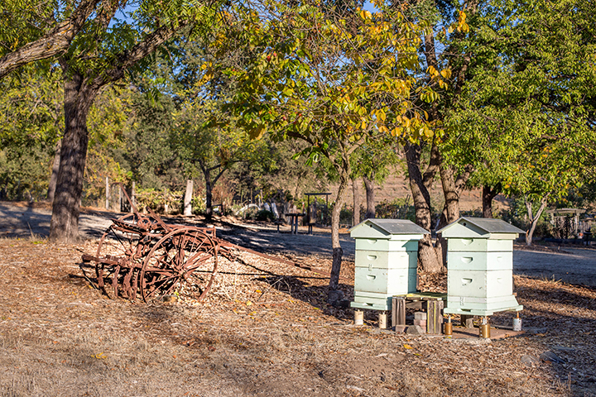
Howe Homestead Park in Walnut Creek
http://www.walnut-creek.org/Home/Components/FacilityDirectory/FacilityDirectory/18/665

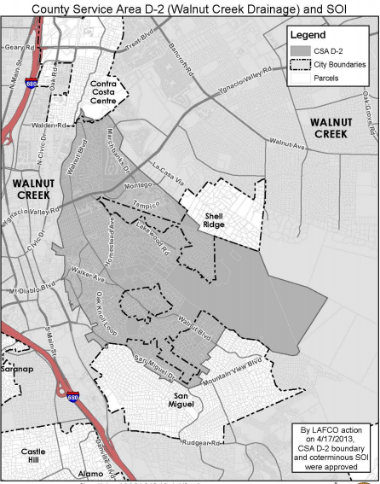
Map of County Service Area D-2 (Walnut Creek)
file:///C:/Users/cchist/Downloads/Sect%2004%20-%20County%20Service%20Areas%202015%20(1).pdf

County Service Area D-2 (Walnut Creek)

WEBSITE:
file:///C:/Users/cchist/Downloads/Sect%2004%20-%20County%20Service%20Areas%202015%20(1).pdf
file:///C:/Users/cchist/Downloads/Miscellaneous%20CSAs%20Final%204-17-13.pdf

ADDRESS: Public Works Department Flood Control Division County of Contra Costa 255 Glacier Drive Martinez, CA 94553-4897

E-MAIL: tjens@pw.cccounty.us

INFORMATION:
Year formed: 1968 Area
Area served: Walnut Creek Population
Population served: Approximately 8,700
Size: Approximately 2.45 square miles
Types of services provided: Master drainage plan, drainage corrections

ABOUT:
County Service Area D-2 was formed on December 31, 1968 as a dependent special district of the County. The CSA was formed at the request of residents to create a taxing entity to alleviate drainage basin flooding and drainage problems, and to seek federal funds. The area had been originally developed in the 1940s and 1950s without a storm drainage system or plans, and some of the homes were being inundated and some roads impassable due to frequent flooding.
CSA D-2 provides the financing for drainage infrastructure in the central portion of the city of Walnut Creek and adjacent unincorporated areas of San Miguel, Walnut Knolls, Wild Oak, and a portion of Shell Ridge.
The CSA’s primary revenue source is parcel fees paid when parcels initially develop or add impervious surface. Its revenues are extremely limited (less than $10,000 annually) because the area is built out. The CSA prepared a master plan in 1970 to address flooding problems in the area; although some planned improvements have been completed, much is left to be constructed. There are significant unfunded infrastructure needs and ongoing flooding affects some of the properties in the CSA.

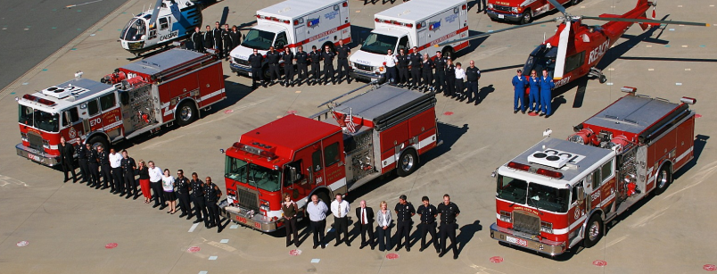
Fleet of Contra Costa County’s Emergency Medical Services
https://www.facebook.com/ContraCostaEMS/

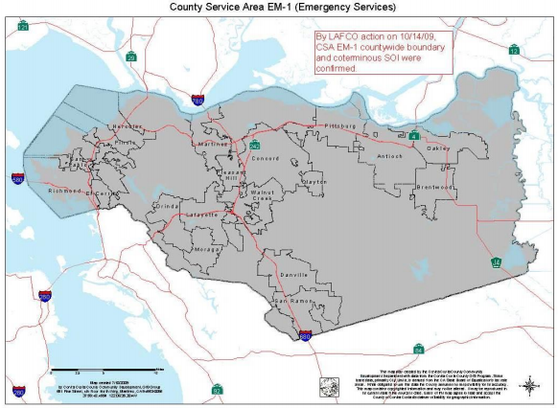
Map of County Service Area EM-1
file:///C:/Users/cchist/Downloads/Sect%2004%20-%20County%20Service%20Areas%202015%20(1).pdf

County Service Area EM-1 (Countywide)

WEBSITE:
https://cchealth.org/ems/feature-saving-lives.php#simpleContained3
file:///C:/Users/cchist/Downloads/Sect%2004%20-%20County%20Service%20Areas%202015%20(1).pdf

ADDRESS: Health Services Department, Emergency Medical Services, County of Contra Costa 1340 Arnold Drive, Suite 126 Martinez, CA 94553-4897

E-MAIL: partricia.frost@hsd.cccounty.us

INFORMATION:
Area served: Contra Costa County
Population served: Approximately 1,094,2051
Size: Approximately 720 square miles

ABOUT:
In 1988, the voters of Contra Costa County passed countywide Measure H providing for enhancements to the Emergency Medical System (EMS) including increased paramedic ambulance service, additional medical training and equipment for firefighter first responders, and an improved EMS communications system. Following a 71.6% affirmative vote, the Board of Supervisors formed County Service Area EM-1 in 1989. The formation of County Service Area EM-1 added six staffed paramedic ambulance units to respond to 9-1-1 calls; established a firefighter first responder defibrillation program and purchased and maintained automatic defibrillators for all fire response units; purchased and maintains medical supply caches for use in multi-casualty and disaster response; upgraded the radio system used for ambulance-to hospital communications; provided ambulances with radios for communication with fire first responders, and upgraded the ambulance dispatch system and dispatcher preparedness.
Types of services provided:
- Paramedic ambulance
- First-responder medical programs
- medical communications systems
- Trauma, EMS for Children, High Risk Heart Attack (STEMI), Stroke and Cardiac Arrest Systems of Care
- Medical Health Disaster Coordination
- HeartSafe Communities
- Public Access Defibrillation Programs
- Prehospital Patient Safety and Quality Improvement
- Prehospital Electronic Data Management and Enhancement

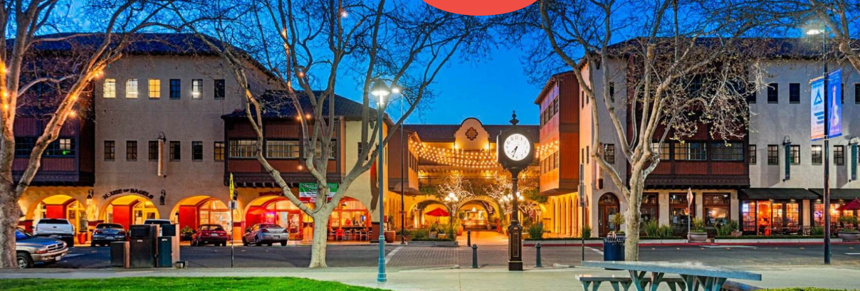
Todos Santos Plaza in Concord is Part of theL-100 Street Lighting District
https://www.visitconcordca.com/things-to-do/outdoors-nature/todos-santos-plaza/

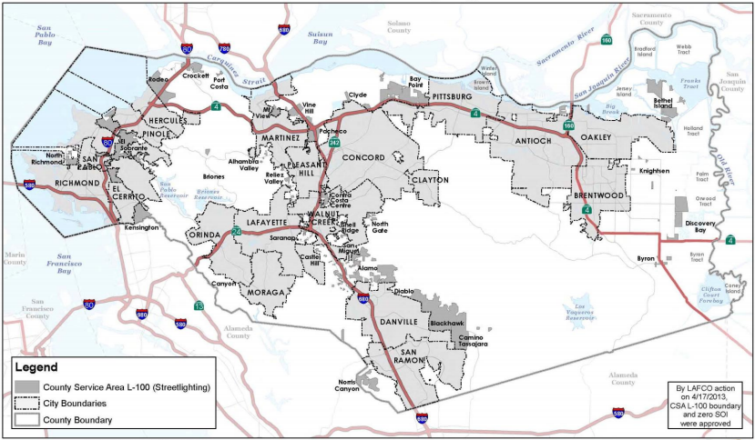
Map of County Service Area L-100
file:///C:/Users/cchist/Downloads/Sect%2004%20-%20County%20Service%20Areas%202015%20(2).pdf

County Service Area L-100 (Street Lighting)

WEBSITE:
file:///C:/Users/cchist/Downloads/Sect%2004%20-%20County%20Service%20Areas%202015%20(2).pdf
file:///C:/Users/cchist/Downloads/Miscellaneous%20CSAs%20Final%204-17-13.pdf

ADDRESS: Public Works Department Attn: Special Districts Unit County of Contra Costa 255 Glacier Drive Martinez, CA 94553-4897

E-MAIL: scohe@pw.cccounty.us

INFORMATION:
Year formed: 1986 (reorganized)
Area served: Contra Costa County
Population served: 1,042,300 (est.)
Size: Approximately 733 square miles in developed and developing portions of the unincorporated areas
Services provided: Public street lighting

ABOUT:

Community Service Area (CSA) L-100 was formed on September 10, 1986 as a dependent special district of Contra Costa County. Formed as part of a consolidation of four lighting CSAs, its stated purpose was to provide more efficient and cost effective street lighting services throughout the County. The scope of CSA L-100 extends only to operations and maintenance of streetlights. It does not include provisions for acquisition, upgrades, inflation, or increasing costs of maintenance. Though the majority of streetlights are owned and maintained by PG&E, the county does own 2,205 lights. The county’s response time for replacing and repairing their streetlights is an average of 29 days, as compared to 41 days for PG&E’s average response time.
At the time of formation in 1986, the CSA was the successor to former lighting CSAs L-32 (Kensington), L-42 (Central County), L-43 (East County), and L-46 (West County). The following year, the County proposed, and the Local Agencies Formation Commission (LAFCO) approved, the consolidation of CSAs M-3, M-7, M-12, M-13, M14, M-21, and M22 into CSA L-100, and transfer of street lighting service responsibility from CSAs M-16, M-20 and M-23 into CSA L-100.

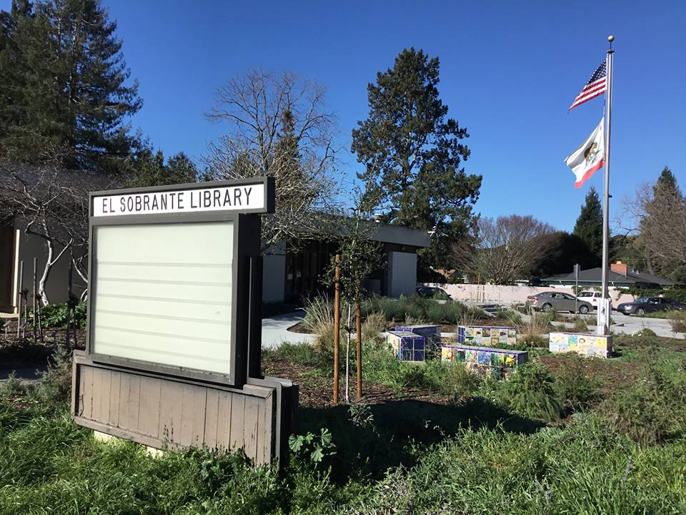
The El Sobrante Library
https://www.facebook.com/pg/elsobrantelibrary/

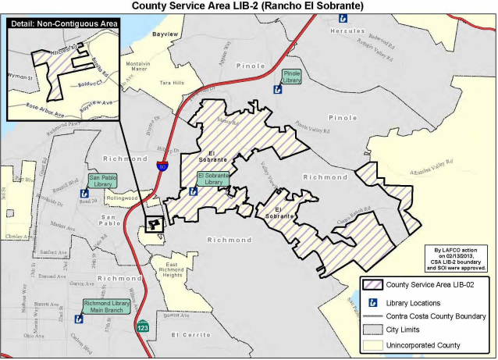
Map of County Service Area LIB-2
file:///C:/Users/cchist/Downloads/Sect%2004%20-%20County%20Service%20Areas%202015%20(1).pdf

County Service Area LIB-2 (CLOSED INDEFINITELY)

WEBSITE:

http://www.ccclib.org/
file:///C:/Users/cchist/Downloads/Sect%2004%20-%20County%20Service%20Areas%202015%20(1).pdf

ADDRESS: 1750 Oak Park Boulevard Pleasant Hill, CA 94523-4497

E-MAIL: llmartin@cclib.org

INFORMATION:
Year formed: 1958; El Sobrante Library was constructed in 1961
Area served: The unincorporated community of El Sobrante
Population served: 14,211
Size: Approximately 3.9 square miles
Services provided: Library services
ABOUT:
County Service Area (CSA) LIB-2 funds approximately 12 percent of operating costs at the El Sobrante Library. Locally-generated property taxes fund about 38 percent of operating costs; the remainder of the operating costs is funded by donations, grants and property taxes generated elsewhere in the County.
CSA LIB-2 does not directly own or operate facilities, but simply contributes funding for library operations and facilities. The El Sobrante Library is located less than two miles from the San Pablo Library. Both libraries have significant underfunded facility needs. There may be opportunities for the service areas to be combined and for the areas to share in a future replacement facility.
After a possible arson fire in early 2018, the library closed for repair. Despite notices in local papers that the library would re-open in spring of 2019, and then summer of 2019, the library remains closed with no definite plans to re-open as of September 2019.

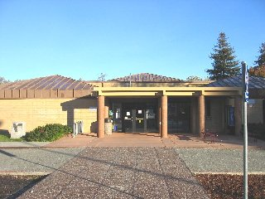
Pinole Library
http://www.waymarking.com/waymarks/WM4J0_Pinole_Library

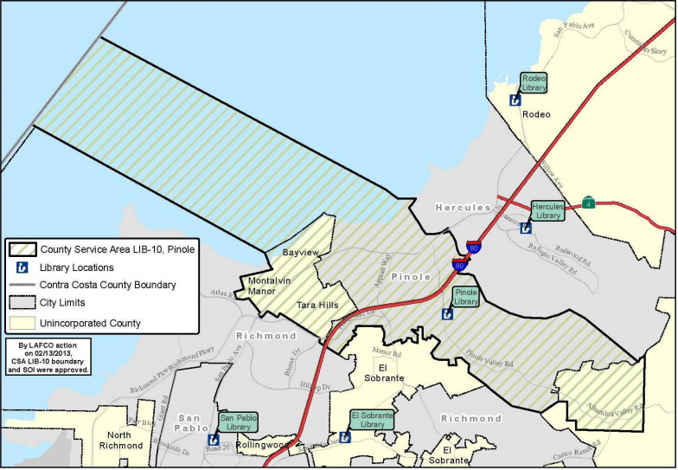
Map of County Service Area LIB-10
file:///C:/Users/cchist/Downloads/Sect%2004%20-%20County%20Service%20Areas%202015%20(2).pdf

County Service Area Lib-10 (City of Pinole)

WEBSITE:
https://ccclib.org/locations/pinole.html
file:///C:/Users/cchist/Downloads/Sect%2004%20-%20County%20Service%20Areas%202015%20(1).pdf

ADDRESS: 1750 Oak Park Boulevard Pleasant Hill, CA 94523-4497

E-MAIL: llmartin@cclib.org

INFORMATION:
Year formed: 1966; library built 1974
Area served: City of Pinole and nearby unincorporated areas
Population served: 28,146 within the
Size: Approximately 6.6 square miles of land area
Services provided: Library service funding

ABOUT:
County Service Area (CSA) LIB-10 funds an inconsequential portion of operating costs at the Pinole Library. Locally-generated property taxes fund about 41 percent of operating costs; the remainder of the operating costs is funded by donations, grants and property taxes generated elsewhere in the County.
CSA LIB-10 does not directly own or operate facilities, but simply contributes funding for library operations and facilities. The Pinole Library is located less than three miles from the Hercules Library, and three miles from the El Sobrante Library.

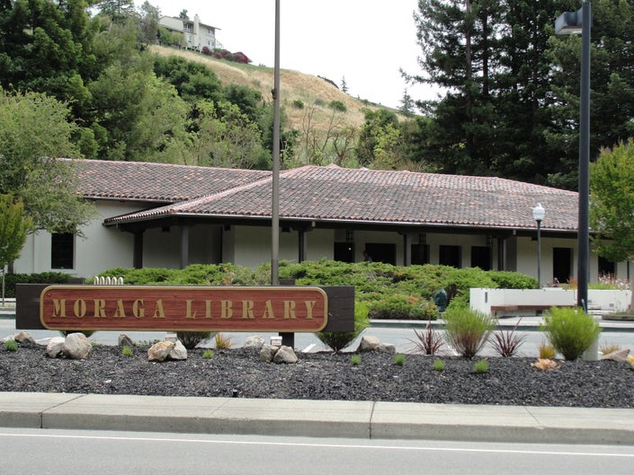
The Moraga Library
https://patch.com/california/lamorinda/friends-of-the-moraga-library-town-council-has-your-back

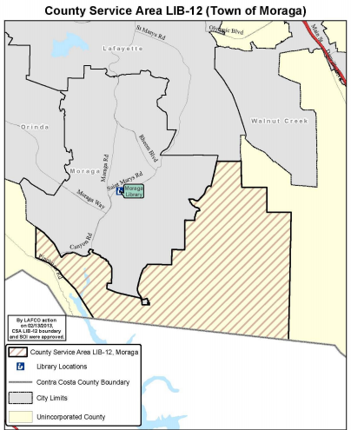
County Service Area LIB-12 Map
file:///C:/Users/cchist/Downloads/Sect%2004%20-%20County%20Service%20Areas%202015%20(2).pdf

County Service Area LIB-12 (Moraga Library)

WEBSITE:
http://www.ccclib.org/
file:///C:/Users/cchist/Downloads/Sect%2004%20-%20County%20Service%20Areas%202015%20(1).pdf

ADDRESS: 1750 Oak Park Boulevard Pleasant Hill, CA 94523-4497

E-MAIL: llmartin@cclib.org

INFORMATION:
Year formed: 1969; Moraga Library was built in 1974 and is owned by the Town of Moraga. Area Served: The Town of Moraga
Population served: 125 within the CSA; 16,465 served by Moraga Library (2010)
Size: Approximately 8.3 square miles
Services provided: Library services

ABOUT:
County Service Area (CSA) 12 funds approximately one percent of the Moraga Library’s operating costs. Locally generated property taxes fund about 49 percent of operating costs; the remainder of the operating costs is funded by donations, grants and property taxes generated elsewhere in the County.
The facility needs to be improved and remodeled, although capital improvements there are not presently funded or planned. CSA LIB-12 is not directly responsible for financing these facility needs, and its present revenue sources would not cover a significant portion of associated costs.
CSA LIB-12 does not directly own or operate facilities, but simply contributes funding for library operations and facilities. No facility sharing opportunities were identified.

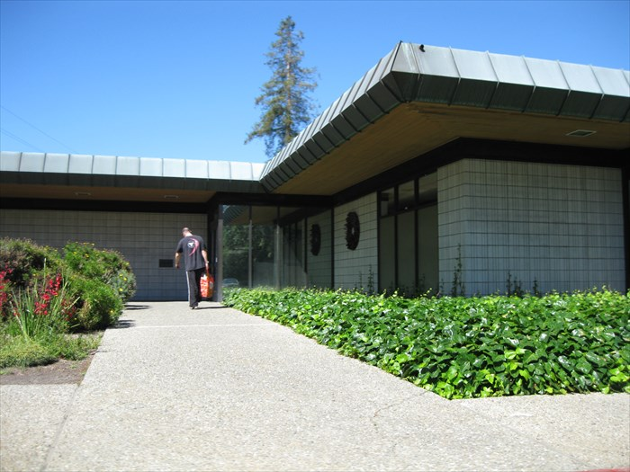
The Ygnacio Valley Library
http://www.waymarking.com/waymarks/WM9007

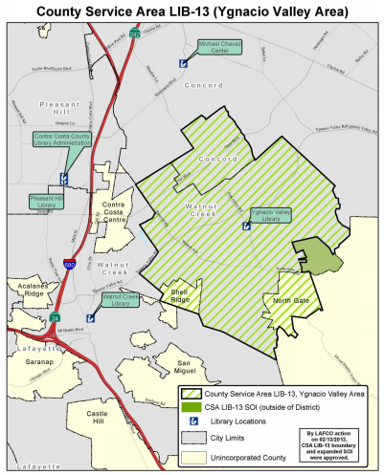
County Service Area LIB-13 Map
file:///C:/Users/cchist/Downloads/Sect%2004%20-%20County%20Service%20Areas%202015%20(2).pdf

County Service Area LIB-13 (Cities of Concord and Walnut Creek)

WEBSITE:
http://www.ccclib.org/
file:///C:/Users/cchist/Downloads/07%20-%20Library%20Services%20MSR%20and%20SOI%20Updates.pdf

ADDRESS: 1750 Oak Park Boulevard Pleasant Hill, CA 94523-4497

E-MAIL: llmartin@cclib.or

INFORMATION:
Year formed: 1970. The former Walnut Creek Library was built in 1961 and demolished in 2008. The current Walnut Creek Library opened in 2010 and is owned by the City of Walnut Creek. The Ygnacio Valley Library was built in 1975 and is owned by Contra Costa County.
Area Served: Portions of the cities of Walnut Creek and Concord and nearby unincorporated areas
Population Served: 20,402
Size: Approximately 9.0 square miles
Services provided: Library services

ABOUT:
County Service Area (CSA) LIB-13 funds seven percent of operating costs at the Ygnacio Valley Library. Locally generated property taxes fund about 51 percent of the operating costs; the remainder of the operating costs is funded by City of Walnut Creek contributions, donations, and grants.
The Ygnacio Valley Library has $6.3 million in unfunded infrastructure needs. The facility needs to be expanded and remodeled, although capital improvements are not presently funded or planned. CSA LIB-13 is not directly responsible for financing these facility needs, and its present revenue sources would not cover a significant portion of associated costs. LIB-13 does not directly own or operate facilities, but simply contributes funding for library operations and facilities.

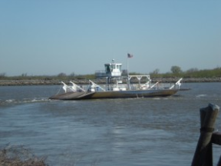
The Delta Ferry
https://bradfordisland.com/ferry-info/

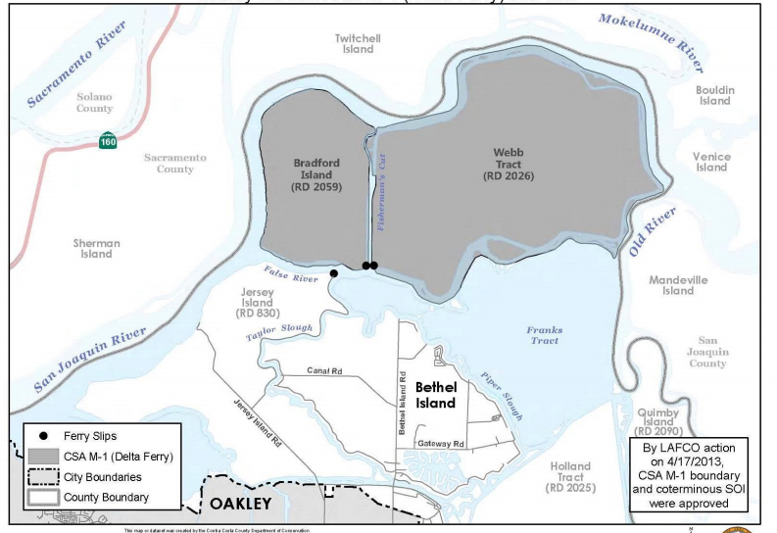
Map of County Service Area M-1 (Delta Ferry)
file:///C:/Users/cchist/Downloads/Sect%2004%20-%20County%20Service%20Areas%202015%20(2).pdf

County Service Area M-1 (Delta Ferry)

WEBSITE:
https://bradfordisland.com/ferry-info/
file:///C:/Users/cchist/Downloads/Sect%2004%20-%20County%20Service%20Areas%202015%20(2).pdf
https://www.discoverthedelta.org/ferries/

ADDRESS: Delta Ferry Authority Attn: David Forkel 1330 Arnold Dr., Suite 142 Martinez, CA 94553

E-MAIL: dforkel@deltawetlands.com

INFORMATION:
Year formed: 1960
Area served: East Contra Costa County (Bradford Island/Webb Tract Island)
Population served: less than 100
Size: Ferry Route; approximately 13.56 square miles
Services provided: Ferry between Bradford, Jersey and Webb Tract Islands

ABOUT:
This service area provides a ferry service for a population of less than 100 people between Bradford Island, Jersey Island, and Webb Tract. Bradford Island and Webb Tract split the operating costs of the Delta Ferry 50/50.
The Victory II is a handsome free-running ferry that takes vehicles from Jersey Island to both Webb Tract and Bradford Island. This is one of only two ferries in the Delta that do not go to private land, which means it is one of two ferries in the Delta that can be taken by the public.

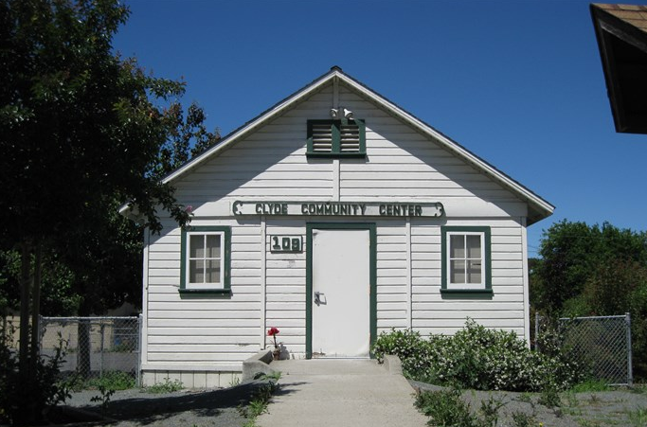
Clyde Community Center
http://www.waymarking.com/gallery/image.aspx?f=1&guid=147c9614-9a21-4bb4-b78f-b5a401fb6c83

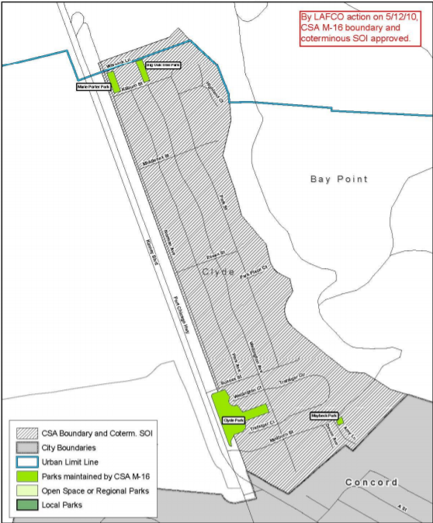
Map of County Service Area M-16 (Community of Clyde)
file:///C:/Users/cchist/Downloads/Sect%2004%20-%20County%20Service%20Areas%202015%20(3).pdf

County Service Area M-16 (Community of Clyde)

WEBSITE:
file:///C:/Users/cchist/Downloads/Sect%2004%20-%20County%20Service%20Areas%202015%20(10).pdf
file:///C:/Users/cchist/Downloads/Miscellaneous%20CSAs%20Final%204-17-13.pdf

ADDRESS: Public Works Department, Attn: Special Districts Unit County of Contra Costa, 255 Glacier Drive Martinez, CA 94553-4897

E-MAIL: scohe@pw.cccounty.us

INFORMATION:

Year formed: 1964 (as L-44), 1972 (changed to M-16)
Area served: Community of Clyde
Population served: 290
Residential dwelling units size: Approximately .14 square miles
Services provided: Public parks, recreation and landscaping for Clyde

ABOUT:

The governing board of County Service Area (CSA) M-16 is the Board of Supervisors. This board is advised by a Citizens Advisory Committee, who, along with advising the Board of Supervisors, also advises county administrative departments on the desires of the community in regards to street lighting facilities and services and recreation and park services in the unincorporated community of Clyde.

Parks that are maintained by CSA M-16 are Clyde Park, Maybeck Park, Big Oak Tree Park, and Marie Porter Park.

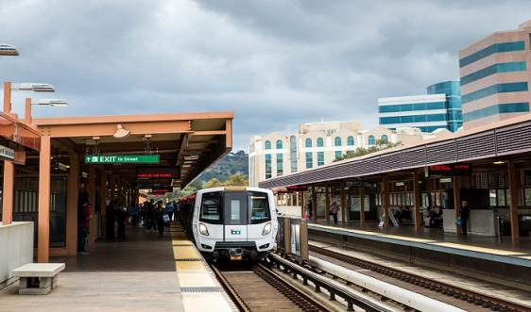
Pleasant Hill BART Station
https://www.bart.gov/stations/phil

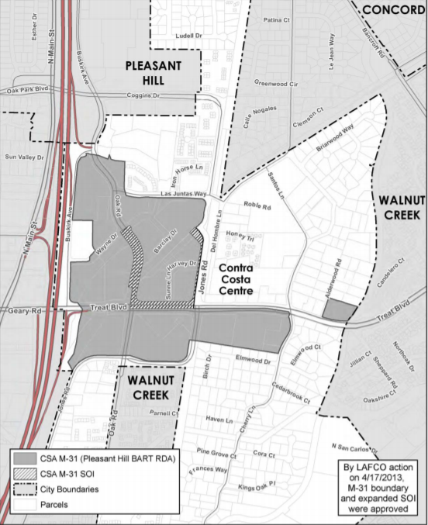
Map of County Service Area M-31-Pleasant Hill BART
file:///C:/Users/cchist/Downloads/Sect%2004%20-%20County%20Service%20Areas%202015%20(1).pdf

County Service Area M-31- Pleasant Hill BART

WEBSITE:
https://www.bart.gov/stations/phil
file:///C:/Users/cchist/Downloads/Miscellaneous%20CSAs%20Final%204-17-13.pdf

ADDRESS: Public Works Department, Attn: Special Districts Unit County of Contra Costa, 255 Glacier Drive Martinez, CA 94553-4897

E-MAIL: scohe@pw.cccounty.us

INFORMATION:

Year formed: 2002
Area served: Pleasant Hill BART and surrounding area
Population served: All commercial Size: Approximately 73 acres or 0.11 square mile
Services provided: Continued Transportation Demand Management Program (TDM) for the Pleasant Hill BART Redevelopment

ABOUT:

County Service Area (CSA) M-31 finances transportation demand management (TDM) services to commercial office properties in Contra Costa Centre. To mitigate traffic impacts, entitlement conditions include a requirement to show that at least 30 percent of full-time employees are using public transit, carpools, vanpools, walking, or bicycling as a mode of transportation. Each property was also required to participate in an area-wide TDM program, and to approve an assessment to fund TDM services. There are now 4,000-5,000 employees working at the commercial properties in the CSA.

The CSA funds services that are provided directly by a non-profit agency, the Contra Costa Centre Association (CCCA), that is governed by the affected property owners. CCCA provides transit subsidies and incentives for employees to use carpools, vanpools, and bicycle or walk to work; about four percent of employees in the CSA use these financial incentive programs. CCCA also provides a mid-day shuttle to nearby malls, and provides employees with access to its fleet of environmentally-friendly vehicles.

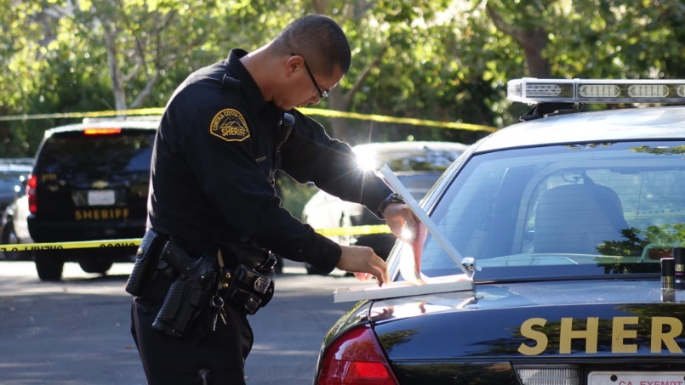
County Service Area P-2 provides extended police services to Blackhawk and Alamo
http://www.danvillesrupdates.com/story/blackhawk-man-stabbed-by-elderly-neighbor-wednesday-night

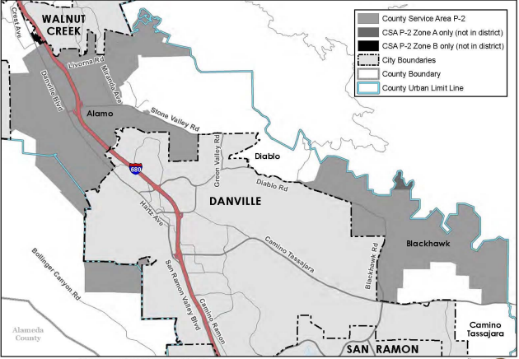
Map of County Service Area P-2 – Alamo and Blackhawk
file:///C:/Users/cchist/Downloads/Sect%2004%20-%20County%20Service%20Areas%202015%20(1).pdf

County Service Area P-2 (Blackhawk & Alamo)

WEBSITE:
http://www.cocosheriff.org/bureaus/field_operations/patrol/blackhawk.htm
http://www.contracostalafco.org/municipal_service_reviews/miscellaneous-county-service-areas/Miscellaneous%20CSAs%20Final%204-17-13.pdf

ADDRESS: Office of the Sheriff Contra Costa County
Zone A: 1092 Eagle Nest Place Danville, CA 94507
Zone B: 150 Alamo Place #C Alamo, CA 94507

E-MAIL: earbu@so.cccounty.us

INFORMATION:
Year formed: 1970
Area served: Blackhawk and Alamo Population
Population served: Approximately 8,700
Size: Approximately 11.5 square miles
Services provided: Police protection services

ABOUT:
The County Services Area P-2 Citizens Advisory Committee advises the Board of Supervisors on the needs of the Blackhawk community for extended police services which shall include, but not be limited to, enforcement of the State Vehicle Code, crime prevention, litter control, and other issues.
County Service Area (CSA) P-2 was formed in 1981 to provide financing for enhanced police services in the Blackhawk, Alamo and west Danville unincorporated areas. CSA P-2 is a dependent special district in which the County Board of Supervisors (Board) is the Board of Directors for the district. Administrative staffing for the District is provided by the Office of the Sheriff.

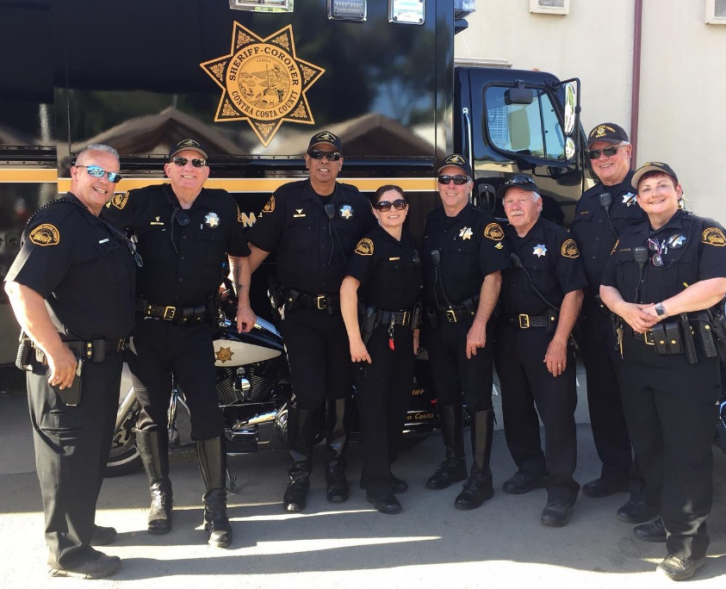
Extended police protection is provided to unincorporated areas of the County
http://www.cocosheriff.org/images/Reserve%20Deputy/IMG_3094_(1)e.jpg

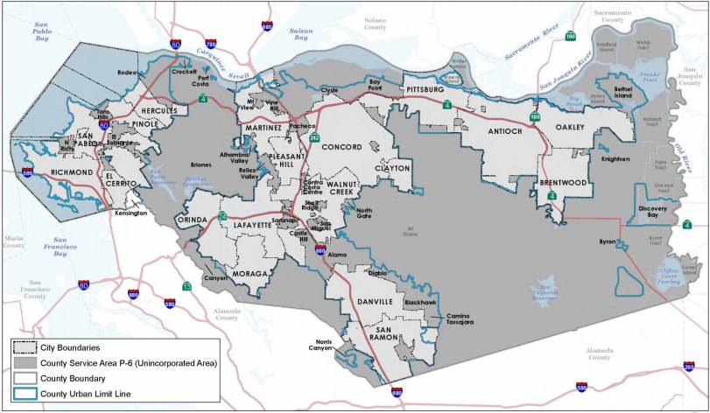
Map of County Service Area P-6 (Unincorporated Areas)
file:///C:/Users/cchist/Downloads/Sect%2004%20-%20County%20Service%20Areas%202015%20(1).pdf

County Service Area P-6 (Unincorporated Area)

WEBSITE:
http://64.166.146.245/docs/2015/PBP/20150309_602/612_March%202015%20PPC%20Packet.pdf

ADDRESS: Office of the Sheriff, 651 Pine Street, Sixth Floor Martinez, CA 94553

E-MAIL: earbu@so.cccounty.us

INFORMATION:
Year formed: 1983
Area served: Countywide; most unincorporated areas
Size: Approximately 491 square miles
Services provided: Extended police protection services in the unincorporated areas of the County, excluding Kensington
ABOUT:
On July 19, 1983, the Board of Supervisors approved formation of County Service Area (CSA) P-6 to provide for additional financial resources for the provision of police protection services in the unincorporated area of the County with the exception of the Kensington Community Services District.
CSA P-6 is a special district authorized by the County Service Area Law commencing with Government Code section 25210 and is governed by the County Board of Supervisors. The District is administered by the Sheriff's Office with legal counsel provided by County Counsel and Clerk of the Board services provided by Contra Costa County.

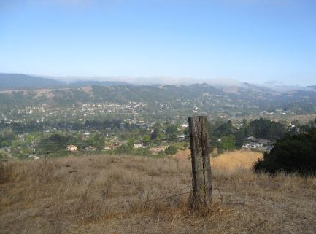
View from Old Moraga Ranch Trails
http://www.moragaparks.org/TrailsGuide.html

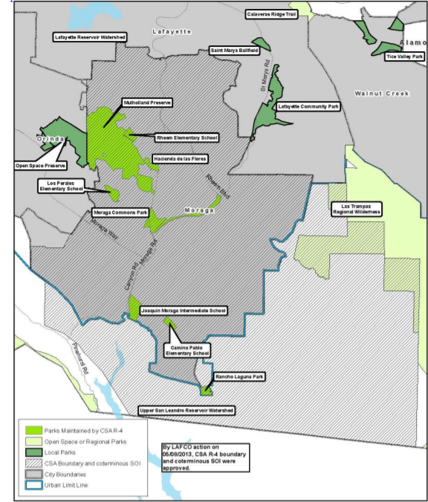
Map of County Service Area R-4 (Moraga)
file:///C:/Users/cchist/Downloads/Sect%2004%20-%20County%20Service%20Areas%202015%20(1).pdf

County Service Area R-4 (Moraga)

WEBSITE:
www.moraga.ca.us
ADDRESS: 329 Rheem Blvd., Moraga, CA 94556
E-MAIL: manager@moraga.ca.us
INFORMATION:
Year formed: 1971
Area served: Town of Moraga
Size: Approximately 17.6 square miles
Population served: 16,016
Services provided: Public parks and recreation in the Town of Moraga
ABOUT:
CSA R-4, formed on December 1, 1970, provides financing for augmented operation and maintenance of park and recreation facilities and recreation programming in the incorporated Town of Moraga, for the unincorporated area to the southeast of the Town.
The CSA bounds encompass the incorporated Town of Moraga and an unincorporated area to the southeast of the Town. The unincorporated area is primarily zoned as agricultural land with parcels of at least five acres and limited residential parcels of at least 15,000 to 20,000 square feet. A majority of the property in the unincorporated area is owned by East Bay Municipal Utility District.
The CSA is a dependent special district of the County, and is not a land use authority. The County is the land use authority in the unincorporated area, while the Town of Moraga is the land use authority within the Town’s limits. These agencies hold primary responsibility for implementing growth strategies.

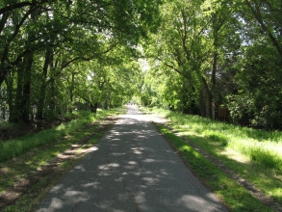
Part of the Iron Horse Trail that runs through Alamo
https://alamoeastbay.wordpress.com/local-hot-spots/parks-and-recreation/

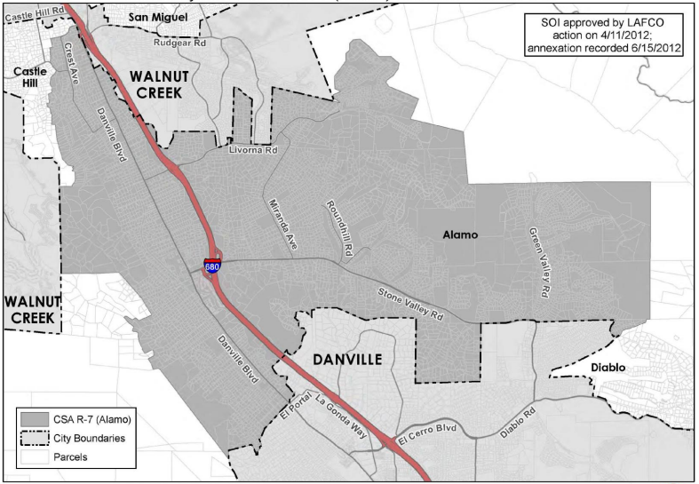
Map of County Service Area R-7 (Alamo)
file:///C:/Users/cchist/Downloads/Sect%2004%20-%20County%20Service%20Areas%202015%20(1).pdf

County Service Area R-7 (Alamo)

WEBSITE:
www.co.contra-costa.ca.us
ADDRESS: Public Works Department, Attn: Special Districts Unit County of Contra Costa, 255 Glacier Drive Martinez, CA 94553-4897
INFORMATION:
Year formed: 1971 (killed by election; new formation in 1984)
Area served: Alamo
Population served: 13,395
Size: Approximately 20.58 square miles
Services provided: Parks, trails, recreation, landscaping and related facilities development, operation, and maintenance for unincorporated Alamo
ABOUT:
County Service Area (CSA) R-7 was formed on July 9, 1974 as a dependent special district of the County. The bounds of CSA R-7 encompass the unincorporated community of Alamo to the north of the Town of Danville and south of the City of Walnut Creek, excluding the Round Hill Area.
CSA R-7 provides park and recreation facility operation and maintenance and recreation programming. Park maintenance services within the CSA are provided in conjunction with multiple other service providers Additionally, recreation programming is provided by the CSA. Recreation programming includes a free summer concert series, youth entertainment at the annual Rotary Alamo Music Festival, an annual doggie day, and an annual multi-cultural festival.

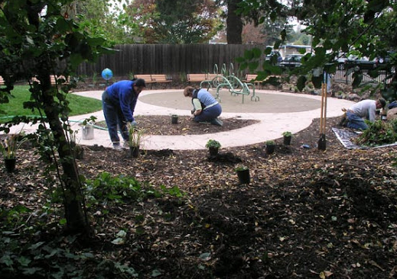
Library’s Children Reading Garden
https://sites.google.com/site/spawnersofelsobrante/home/gallery/library-s-children-reading-garden?overridemobile=true

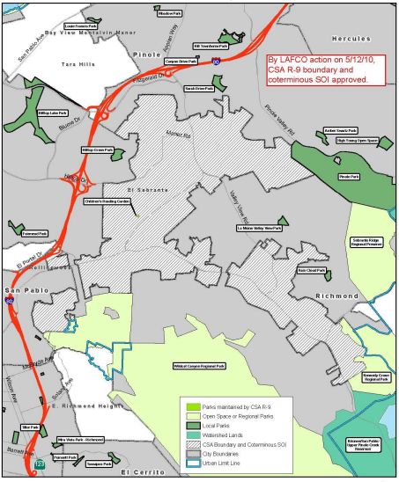
Map of County Service Area R-9 (El Sobrante)
file:///C:/Users/cchist/Downloads/Sect%2004%20-%20County%20Service%20Areas%202015%20(1).pdf

County Service Area R-9 (El Sobrante)

WEBSITE:
http://www.co.contra-costa.ca.us
ADDRESS: Public Works Department, Attn: Special Districts Unit County of Contra Costa, 255 Glacier Drive Martinez, CA 94553-4897
E-MAIL: scohe@pw.cccounty.us
INFORMATION:
Year formed: 1974
Area served: El Sobrante Valley including parts of Richmond population
Served: 12,260 people
Size: Approximately 3.1 square miles
Services provided: Parks and recreation
ABOUT:
CSA R-9 was formed on December 17, 1974 as a dependent special district of the County. It is located immediately south of the City of Pinole, adjacent to the City of Richmond in the east, west and south, with the southwest corner of the CSA abutting the City of San Pablo.
Parks and recreation facilities serving the CSA include the Children’s Reading Garden located at the county library in El Sobrante. The garden’s construction was completed in 2007 and offers an area for children to read and an area for public reading events. The County reported that the garden is in good condition. No needs or deficiencies were identified for the garden.
The CSA has no regular source of financing, lacks public interest to fill advisory committee positions, and provides minimal services at a less than adequate service level. The County reported that it is amenable to exploring options, including dissolution of this CSA, if a better and more efficient funding source is available to provide the same services to the public.
As the El Sobrante library is indefinitely closed following a fire in early 2018, the reading garden is not accessible. This CSA is essentially defunct.

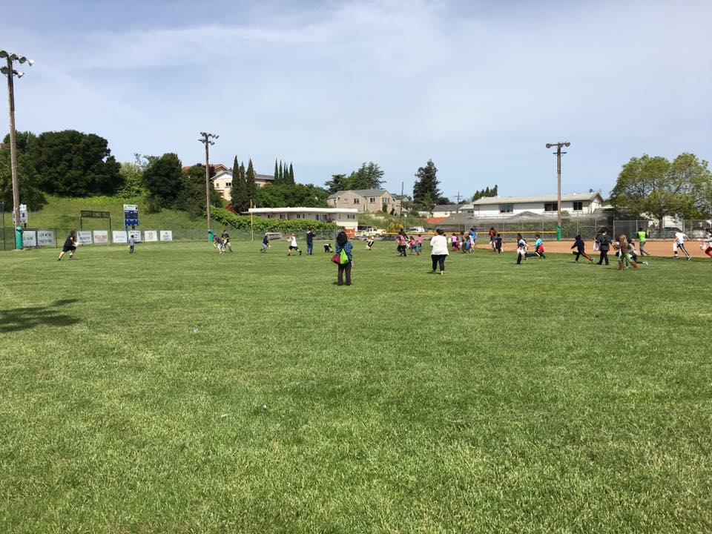
Egg hunt located at Left Gomez Recreation Center and Ball Field, Rodeo, CA
https://www.facebook.com/pg/City-of-Rodeo-Parks-and-Recreation-R-10-148086075288797/about/?ref=page_internal

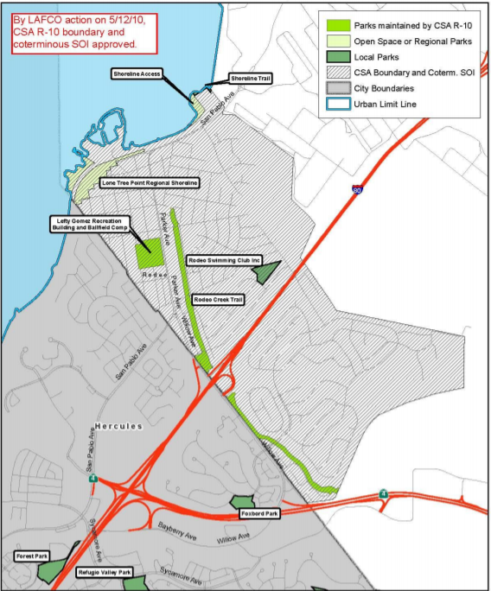
Map of County Service Area R-10 (Rodeo)
file:///C:/Users/cchist/Downloads/Sect%2004%20-%20County%20Service%20Areas%202015%20(1).pdf

County Service Area R-10 (Rodeo)

WEBSITE:
www.co.contra-costa.ca.us
ADDRESS: Public Works Department, Attn: Special Districts Unit County of Contra Costa, 255 Glacier Drive Martinez, CA 94553-4897
E-MAIL: scohe@pw.cccounty.us
INFORMATION:
Year formed: 1987
Area served: Rodeo
Population served: 6,862
Size: Approximately 7.37 square miles
Services provided: Recreation services through the operation of the Lefty Gomez Community Center facility and its baseball fields
ABOUT:
CSA R-10 was formed on June 24, 1988 as a dependent special district of the County. It lies immediately adjacent to the northeastern boundary of the City of Hercules. The area within the CSA is primarily residential with some commercial activity in the northwest corner of the District along Parker Avenue.
CSA R-10 provides operation and maintenance of park and recreation facilities and recreation programming in the unincorporated community of Rodeo. All services provided by the CSA are supplied by contract providers, including community center coordination, recreation programming and facility maintenance. Recreation programming at the Lefty Gomez Recreation Center and ball fields is offered by the Rodeo Baseball Association and private instructors. Classes in the recreation center include sewing, painting for children, jewelry making, and oil painting. In addition, the CSA advisory committee coordinates annual events that are open to the public.

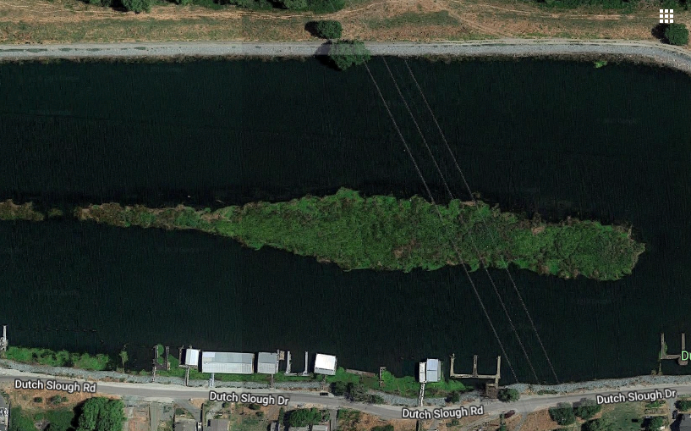
Google Earth view of RD-4 portion of Dutch Slough Road
https://www.google.com/maps/place/Dutch+Slough+Rd,+California+94561/@38.0125639,-121.6518904,292m/data=!3m1!1e3!4m5!3m4!1s0x8085555de217f5dd:0xf5af94d6e29903ee!8m2!3d38.0118905!4d-121.6486843
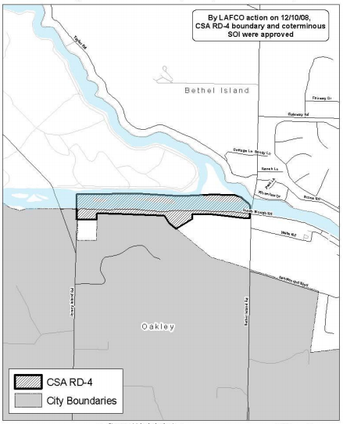
Map of County Service Area RD-4 (Vicinity of Bethel Island)
file:///C:/Users/cchist/Downloads/Sect%2004%20-%20County%20Service%20Areas%202015%20(1).pdf

County Service Area RD-4 (Vicinity of Bethel Island)

WEBSITE:
file:///C:/Users/cchist/Downloads/Sect%2004%20-%20County%20Service%20Areas%202015%20(1).pdf

ADDRESS: Public Works Department, Attn: Special Districts Unit, County of Contra Costa, 255 Glacier Drive Martinez, CA 94553-4897

E-MAIL: scohe@pw.cccounty.us

INFORMATION:
Year formed: 1973
Area served: Bethel Island
Population served: 61 Residential Dwelling Units
Size: Approximately 3.45 linear miles
Services provided: Road Maintenance (maintains Dutch Slough Road, Jersey Island Road to Bethel Island Road)

ABOUT:

County Service Area RD-4, in the vicinity of Bethel Island, was created in 1974. It encompasses less than one square mile and maintains approximately 3.45 linear miles of Dutch Slough Road extending from Jersey Island Road on the west to Bethel Island Road on the east. The District is part of an area known as the Hotchkiss Tract that was recently considered for annexation to the City of Oakley as one of the Cypress Corridor proceedings.
The District provides road maintenance services, including: highway and bridge construction, improvement, and maintenance, including related drainage facilities and structures, and necessary design and engineering services.

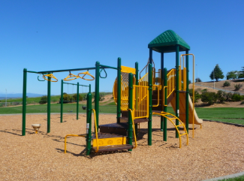
Montalvin Park
https://www.contracosta.ca.gov/Facilities/Facility/Details/Montalvin-Park-5

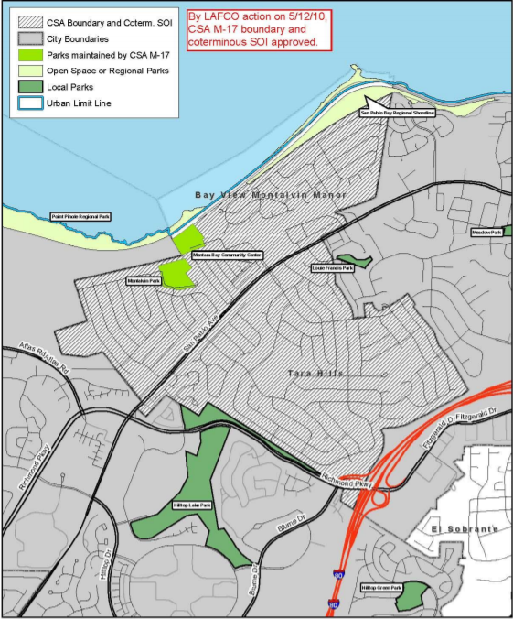
Map of County Service Area M-17 (West County)
file:///C:/Users/cchist/Downloads/Sect%2004%20-%20County%20Service%20Areas%202015%20(1).pdf

County Service Area M-17 (West County)

WEBSITE:
www.co.contra-costa.ca.us
INFORMATION:
ADDRESS: Public Works Department, Attn: Special Districts Unit, County of Contra Costa, 255 Glacier Drive Martinez, CA 94553-4897
E-MAIL: scohe@pw.cccounty.us
INFORMATION:
Year formed: 1965
Area served: Tara Hills, Bayview, & Montalvin Manor in West County
Population served: 2,794 Residential Dwelling Units
Size: Approximately 1.3 square miles
Services provided: Operates parks and community center for the West Contra Costa County area of Tara Hills, Montalvin Manor, and Bayview
ABOUT:
CSA M-17 was formed on January 26, 1965 as a dependent special district of the County. The boundary area of the CSA is approximately 1.3 square miles, or approximately 832 acres. Since formation, there have been six boundary changes to the CSA according to LAFCO records. In 1971, the CSA annexed County Sanitation District Number 3. All of the subsequent boundary changes were reorganizations that annexed territory to the City of Pinole and resulted in a detachment from the CSA.

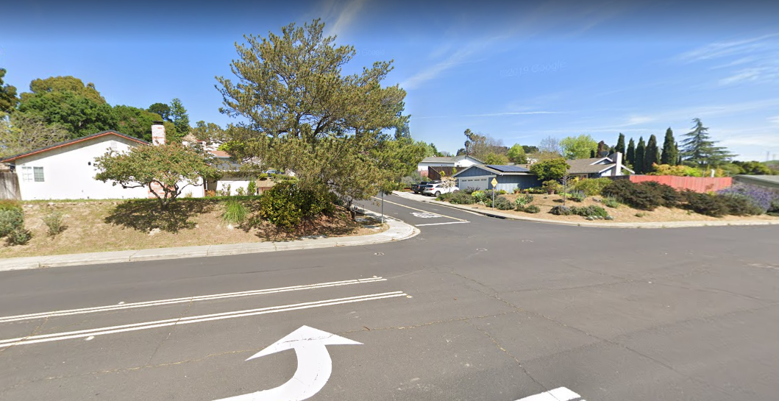
Google Earth Street View of the Viewpointe Subdivision
https://www.google.com/maps/@38.0219154,-122.2566156,3a,75y,80.69h,84.75t/data=!3m6!1e1!3m4!1sztbOhV8kv9PR-VjZlws4AQ!2e0!7i16384!8i8192
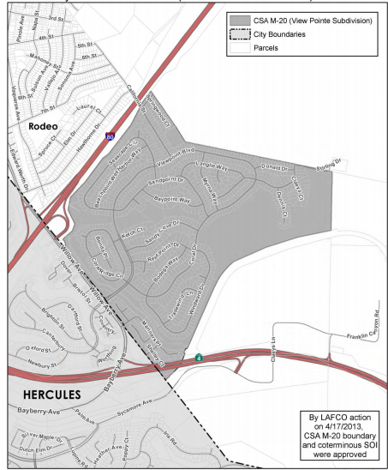
Map of County Service Area M-20 – View Pointe Subdivision
file:///C:/Users/cchist/Downloads/Sect%2004%20-%20County%20Service%20Areas%202015%20(1).pdf

County Service Area M-20 (View Pointe Subdivision)

WEBSITE:
file:///C:/Users/cchist/Downloads/Sect%2004%20-%20County%20Service%20Areas%202015%20(1).pdf
file:///C:/Users/cchist/Downloads/Miscellaneous%20CSAs%20Final%204-17-13.pdf
ADDRESS: Public Works Department, Attn: Special Districts Unit, County of Contra Costa, 255 Glacier Drive Martinez, CA 94553-4897
E-MAIL: scohe@pw.cccounty.us
INFORMATION:
Year formed: 1973
Area served: View Pointe Subdivision, Rodeo
Population served: 1,084 Residential Dwelling Units
Size: Approximately 0.6 square mile
Services provided: Parkway maintenance

ABOUT:
County Service Area (CSA) M-20 was formed on April 8, 1973 as a dependent special district of the County, in order to provide street lighting, street sweeping and parkway maintenance services to the View Pointe subdivision. In 1987, the CSA’s street lighting function was transferred to the authority of CSA L-100. The northern and eastern boundary follows the subdivision bounds, extending to the northeast to include Viewpoint Blvd.; the subdivision is bounded on the north and east by the Contra Costa Carbon Plant.
Financed primarily through property taxes, CSA M-20 provides weekly tree trimming services for parkway trees along the north side of Willow Avenue between Mariner’s Point and the I-80 on-ramp. On average, two crew members from the County Public Works Department spend about one hour weekly trimming the trees, as part of their maintenance route.

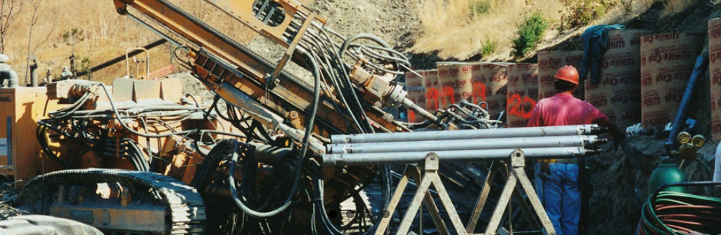
Geologic Hazzard Abatement Equipment in Blackhawk
https://blackhawkghad.com/

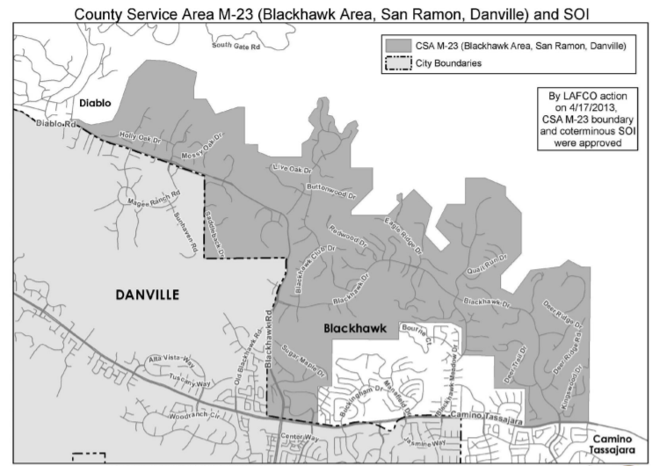
Map of County Service Area M-23
file:///C:/Users/cchist/Downloads/Sect%2004%20-%20County%20Service%20Areas%202015%20(1).pdf

County Service Area M-23 (Blackhawk Area, San Ramon, Danville)

WEBSITE:
file:///C:/Users/cchist/Downloads/Sect%2004%20-%20County%20Service%20Areas%202015%20(1).pdf
file:///C:/Users/cchist/Downloads/Miscellaneous%20CSAs%20Final%204-17-13.pdf

ADDRESS: Public Works Department, Attn: Special Districts Unit, County of Contra Costa, 255 Glacier Drive Martinez, CA 94553-4897

E-MAIL: scohe@pw.cccounty.us

INFORMATION:
Year formed: 1977
Area served: Blackhawk, San Ramon and Danville
Population served: 2,696 Residential Dwelling Units
Size: Approximately 4.34 square miles
Services provided: Abate geologic hazards, maintain drainage facilities

ABOUT:

CSA M-23 provides funding for drainage maintenance and geologic hazard abatement services in the unincorporated area of Blackhawk. Geological hazard abatement services provide prevention, mitigation, control, and abatement of geological hazards such as earthquakes, landslides, or soil erosion. The service area includes six gated communities, and is located at the base of Mount Diablo. Funded by property taxes, the CSA’s annual revenues are $1.7 million.
The CSA spends 97 percent of its budget on geologic hazard abatement services, as the clay soils and slopes in the area are conducive to landslides after heavy rains. The CSA-funded Blackhawk Geologic Hazard Abatement District (GHAD) has accumulated enough financial reserves to address extraordinary landslide needs in the event of an El Niño or a very heavy rain.

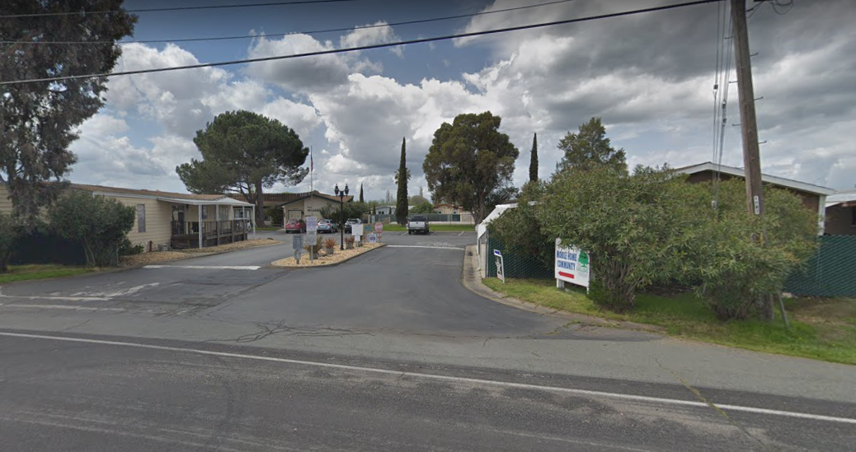
Google Earth Image of Willows Mobile Home Park on Bethel Island
https://www.google.com/maps/@38.0383953,-121.6291106,3a,60y,245.38h,85.92t/data=!3m6!1e1!3m4!1sNojIGNMgaJDDBR8InzKP0A!2e0!7i16384!8i8192

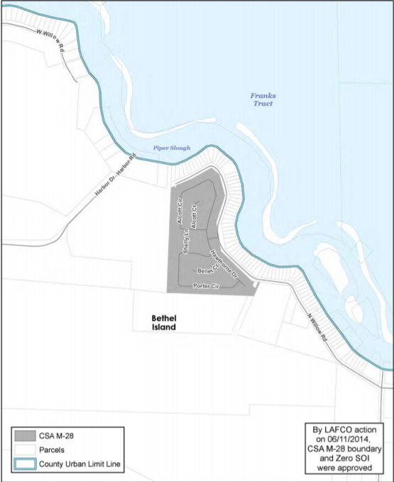
Map of County Service Area M-28 (Bethel Island)
file:///C:/Users/cchist/Downloads/Sect%2004%20-%20County%20Service%20Areas%202015%20(1).pdf

County Service Area M-28 (Bethel Island)

WEBSITE:
file:///C:/Users/cchist/Downloads/Sect%2004%20-%20County%20Service%20Areas%202015%20(1).pdf
http://64.166.146.245/docs/2018/BOS/20180605_1112/33168_CSA_M-28_18-19_TAR.pdf

ADDRESS: Public Works Department, Attn: Special Districts Unit, County of Contra Costa, 255 Glacier Drive Martinez, CA 94553-4897

E-MAIL: scohe@pw.cccounty.us

INFORMATION:

Year formed: 1991
Area served: Bethel Island
Population served: Mobile Home Park with 182 spaces
Size: Less than one acre
Services provided: Operate and maintain domestic water treatment system

ABOUT:
On December 10, 1991 the Contra Costa Board of Supervisors approved and formed County Service Area M-28 (Willow Mobile Home Park Water District), in order to ensure the proper flow of funds for the ongoing operation, maintenance, and servicing of community water system services within the Bethel Island Area. CSA M-28 has been given the power to acquire, construct, operate, replace, maintain, and repair a water supply and distribution system.
The funding for CSA M-28 comes from service charges which are obtained from the users of the water system. In fiscal year 2015-2016, CSA M-28 made improvements to the aging system and infrastructure. Some of the improvements completed included the upgrade of the auto-dialer alarm system, installation of a flow-based chlorine injection pump system, and installation of new wiring to the well pump. In fiscal year 2016-2017, CSA M-28 also replaced the existing well pump and upgraded its emergency response options.

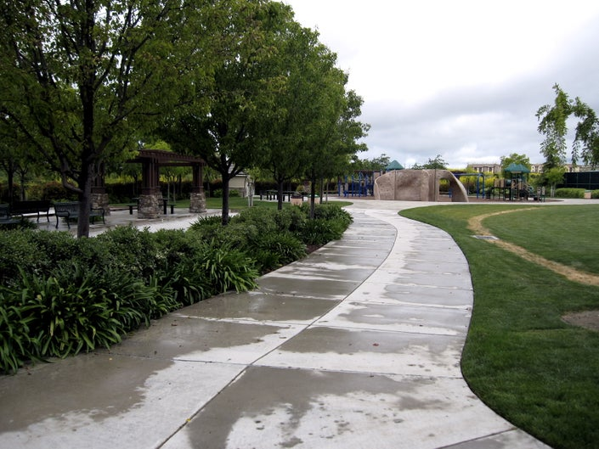
Souyen Park in San Ramon
https://patch.com/california/sanramon/park-of-the-week-souyen-park

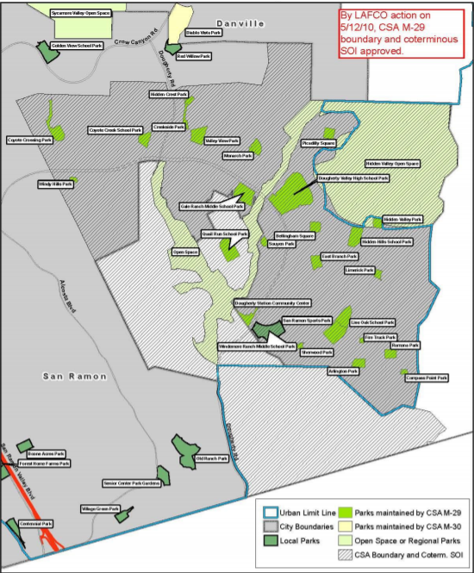
Map of County Service Area M-29 (San Ramon, Dougherty Valley)
file:///C:/Users/cchist/Downloads/Sect%2004%20-%20County%20Service%20Areas%202015%20(1).pdf

County Service Area M-29 (San Ramon, Dougherty Valley)

WEBSITE:
file:///C:/Users/cchist/Downloads/Sect%2004%20-%20County%20Service%20Areas%202015%20(1).pdf
www.co.contra-costa.ca.us
ADDRESS: Public Works Department, Attn: Special Districts Unit, County of Contra Costa, 255 Glacier Drive Martinez, CA 94553-4897
E-MAIL: scohe@pw.cccounty.us
INFORMATION:
Year formed: 1996
Area served: San Ramon and Dougherty Valley area
Population served: 25,710 residents
Size: Approximately 9.34 square miles
Services provided: Law enforcement, public parks, road and storm drain maintenance, community center, library services, landscaping, and streetlights
ABOUT:
CSA M-29 was formed on July 9, 1996 as a dependent special district of the County. The district provides financing for facilities and services in the Dougherty Valley area, a portion of which lies within the boundaries of the City of San Ramon. Eligible services include internal road maintenance, street landscaping, park maintenance, open space maintenance, flood control, police services, community facilities maintenance, and city administration overhead charge.
Parks and recreation facilities serving the CSA include 26 city-owned parks consisting of a total of 136 developed park acres and seven district-owned school parks with 66 acres of developed park land. In addition to the parks, there is a community center, an aquatic center, and a performing arts center. All of the facilities were constructed between 2000 and 2009 and were reported to be in excellent condition by the City.

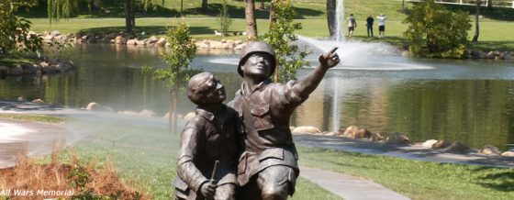
Oak Hill Park War Memorial
https://www.danville.ca.gov/619/Oak-Hill-Park

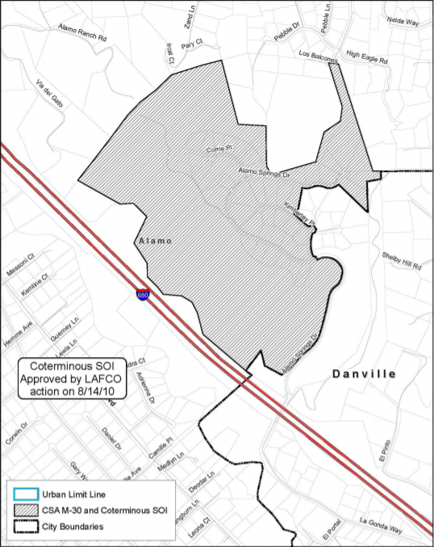
Map of County Service Area M-30 (Alamo)
file:///C:/Users/cchist/Downloads/Sect%2004%20-%20County%20Service%20Areas%202015%20(1).pdf

County Service Area M-30 (Alamo)

WEBSITE:
www.co.contra-costa.ca.us
file:///C:/Users/cchist/Downloads/Sect%2004%20-%20County%20Service%20Areas%202015%20(1).pdf

ADDRESS: Public Works Department, Attn: Special Districts Unit, County of Contra Costa, 255 Glacier Drive Martinez, CA 94553-4897

E-MAIL: scohe@pw.cccounty.us

INFORMATION:
Year formed: 1997
Area served: Alamo
Population served: 70
Size: Approximately 1.7 square miles
Services provided: Law enforcement, street maintenance, parks, landscaping and street lighting for the Alamo Springs Community.
ABOUT:
CSA M-30 was formed on December 30, 1997 as a dependent special district of the County. CSA M-30 provides financing for extended facilities and services in the unincorporated community of Alamo Springs through the Town of Danville. Town services that are eligible to receive CSA M-30 funds include parks and recreation, law enforcement, street maintenance, and landscaping. Law enforcement services are provided by contract with the County Sheriff to the Town and the CSA.
While there are no public streets for the Town to maintain within the CSA, the Town maintains public roads and landscaping on those roads leading to the CSA. The same is true for park and recreation services—there are no park facilities within the CSA; however, the Town uses CSA funds to provide park and recreation services within town limits for CSA resident use.

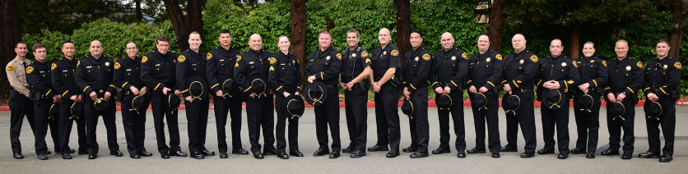
Officers of the Valley Police Station who serve the area of Roundhill
http://www.cocosheriff.org/bureaus/field_operations/patrol/valley.htm

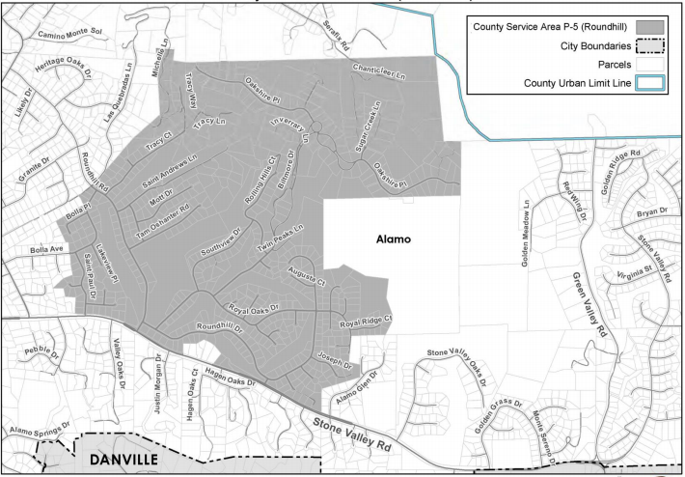
Map of County Service Area P-5 (Roundhill)
file:///C:/Users/cchist/Downloads/Sect%2004%20-%20County%20Service%20Areas%202015%20(1).pdf

County Service Area P-5 (Roundhill)

WEBSITE:
https://valleysentinel.com/law-enforcement-alamo/
file:///C:/Users/cchist/Downloads/Sect%2004%20-%20County%20Service%20Areas%202015%20(1).pdf
ADDRESS: Office of the Sheriff, Contra Costa County, 150 Alamo Place #C Alamo, CA 94507
E-MAIL: earbu@so.cccounty.us
INFORMATION:
Year formed: 1972
Area served: Roundhill
Size: Approximately 1.17 square miles
Services provided: Police protection services
ABOUT:
This CSA was organized in 1972 to provide enhanced police services for the Round Hill area. P-5 has an advisory committee that provides advice to the Board of Supervisors and the sheriff's office. P-5 is funded by a portion of the 1% property tax. Added funding is provided by parcel tax of $330 per residence for a total revenue of about $450,000 per year.

