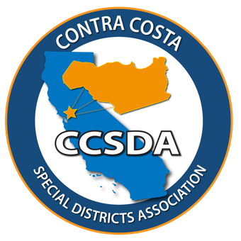
Contra Costa Special Districts Association

Mail completed form with payment to CCSDA treasurer:
Geoff Michalczyk
c/o Central Contra Costa Sanitary District
5019 Imhoff Place
Martinez, CA 94553

ASSOCIATE MEMBER APPLICATION FORM

Membership Requirements: Any person or organization that provides services to special districts or has evidenced interest in the purpose of the Chapter may become an associate member upon approval of Chapter membership and payment of dues. Associate members have no voting privileges.
Simply complete the form below and return to CCSDA with your dues investment.
There are two dues Categories for Associate Membership:
Regular Associate Members - $200 Annually
Sponsoring Associate Member - $500 Annually
By becoming an Associate Member you will become part of a growing number of community leaders that believe that Special Districts care about our community.
Please complete the following information:
Company Name: ____________________________________________________________________
Associates Name: ___________________________________________________________________
Mailing Address: ____________________________________________________________________
Company Web Site: __________________________________________________________________
Telephone Number: ____________________ E-Mail Address: _______________________________
Signature: _______________________________________ Today’s Date _______________________
Please return this form with your dues investment and a company brochure or informational flyer to CCSDA Treasurer Geoff Michalczyk:

Geoff Michalczyk
c/o Central Contra Costa Sanitary District
5019 Imhoff Place
Martinez, CA 94553

https://contracostasda.specialdistrict.org

